Île-d'Aix, Charente-Maritime, France
A car-free crescent of whitewashed cottages and Napoleonic ghosts off France's Atlantic coast — where the Emperor spent his final hours on French soil before surrendering to the British.
⚓ Tender port (no pier) · 🕒 Typical call: 5–7 hrs · 💶 Currency: Euro · 🗣️ Language: French · 🚲 Explore by bicycle or on foot
✍️ MY DAY IN PORT (FILL IN)
Ship / Date
In port | arrive ______ · all aboard ______
Booked excursion
Notes / meeting point
GETTING ASHORE
- Docking: Tender — ships anchor offshore; boats land at the island's jetty (Jetée Barbotin / Quai de l'Arcadie)
- Walk to center: 2 min from tender dock to village gate
- Best For: History buffs, beach lovers, slow-travel cyclists
- Don't Miss: Musée Napoléon & views of Fort Boyard from the beach
GETTING AROUND
TOP THINGS TO DO
- Musée Napoléon — Tour the house where Napoleon spent his last nights on French soil in July 1815, awaiting a ship to America that never came.
- Fort Liédot — Napoleon ordered this massive stone fort in 1808.
- Fort Boyard Views — The oval sea-fort made famous by the French TV game show sits just offshore to the west.
- Island Bicycle Loop — Rent a bike at the pier and circuit the entire 3 km island: pine forest in the north, Atlantic beaches on every side, ramparts in…
- Anse de la Croix & Oysters — Settle on the sandy Anse de la Croix cove just west of the village near the pier — or the longer Grande Plage further along the…
BEST WALKS
- Village & Rampart Walk: 45 min · Easy · Flat — Enter through Porte de la Ville and explore the walled village streets, then climb the Vauban…
- Fort Liédot Forest Walk: 1.5 hrs return · Easy · Pine forest path — Follow the shaded forest path north through the Bois de la Chasse to Fort Liédot.
WEATHER · DAYLIGHT · MONEY
Month | High °F | Low °F | Rainy days
May | 65 | 55 | 11
Jul | 75 | 64 | 8
Sep | 72 | 61 | 9
Daylight: May 6:32AM–9:30PM · Jul 6:29AM–9:51PM · Sep 7:43AM–8:15PM
cruiseports.org/ile-daix-island · Confirm terminal & all-aboard time with your ship

Île-d'Aix, Charente-Maritime, France — Port Map
Red = walkable sights · Amber = excursions farther out · P = cruise terminal
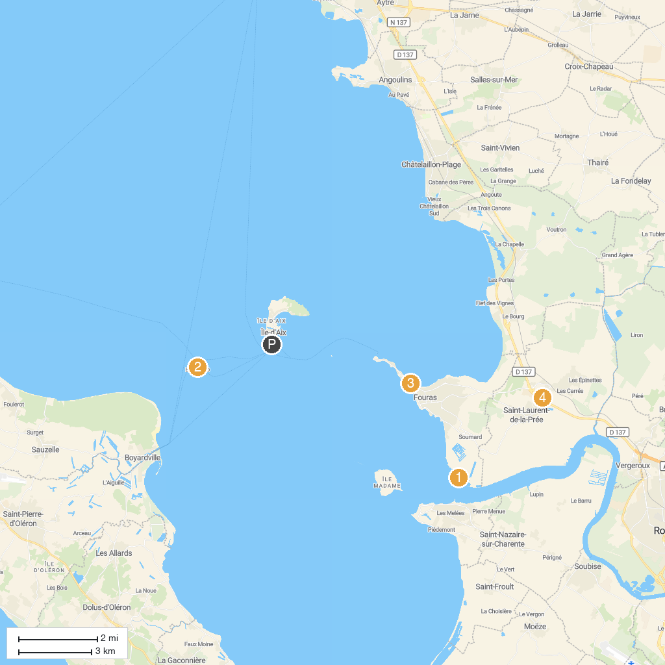
MAP KEY
1. Fort Lapointe | 5. Ecuries Laguivari
2. Fort Boyard | 6. Aquatic Center Iléo
3. Les Salons du Parc | 7. Église Saint-André
4. Yaka-jouer | 8. Église Notre-Dame-de-l'Assomption
P. Cruise port / terminal
Map © MapTiler © OpenStreetMap contributors · cruiseports.org

