Île-Rousse, Corsica, France
Founded by Corsican patriot Pasquale Paoli, Île-Rousse earns its name from the blazing red porphyry granite of the Pietra islet — a striking contrast to the turquoise sea and white-sand beaches that line the heart of this easygoing resort town.
⚓ Pier (small ships) / Tender (large ships) · 🕒 Typical call: 7-9 hrs · 💶 Euro (€) · 🗣️ French / Corsican
✍️ MY DAY IN PORT (FILL IN)
Ship / Date
In port | arrive ______ · all aboard ______
Booked excursion
Notes / meeting point
GETTING ASHORE
- Docking: Small/mid ships dock at Jetée d'Orléans; larger ships anchor and tender
- Walk to Centre: 5–10 min flat walk from pier to Place Paoli
- Best For: Beach days, local markets, scenic coastal train to Calvi
- Don't Miss: Walk the causeway to the Pietra lighthouse for panoramic views
GETTING AROUND
- 🚕 Taxi: €10–€20 — Local taxis (Taxi L'Île-Rousse, Taxis Costa) operate at the port. The ride to town is very short; expect minimum-fare ch
- 📱 Rideshare: ❌ not available
TOP THINGS TO DO
- Scenic Coastal Train to Calvi — Board "U Trinichellu" and ride the vintage two-car train hugging the coastline to Calvi, passing beaches and maquis.
- Agriates Desert & Saleccia Beach — The wild Agriates Desert hides some of Corsica's most pristine beaches — Saleccia and Lotu.
- Balagne Villages Tour — The hilltop villages of Balagne — Sant'Antonino, Pigna, and Speloncato — cling to the hills above the coast with panoramic views…
- Bodri Beach Day — A 10-minute taxi or one coastal train stop west, Bodri is an undeveloped crescent of fine white sand and turquoise water…
- Wine Tasting in the Balagne — The Balagne is one of Corsica's premier wine regions.
BEST WALKS
- Pier to Pietra Lighthouse: 3 km round trip · Easy (uphill on Pietra) · ~1 hr — Walk from the port along Plage Napoléon, through Place Paoli, and out along the causeway to the…
- Town Centre Stroll: 1 km · Flat · 30–45 min — From the port, walk to Plage Napoléon for a swim or a sunbed, then head into Place Paoli to browse…
WEATHER · DAYLIGHT · MONEY
Month | High °F | Low °F | Rainy days
May | 71 | 60 | 8
Jul | 86 | 74 | 2
Sep | 79 | 68 | 7
Daylight: May 6:02AM–8:39PM · Jul 6:00AM–8:59PM · Sep 7:04AM–7:33PM
cruiseports.org/ile-rousse · Confirm terminal & all-aboard time with your ship

Île-Rousse, Corsica, France — Port Map
Red = walkable sights · Amber = excursions farther out · P = cruise terminal
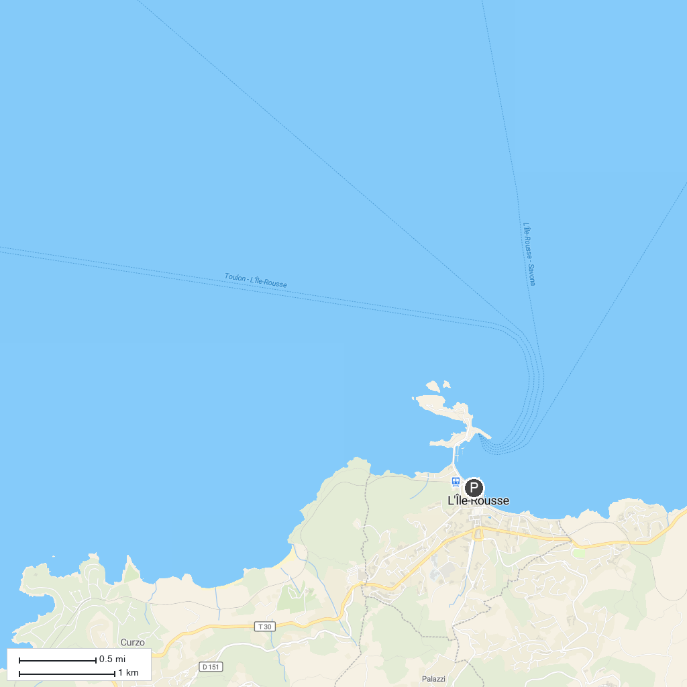
MAP KEY
1. Lac de Melu | 5. Tree Adventure Park Vizzavona
2. Ski resort of Ghisoni | 6. Fortin de Pasciola - Bastione di Pasciola
3. Cascade des Anglais | 7. Rivière du Vecchio - Fiumicellu d'U Vechju
4. Fort de Vaux - U Forte di Vaux | 8. Lac de Capitellu
P. Cruise port / terminal
Map © MapTiler © OpenStreetMap contributors · cruiseports.org

