Iles des Saintes, Guadeloupe, France
Nicknamed the 'Saint-Tropez of the Caribbean,' Iles des Saintes is a tiny, car-free French archipelago where the pace is slow, the beaches pristine, and the pastries irresistible.
⚓ Tender port (no cruise pier) · 🕒 Typical call: 6–8 hrs · 💶 Euro (€) — bring cash · 🗣️ French / basic English in tourism · 🌴 Small-ship & luxury lines
✍️ MY DAY IN PORT (FILL IN)
Ship / Date
In port | arrive ______ · all aboard ______
Booked excursion
Notes / meeting point
GETTING ASHORE
- Docking: Tender only — ships anchor in Baie des Saintes; tenders land at the Gare Maritime in Bourg
- Walk to Center: 0 min — you step off the tender into the village
- Best For: Beaches, French Creole food, Fort Napoléon, golf-cart exploration
- Don't Miss: Tourment d'amour pastries at the pier and Fort Napoléon (closes 12:30 PM)
GETTING AROUND
- 🚕 Taxi: €12–€15 per trip / tour packages vary — Taxis de l'Ile minibuses carry 6–8 passengers and are available for island tours or point-to-point transport. Often incl
- 📱 Rideshare: ❌ not available
TOP THINGS TO DO
- Fort Napoléon & Botanical Garden — A 19th-century fortress built on volcanic heights, housing a museum on the 1782 Battle of the Saintes and a cactus garden roamed…
- Plage de Pompierre — The island's most popular beach — a reef-sheltered cove with impossibly calm, shallow turquoise water and a palm-shaded shore.
- Plage du Pain de Sucre & Snorkeling — Named after its dramatic basalt cliff, this intimate cove has the best snorkeling on the island — corals and reef fish right off…
- Le Chameau Summit Hike — The highest point on the island (309 m) has a Napoleonic watchtower and 360° views of Guadeloupe, Marie-Galante, and Dominica.
- Bourg Village Stroll & Local Food — Wander the pastel-painted main street, visit the Notre-Dame de l'Assomption church, spot the boat-shaped maison-bateau on the…
BEST WALKS
- Bourg Village & Cemetery Loop: 1.5 km · 20 min · Easy — From the Gare Maritime, stroll through the colorful village center, past the Notre-Dame church, out…
- Pier to Plage de Pompierre: 1.8 km · 20-25 min · Easy-moderate — Head east from the Gare Maritime along the main road, following signs to Pompierre.
WEATHER · DAYLIGHT · MONEY
Month | High °F | Low °F | Rainy days
May | 81 | 79 | 12
Jul | 82 | 79 | 18
Sep | 84 | 80 | 16
Daylight: May 5:36AM–6:28PM · Jul 5:43AM–6:41PM · Sep 5:54AM–6:07PM
cruiseports.org/iles-des-saintes · Confirm terminal & all-aboard time with your ship

Iles des Saintes, Guadeloupe, France — Port Map
Red = walkable sights · Amber = excursions farther out · P = cruise terminal
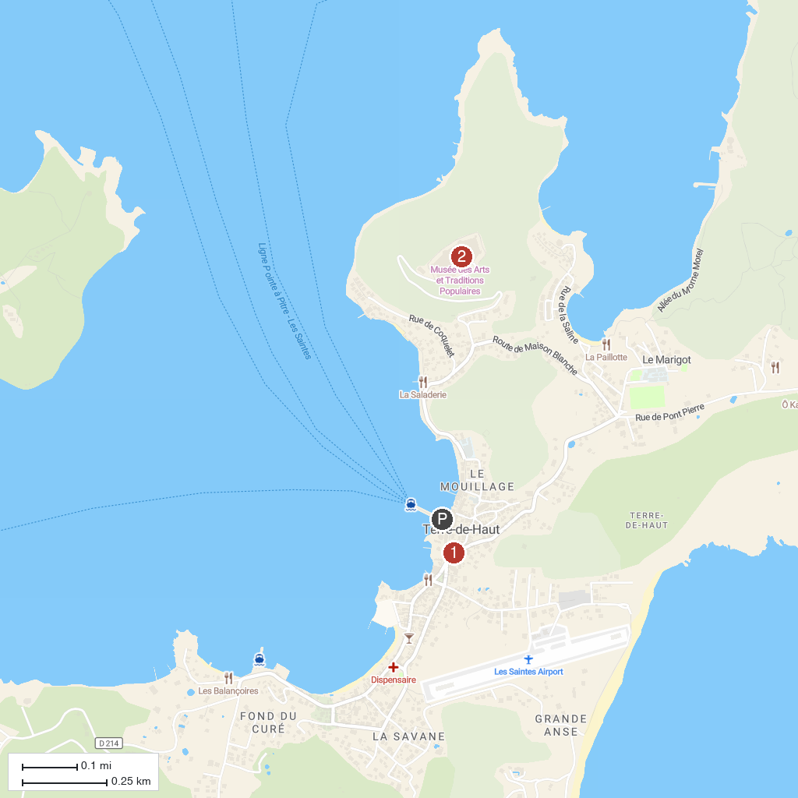
MAP KEY
1. Notre Dame de l'Assomption, les Saintes | 2. Fort Napoléon des Saintes
P. Cruise port / terminal
Map © MapTiler © OpenStreetMap contributors · cruiseports.org

