Ilfracombe, Devon, England
A Victorian resort town pinned between slate cliffs and the Bristol Channel, where Damien Hirst's colossal harbour statue sets the tone for a place that's simultaneously traditional and delightfully odd.
⚓ Tender port (no pier) · 🕒 Typical call: 6–8 hrs · 💷 Currency: British Pound (GBP) · 🗣️ Language: English
✍️ MY DAY IN PORT (FILL IN)
Ship / Date
In port | arrive ______ · all aboard ______
Booked excursion
Notes / meeting point
GETTING ASHORE
- Docking: Tender — ships anchor in Bristol Channel; 10–15 min ride to the Old Harbour
- Walk to centre: 0 min — tender lands right in the harbour heart
- Best for: Scenic walks, public art, Victorian history, seafood
- Don't miss: Verity statue, Tunnels Beaches, Lantern Hill chapel views
GETTING AROUND
- 🚕 Taxi: £5–£10 — Licensed taxis are available at the harbour and around town. North Devon taxi fares are regulated; short trips within Il
- 📱 Rideshare: ✅ Uber
- 🚌 Hop-on hop-off: ✅
TOP THINGS TO DO
- Verity & the Harbour Art Walk — Start at Damien Hirst's 66-foot bronze pregnant figure at the pier entrance — one side reveals raw anatomy.
- Tunnels Beaches — Four tunnels hand-quarried by Welsh miners in the 1820s lead to sheltered coves and a Victorian tidal bathing pool.
- Capstone Hill & South West Coast Path — A distinctive dome rising directly from the seafront.
- St Nicholas Chapel (Lantern Hill) — A 14th-century chapel perched high above the harbour that doubles as the UK's oldest working lighthouse.
- Lundy Island Day Trip — Boat trips depart from Ilfracombe harbour to Lundy Island, a remote granite island in the Bristol Channel.
BEST WALKS
- Harbour to Lantern Hill Loop: 1.5 miles · 45–60 min · Easy-moderate — From the harbour tender landing, pass Verity on the pier, then loop up through town to St Nicholas…
- Capstone Hill & Wildersmouth Beach: 1 mile · 30–45 min · Moderate — From the harbour, walk along the seafront to Wildersmouth Beach (shingle, good for rock-pooling)…
- Town to Tunnels Beaches: 0.8 miles each way · 25 min · Easy — Mostly flat walk through town along Wilder Road to the famous hand-carved tunnels.
WEATHER · DAYLIGHT · MONEY
Month | High °F | Low °F | Rainy days
May | 59 | 50 | 14
Jul | 67 | 59 | 15
Sep | 64 | 57 | 14
Daylight: May 5:25AM–9:00PM · Jul 5:18AM–9:25PM · Sep 6:52AM–7:30PM
cruiseports.org/ilfracombe · Confirm terminal & all-aboard time with your ship

Ilfracombe, Devon, England — Port Map
Red = walkable sights · Amber = excursions farther out · P = cruise terminal
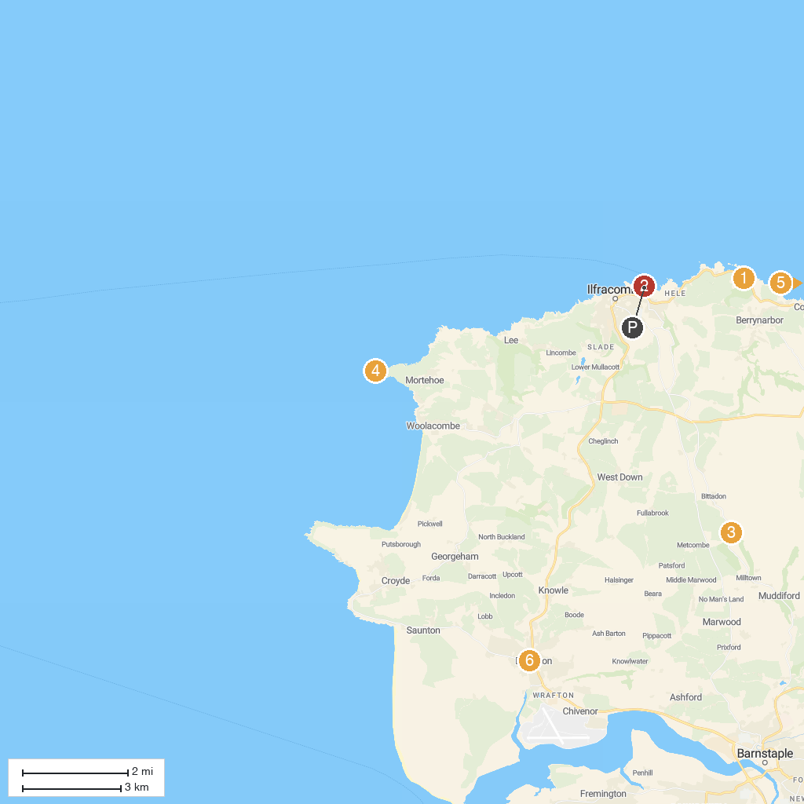
MAP KEY
1. Watermouth Castle | 5. Holdstone Down
2. Chapel of St Nicholas | 6. Braunton & District Museum
3. Nelson's Distillery & School | 7. Goldcoast Oceanfest
4. National Trust - Morte Point | 8. National Trust - Baggy Point
P. Cruise port / terminal
Map © MapTiler © OpenStreetMap contributors · cruiseports.org

