Ilha Grande, Rio de Janeiro, Brazil
A car-free Atlantic Rainforest island ringed by more than 100 beaches, Ilha Grande hides powdery coves, snorkel-worthy blue lagoons, and a dark prison past all within a short tender ride of Vila do Abraão.
⚓ Tender (no pier) · 🕒 Typical call: 6-8 hrs · 💵 Brazilian Real (BRL) · 🗣️ Portuguese · 🌿 Eco reserve
✍️ MY DAY IN PORT (FILL IN)
Ship / Date
In port | arrive ______ · all aboard ______
Booked excursion
Notes / meeting point
GETTING ASHORE
- Docking: Tender to Vila do Abraão pier
- Walk to centre: 0 min — tender lands in the village
- Best For: Beaches, snorkelling, jungle hikes
- Don't Miss: Lagoa Azul snorkel boat tour
GETTING AROUND
- 🚕 Taxi: R$20/person (~$4 USD) daytime; R$40 (~$8 USD) at night — Local water taxis operate short hops within Abraão and to Abraãozinho beach. Boats depart from the village waterfront.
- 📱 Rideshare: ❌ not available
TOP THINGS TO DO
- Lagoa Azul & Lagoa Verde Snorkel Tour — Speedboat tours depart the pier and zip around the island's northwest tip to two dazzling natural pools — Lagoa Azul…
- Hike to Lopes Mendes Beach — One of Brazil's most beautiful beaches: 3 km of wild, powdery white sand with rolling surf.
- Lazareto Ruins & Jungle Aqueduct — Follow the easy T01 trail past Praia Preta to the 19th-century quarantine hospital ruins and the 1893 stone aqueduct.
- Praia Preta (Black Sand Beach) Afternoon — A 15-minute flat walk west of the pier leads to Praia Preta's dark mineral sands, calm shallow water, and a freshwater stream.
- Seafood Lunch in Vila do Abraão — Vila do Abraão's sand-floored restaurants serve moqueca (coconut-milk seafood stew) and peixe com banana (fish with sautéed…
BEST WALKS
- Pier to Praia Preta & Lazareto Ruins: 2.5 km · 45-60 min · Easy · Free — Walk west along the waterfront from the pier, passing through Vila do Abraão and continuing to the…
- Village Walk & Praia do Abraãozinho: 3 km · 40-50 min · Easy-moderate · Free — From the pier, head east through the village square (Igreja de São Sebastião) and follow the…
WEATHER · DAYLIGHT · MONEY
Month | High °F | Low °F | Rainy days
May | 76 | 68 | 13
Jul | 74 | 65 | 7
Sep | 77 | 68 | 11
Daylight: May 6:23AM–5:23PM · Jul 6:37AM–5:28PM · Sep 5:54AM–5:50PM
cruiseports.org/ilha-grande · Confirm terminal & all-aboard time with your ship

Ilha Grande, Rio de Janeiro, Brazil — Port Map
Red = walkable sights · Amber = excursions farther out · P = cruise terminal
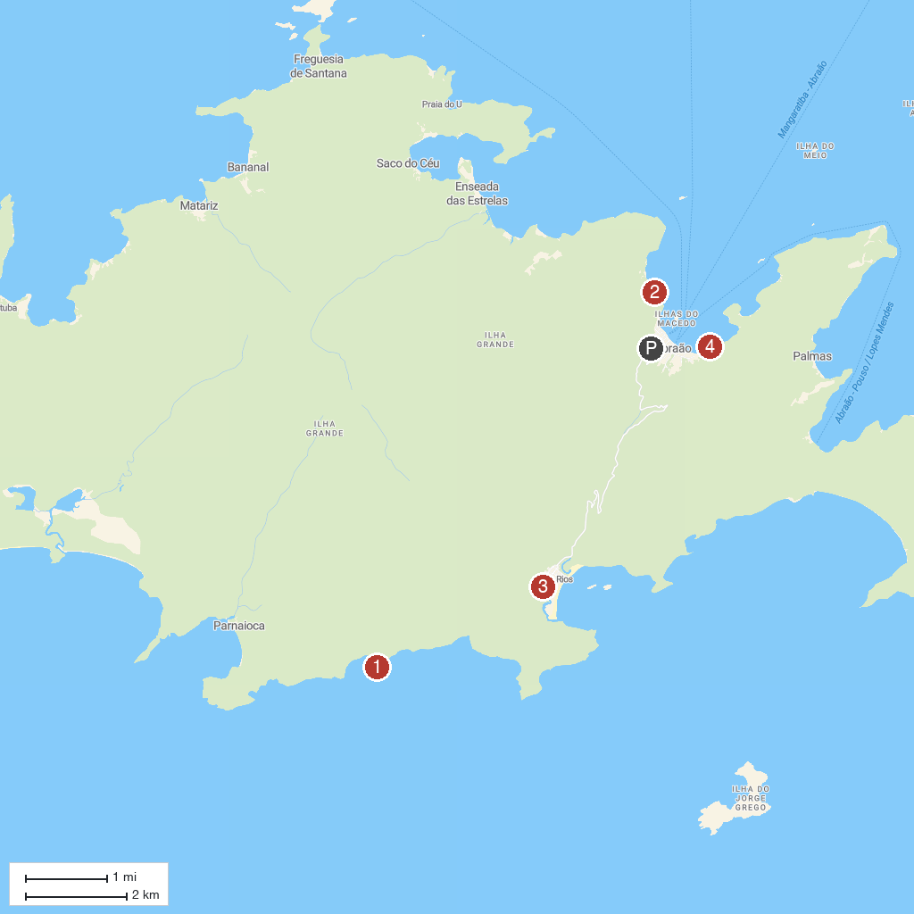
MAP KEY
1. Praia Lopes Mendes | 4. Antigo Presídio Cândido Mendes
2. Ruínas do Lazareto | 5. Praia da Julia
3. Praia do Aventureiro
P. Cruise port / terminal
Map © MapTiler © OpenStreetMap contributors · cruiseports.org

