Ilhabela, São Paulo State, Brazil
An island of emerald rainforest, hidden waterfalls, and over 40 beaches — Ilhabela is Brazil's sailing capital and one of its most beautiful island escapes.
⚓ Tender (no pier) · 🕒 Typical call: 8-10 hrs · 💵 Brazilian Real (BRL) · 🗣️ Portuguese · 🌿 85% State Park / UNESCO Biosphere
✍️ MY DAY IN PORT (FILL IN)
Ship / Date
In port | arrive ______ · all aboard ______
Booked excursion
Notes / meeting point
GETTING ASHORE
- Docking: Tender to Píer da Vila in the historic center
- Walk to center: 0 min — tender drops right in Vila
- Best For: Beaches, waterfalls, 4x4 adventures, sailing
- Don't Miss: Cachoeira da Toca waterfall slide & Praia de Castelhanos
GETTING AROUND
- 🚕 Taxi: Varies by destination — Taxis and vans wait at the tender pier and are the easiest way to reach beaches and attractions beyond Vila. Agree on a
- 📱 Rideshare: ✅ Uber
TOP THINGS TO DO
- 4x4 Jeep Tour to Castelhanos Beach — The island's signature excursion: a 22 km off-road drive through Atlantic Rainforest to the wild east-coast bay of Castelhanos…
- Cachoeira da Toca Waterfall & Natural Slide — A historic sugarcane estate turned eco-park with a natural rock waterslide, cool plunge pools, and a working artisan cachaça…
- Praia do Curral Beach Day — Ilhabela's most popular and lively beach, lined with seafood restaurants and upbeat beach bars.
- Snorkeling & Shipwreck Diving — The São Sebastião Channel is one of Brazil's shipwreck capitals, with dozens of historic wrecks dating from the 1800s and early…
- Vila Historic Center Walk — Explore colonial cobblestone streets, the 18th-century Igreja Matriz de Nossa Senhora d'Ajuda e Bom Sucesso church on the…
BEST WALKS
- Vila Historic Center & Píer Promenade: 1-2 hrs | Flat | Free — From the tender pier, stroll the cobblestone streets of Vila.
- Pier to Praia do Saco da Capela: 15 min | Flat paved path | Free — A pleasant coastal walk north from the tender pier along a paved promenade lined with palm trees…
WEATHER · DAYLIGHT · MONEY
Month | High °F | Low °F | Rainy days
May | 76 | 67 | 13
Jul | 75 | 63 | 7
Sep | 77 | 66 | 13
Daylight: May 6:28AM–5:26PM · Jul 6:43AM–5:31PM · Sep 5:58AM–5:55PM
cruiseports.org/ilhabela · Confirm terminal & all-aboard time with your ship

Ilhabela, São Paulo State, Brazil — Port Map
Red = walkable sights · Amber = excursions farther out · P = cruise terminal
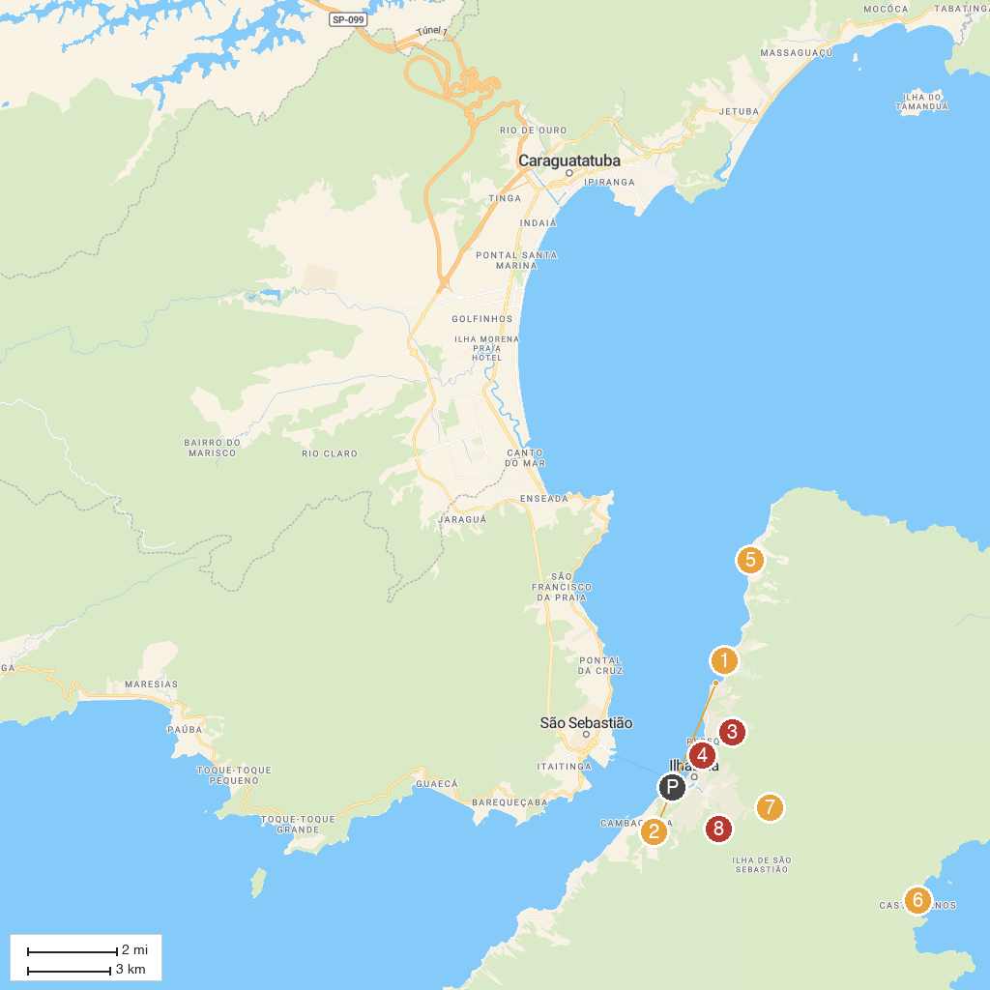
MAP KEY
1. Church of Our Lady Help Of | 5. Bell Stone
2. Praia Saco da Capela | 6. Praia De Castelhanos
3. Trail Baepi Pico | 7. Cachoeira da Toca
4. Caiçara Beach Ilhabela | 8. Cachoeira da Água Branca
P. Cruise port / terminal
Map © MapTiler © OpenStreetMap contributors · cruiseports.org

