Incheon, South Korea
South Korea's great port city opens the door to Seoul's palaces and K-culture — while Incheon's own Chinatown, futuristic Songdo, and harbor views reward those who stay local.
⚓ Pier (Incheon International Cruise Terminal) · 🕒 Typical call: 8-10 hrs · 💵 Korean Won (KRW) · 🗣️ Korean (limited English outside tourist zones) · 🚇 Excellent subway access to Seoul
✍️ MY DAY IN PORT (FILL IN)
Ship / Date
In port | arrive ______ · all aboard ______
Booked excursion
Notes / meeting point
GETTING ASHORE
- Docking: Pier — Incheon International Cruise Terminal, Songdo (opened 2019)
- Walk to Center: Not walkable — shuttle or taxi required to reach attractions
- Best For: Seoul day trip, Korean street food, K-culture, futuristic architecture
- Don't Miss: Incheon Chinatown's Jajangmyeon, Songdo Central Park, Sinpo Market chicken
GETTING AROUND
- 🚕 Taxi: ₩40,000–₩56,000 — Metered taxis to central Seoul take about 40–60 min depending on traffic. Fares do not include expressway tolls (~₩7,000
- 📱 Rideshare: ✅ Uber, Kakao T, K-RIDE
- 🚌 Hop-on hop-off: ✅
TOP THINGS TO DO
- Seoul Highlights: Palaces & Myeongdong — The big draw for most passengers — take the subway or a ship tour to Gyeongbokgung Palace (Korea's grandest), wander Bukchon…
- Incheon Chinatown & Songwol-dong Fairy Tale Village — Korea's only official Chinatown — established in 1883 — is a colorful hillside neighborhood famous for Jajangmyeon (black bean…
- Sinpo International Market & Street Food — Incheon's oldest traditional market is famous for Dakgangjeong — sweet, spicy, incredibly crunchy glazed chicken.
- Songdo Central Park & Smart City Walk — Built from scratch on reclaimed sea, Songdo's Central Park features a seawater canal inspired by New York's Central Park, water…
- Gaehangjang Open Port & Colonial Architecture — Adjacent to Chinatown, this preserved late-19th century district showcases Japanese and Western colonial-era buildings from when…
BEST WALKS
- Chinatown to Fairy Tale Village Loop: 1.5 km · 45 min · Easy — From Incheon Chinatown Gate, walk up the hill through colorful Chinese restaurants and murals, then…
- Songdo Central Park Waterfront: 2 km · 40 min · Easy — Stroll the Songdo Central Park canal from the Tri-Bowl pavilion along the seawater waterway…
WEATHER · DAYLIGHT · MONEY
Month | High °F | Low °F | Rainy days
May | 69 | 54 | 8
Jul | 82 | 72 | 15
Sep | 77 | 64 | 8
Daylight: May 5:24AM–7:35PM · Jul 5:24AM–7:53PM · Sep 6:15AM–6:41PM
cruiseports.org/incheon · Confirm terminal & all-aboard time with your ship

Incheon, South Korea — Port Map
Red = walkable sights · Amber = excursions farther out · P = cruise terminal
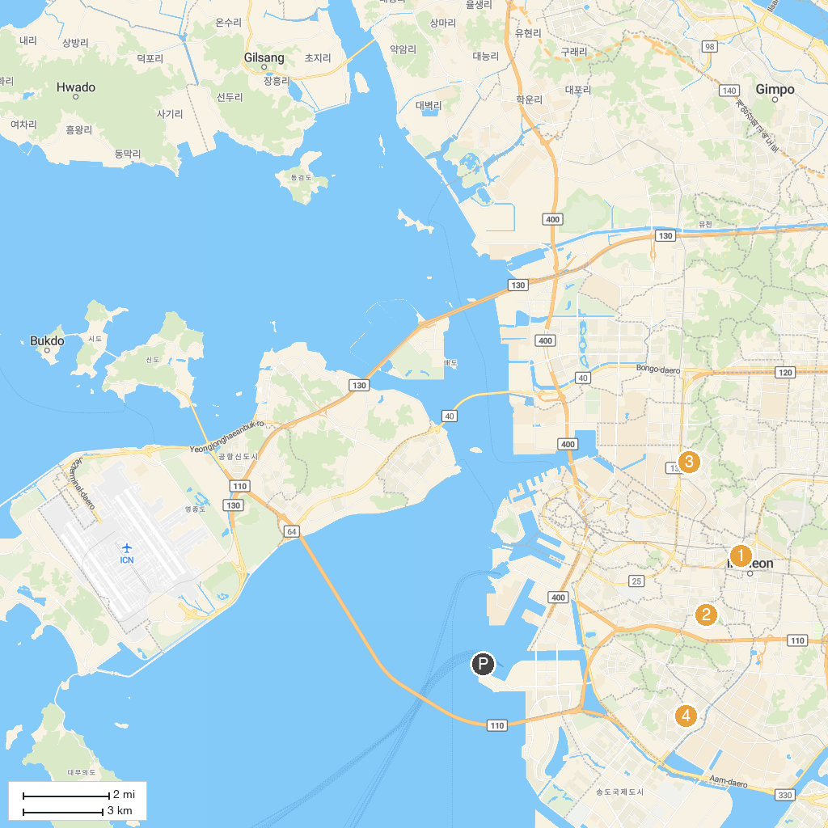
MAP KEY
1. 중앙공원 | 5. 원적산체육공원
2. 남동문화근린공원 | 6. 부수지근린공원
3. 관교공원 | 7. 체육공원
4. 건지공원 | 8. 부천원미공원
P. Cruise port / terminal
Map © MapTiler © OpenStreetMap contributors · cruiseports.org

