Inverie, Knoydart, Scotland
No roads reach this place — just sea, mountains, and silence. Inverie is mainland Britain's last true wilderness, where expedition ships anchor in Loch Nevis and passengers step ashore into a community that runs entirely on its own terms.
⚓ Tender (anchor in Loch Nevis) · 🕒 Typical call: 5–8 hrs · 💷 Currency: British Pounds (GBP) · 🗣️ Language: English (Gaelic heritage) · 🏔️ Expedition & small-ship only
✍️ MY DAY IN PORT (FILL IN)
Ship / Date
In port | arrive ______ · all aboard ______
Booked excursion
Notes / meeting point
GETTING ASHORE
- Docking: Tender — ships anchor in Loch Nevis; tenders land at Inverie Pier
- Walk to village: 3–5 min from the pier to pub, tearoom, and community shop
- Best For: Wild hiking, wildlife watching, off-grid atmosphere, historic pub
- Don't Miss: The Old Forge — Guinness-certified mainland Britain's most remote pub
GETTING AROUND
- 🚕 Taxi: £9–£18 return (adult) — Western Isles Cruises and Knoydart Seabridge operate ferry services from nearby Mallaig to Inverie across Loch Nevis (~3
- 📱 Rideshare: ❌ not available
TOP THINGS TO DO
- Knoydart Ranger Guided Walk — Join a Knoydart Foundation ranger for a guided walk through the peninsula's ancient woodland and open hillside.
- Otter & Seal Spotting on Loch Nevis — Otters are regularly seen playing around the pier and rocky foreshore.
- Hike to the Brocket Monument — A strenuous hill walk leads up over the hills behind Inverie to the towering stone cross erected in the 1930s by Lord Brocket…
- Knoydart Brewery Tour & Tasting — One of Britain's most remote craft breweries operates out of a converted chapel.
- Land Raiders Monument & Community Story — A short walk from the pier stands the cairn commemorating the 1948 Land Raiders — seven local men who defied an absentee landlord…
BEST WALKS
- Village Foreshore Stroll: 1.5 km | 30 min | Easy | Flat paved track — Walk east from the pier along the single-track road through the village to Long Beach, passing The…
- Brocket Monument Hill Walk: ~10 km return | ~5 hrs | Strenuous | Rough boggy hill path — From the village, head up over the hills behind Inverie to the Brocket Monument, a tall stone cross…
WEATHER · DAYLIGHT · MONEY
Month | High °F | Low °F | Rainy days
May | 56 | 46 | 19
Jul | 62 | 53 | 23
Sep | 59 | 51 | 20
Daylight: May 5:04AM–9:35PM · Jul 4:51AM–10:05PM · Sep 6:54AM–7:40PM
cruiseports.org/inverie · Confirm terminal & all-aboard time with your ship

Inverie, Knoydart, Scotland — Port Map
Red = walkable sights · Amber = excursions farther out · P = cruise terminal
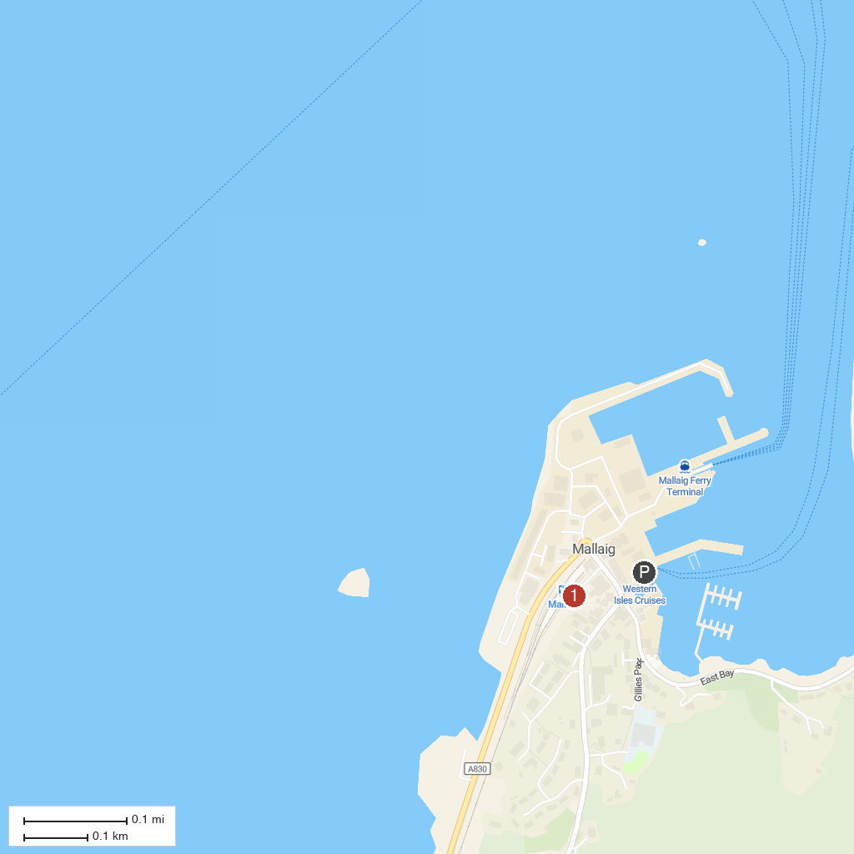
MAP KEY
1. Castle Tioram | 5. Castle Moil
2. Mallaig Heritage Centre | 6. Bella Jane Boat Trips
3. Otter Hide | 7. Balmacara Estate Visitor Centre (National Trust for Scotland)
4. Glenfinnan Viaduct
P. Cruise port / terminal
Map © MapTiler © OpenStreetMap contributors · cruiseports.org

