Inverness, Scottish Highlands, Scotland
The northernmost city in Britain sits at the heart of the Scottish Highlands — your gateway to Loch Ness, clan battlefields, and wild Highland scenery. Ships dock 25 miles away at Invergordon; the rewards are worth the transfer.
⚓ Pier port (Invergordon) · 🕒 Typical call: 8-10 hrs · 💷 Currency: Pound Sterling (£) · 🗣️ Language: English / Scots Gaelic · 🚂 Train to Inverness: ~55 min
✍️ MY DAY IN PORT (FILL IN)
Ship / Date
In port | arrive ______ · all aboard ______
Booked excursion
Notes / meeting point
GETTING ASHORE
- Docking: Walk-off pier at Invergordon; free shuttle to town, then train or bus to Inverness (25 mi)
- Walk to center: Invergordon pier to town: 10 min walk. Inverness city center is compact and walkable.
- Best For: History buffs, Outlander fans, Loch Ness seekers, Scottish culture
- Don't Miss: Culloden Battlefield — the last battle fought on British soil, just 5 miles from Inverness
GETTING AROUND
- 🚕 Taxi: £50–£65 one-way — Taxis available at the port for the ~23-mile trip to Inverness city center (~29 min). Shareable between groups to offset
- 📱 Rideshare: ✅ Uber
- 🚌 Hop-on hop-off: ✅
TOP THINGS TO DO
- Loch Ness & Urquhart Castle — The must-do Highland experience: a boat cruise on the legendary dark waters of Loch Ness paired with a visit to the dramatic…
- Culloden Battlefield — Five miles from Inverness, this haunting moorland marks the site of the last pitched battle on British soil (1746).
- Cawdor Castle & Gardens — A beautifully preserved 14th-century inhabited castle linked to Shakespeare's Macbeth, with magnificent formal gardens and…
- Inverness City Exploration — The Highland capital is compact and walkable: riverside Inverness Cathedral, the Victorian Market arcade, Ness Islands footbridge…
- Chanonry Point Dolphin Watch — Chanonry Point on the Black Isle (between Invergordon and Inverness) is one of the UK's best spots to watch bottlenose dolphins…
BEST WALKS
- River Ness & Ness Islands Loop: 3.5 km · Easy · 45–60 min — From Inverness Train Station, walk south along the riverside to Inverness Cathedral, cross to the…
- Victorian Market to Leakey's Bookshop: 0.8 km · Easy · 20 min stroll — A short city-centre wander through Inverness's best indoor spaces: the ornate Victorian Market…
WEATHER · DAYLIGHT · MONEY
Month | High °F | Low °F | Rainy days
May | 57 | 43 | 15
Jul | 65 | 53 | 16
Sep | 61 | 49 | 13
Daylight: May 4:55AM–9:30PM · Jul 4:41AM–10:04PM · Sep 6:47AM–7:37PM
cruiseports.org/inverness · Confirm terminal & all-aboard time with your ship

Inverness, Scottish Highlands, Scotland — Port Map
Red = walkable sights · Amber = excursions farther out · P = cruise terminal
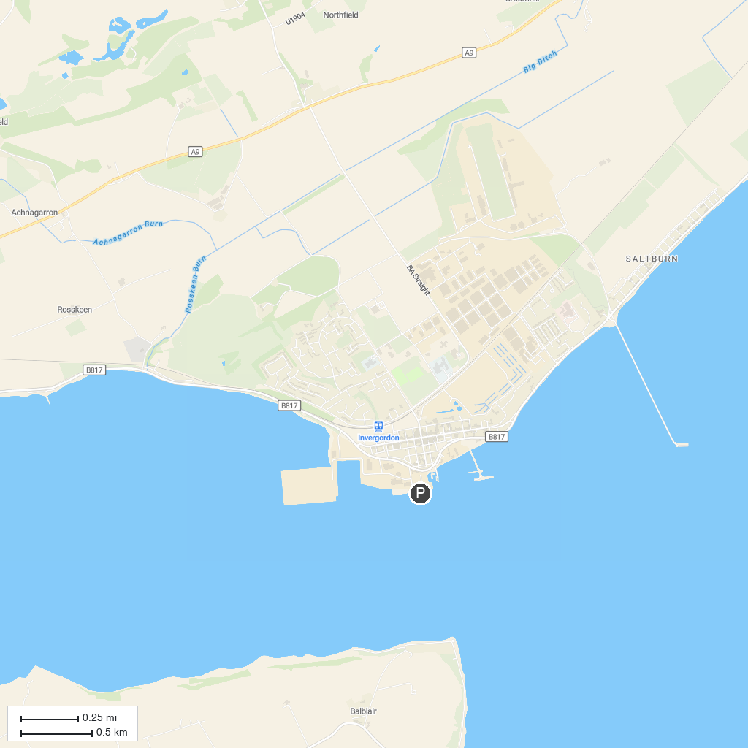
MAP KEY
1. Eden Court Inverness | 5. Craig Phadrig
2. Clava Cairns | 6. Ness Bank Church
3. Whin Park | 7. Dolphin Spirit Inverness
4. Bellfield Park | 8. Merkinch Local Nature Reserve (North end)
P. Cruise port / terminal
Map © MapTiler © OpenStreetMap contributors · cruiseports.org

