Ios Island, Cyclades, Greece
A Cycladic gem of whitewashed alleyways, turquoise coves, and Bronze Age secrets — best experienced in the tranquil morning hours before the island wakes.
⚓ Tender port (no pier) · 🕒 Typical call: 6–8 hrs · 💶 Currency: Euro · 🗣️ Language: Greek
✍️ MY DAY IN PORT (FILL IN)
Ship / Date
In port | arrive ______ · all aboard ______
Booked excursion
Notes / meeting point
GETTING ASHORE
- Docking: Tender to Gialos marina
- Walk to Chora: 20 min uphill or 5-min bus (€2)
- Best For: Beaches, Cycladic architecture, archaeology
- Don't Miss: Chora old town early morning; Skarkos Bronze Age site
GETTING AROUND
- 🚕 Taxi: €3–€8 — Taxis wait at the port for arrivals. The quick ride to Chora (2–3 km) typically costs €3–€8. Can be hard to find in peak
TOP THINGS TO DO
- Chora Old Town & Windmills — Wander the labyrinthine whitewashed alleys of Chora, lined with blue-domed churches and bougainvillea.
- Mylopotas Beach Day — A sweeping arc of golden sand and brilliant turquoise water.
- Skarkos Bronze Age Settlement — A UNESCO-nominated circular settlement dating to 2800 BC, among the best-preserved Early Cycladic sites in Greece.
- Koumbara Beach — A quieter, sheltered sandy cove a 20-minute flat walk northwest of the Gialos tender dock.
- ATV Ride to Homer's Tomb — Rent an ATV at the port and wind up mountain roads to Plakoto on the island's north tip, where locals claim the poet Homer was…
BEST WALKS
- Gialos Port to Chora via the Donkey Path: 1.2 km · 20 min · Uphill — From the Gialos marina, follow the signs up the old paved stone donkey path to Chora.
- Chora to Skarkos Archaeological Site: 0.8 km · 15 min · Easy downhill — From Chora's main square, head downhill toward the valley.
WEATHER · DAYLIGHT · MONEY
Month | High °F | Low °F | Rainy days
May | 73 | 64 | 3
Jul | 83 | 75 | 0
Sep | 79 | 72 | 2
Daylight: May 6:11AM–8:19PM · Jul 6:12AM–8:37PM · Sep 7:01AM–7:26PM
cruiseports.org/ios-island · Confirm terminal & all-aboard time with your ship

Ios Island, Cyclades, Greece — Port Map
Red = walkable sights · Amber = excursions farther out · P = cruise terminal
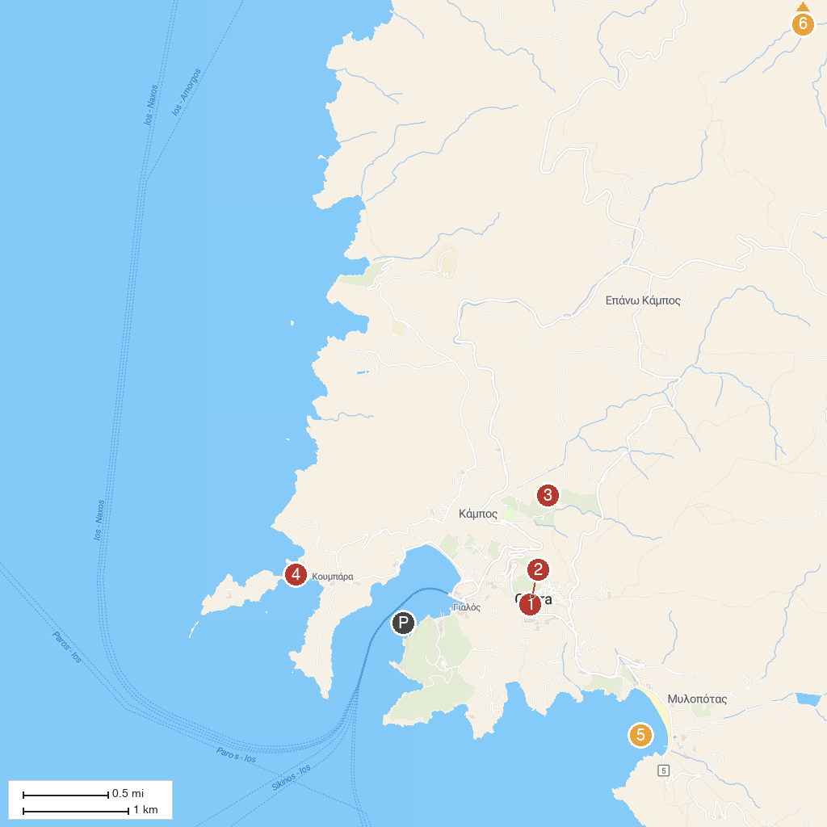
MAP KEY
1. Panagia Gremiotissa | 4. Koumbara Beach
2. Chora Windmills | 5. Mylopotas Beach
3. Skarkos Archaeological Site | 6. Homer's Tomb
P. Cruise port / terminal
Map © MapTiler © OpenStreetMap contributors · cruiseports.org

