Iquique, Tarapacá, Chile
A Victorian boomtown frozen in time between colossal sand dunes and the Pacific — UNESCO ghost towns, duty-free bazaars, and sea lions on white-sand beaches await.
⚓ Pier (docked) · 🕒 Typical call: 6–8 hrs · 💵 Chilean Peso (CLP) · 🗣️ Spanish
✍️ MY DAY IN PORT (FILL IN)
Ship / Date
In port | arrive ______ · all aboard ______
Booked excursion
Notes / meeting point
GETTING ASHORE
- Docking: Pier — ships dock at Puerto de Iquique; port shuttle to gate
- Walk to center: ~1 km / 12 min from port gate to Plaza Prat
- Best For: History lovers, beach days, and UNESCO day-trips
- Don't Miss: Humberstone UNESCO ghost town & Paseo Baquedano
GETTING AROUND
- 🚕 Taxi: ~USD 3–5 — Taxis wait at the port exit. Fares to the city center are short and affordable; agree on a price before boarding as mete
- 📱 Rideshare: ✅ Uber
TOP THINGS TO DO
- Humberstone & Santa Laura UNESCO Ghost Towns — Two abandoned nitrate-mining settlements 48 km inland, preserved exactly as workers left them — rusting machinery, a school, a…
- Paseo Baquedano & Plaza Prat Walking Tour — Stroll Iquique's pedestrian street lined with Georgian-style mansions built from Oregon pine during the 1880s saltpeter boom.
- Tandem Paragliding over Iquique — Launch from the clifftops above Playa Brava and soar over the city, the giant Cerro Dragón sand dune, and the Pacific — Iquique…
- Cerro Dragón Sand Dune & Desert Views — One of the world's largest urban sand dunes rises over 300 m at the city's edge.
- Playa Cavancha Beach Day — Iquique's main beach has soft white sand, palm-fringed boardwalk, calm swimming waters, and a resident sea lion colony on the…
BEST WALKS
- Port Gate to Plaza Prat Heritage Walk: 1 km · 12 min · Flat · Free — From the port exit gate, walk south along Avenida Esmeralda past the Esmeralda museum, then along…
- Plaza Prat to Playa Cavancha Boardwalk: 2.5 km · 30 min · Flat · Scenic — Head west from Plaza Prat down Calle Arturo Prat to the coast, then follow the beachfront boardwalk…
WEATHER · DAYLIGHT · MONEY
Month | High °F | Low °F | Rainy days
May | 70 | 60 | 1
Jul | 66 | 56 | 1
Sep | 68 | 57 | 0
Daylight: May 7:02AM–6:11PM · Jul 7:16AM–6:17PM · Sep 7:36AM–7:35PM
cruiseports.org/iquique · Confirm terminal & all-aboard time with your ship

Iquique, Tarapacá, Chile — Port Map
Red = walkable sights · Amber = excursions farther out · P = cruise terminal
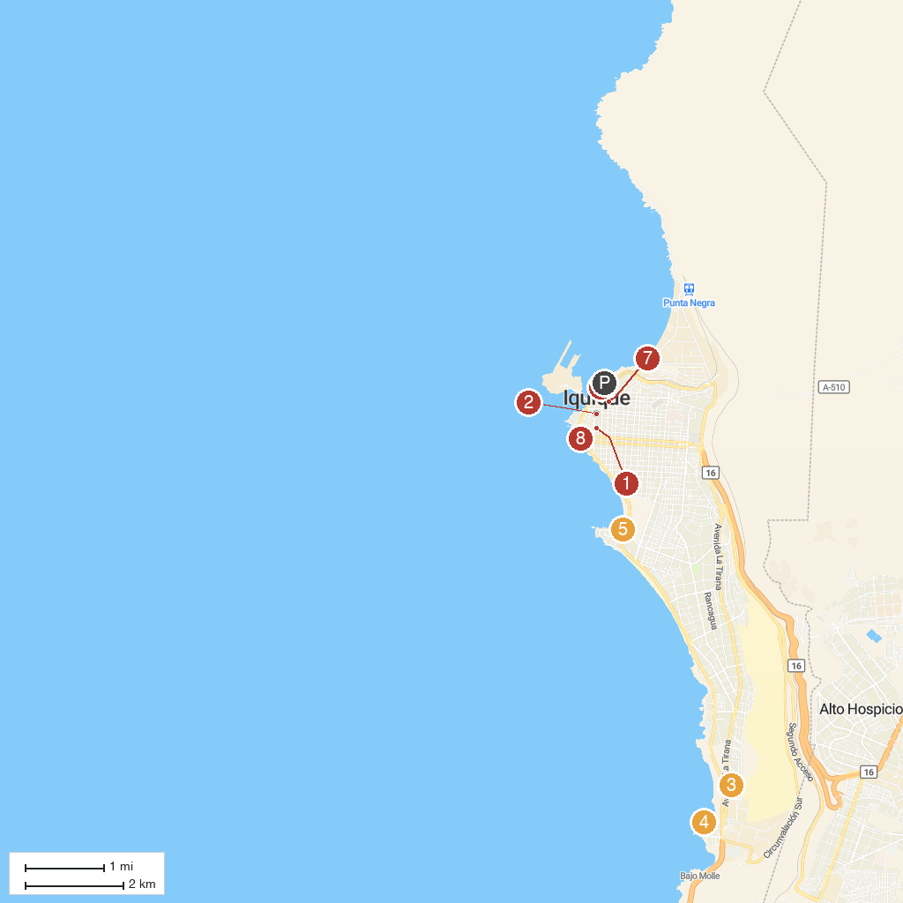
MAP KEY
1. Museo Regional | 5. Casino Dreams Iquique
2. Clock Tower | 6. Corbeta Esmeralda Museum
3. Sendero Iquique | 7. Immaculate Conception Cathedral
4. Recreation Center Huayquique | 8. Paseo Playa Bellavista
P. Cruise port / terminal
Map © MapTiler © OpenStreetMap contributors · cruiseports.org

