Ishigaki Island, Okinawa, Japan
Japan's southernmost frontier — a subtropical island where turquoise bays, living coral reefs, and centuries-old Ryukyu culture sit just steps from the pier.
⚓ Pier (most ships dock) · 🕒 Typical call: 7-10 hrs · 💴 Japanese Yen (cash essential) · 🗣️ Japanese (little English)
✍️ MY DAY IN PORT (FILL IN)
Ship / Date
In port | arrive ______ · all aboard ______
Booked excursion
Notes / meeting point
GETTING ASHORE
- Docking: Ishigaki Port pier; large ships may anchor & tender
- Walk to center: ~10 min on foot to Ishigaki city center & ferry terminal
- Best For: Snorkeling, glass-bottom boats, Taketomi day trip, subtropical nature
- Don't Miss: Kabira Bay glass-bottom boat and a Taketomi Island buffalo cart ride
GETTING AROUND
- 🚕 Taxi: ¥1,500–¥2,000 — Taxis are readily available at the port and city center. The fare from the cruise terminal to downtown is approximately
TOP THINGS TO DO
- Kabira Bay Glass-Bottom Boat — Japan's most photographed bay has emerald waters, black pearl farms, and no swimming allowed — which means you glide over…
- Taketomi Island Day Trip — A 10-minute ferry from Ishigaki drops you on a perfectly preserved Ryukyu village — coral-walled lanes, shisa-topped rooftops…
- Snorkeling at Yonehara or Shiraho Reef — Yonehara Beach's shallow reef is alive with clownfish and sea turtles.
- Mangrove Kayaking (Miyara River) — Paddle under a canopy of mangroves along the Miyara River — one of Okinawa's most accessible subtropical jungle experiences…
- Stalactite Cave & Yaeyama Museum — The Ishigaki Island Stalactite Cave formed over 200,000 years ago; combine it with a stop at Yaeyama Museum for context on Ryukyu…
BEST WALKS
- Port to City Center & Euglena Mall: ~1.5 km · 15-20 min · flat — Walk north from the cruise pier along the waterfront promenade to the covered Euglena Mall shopping…
- Torinji Temple & Gongen-do Shrine Loop: ~2.5 km · 30-40 min · flat — Ishigaki's oldest Rinzai Zen temple dates to 1614 and houses two remarkable wooden guardian figures…
WEATHER · DAYLIGHT · MONEY
Month | High °F | Low °F | Rainy days
May | 81 | 76 | 21
Jul | 87 | 82 | 20
Sep | 85 | 80 | 21
Daylight: May 6:00AM–7:19PM · Jul 6:04AM–7:34PM · Sep 6:29AM–6:47PM
cruiseports.org/ishigakijima-island · Confirm terminal & all-aboard time with your ship

Ishigaki Island, Okinawa, Japan — Port Map
Red = walkable sights · Amber = excursions farther out · P = cruise terminal
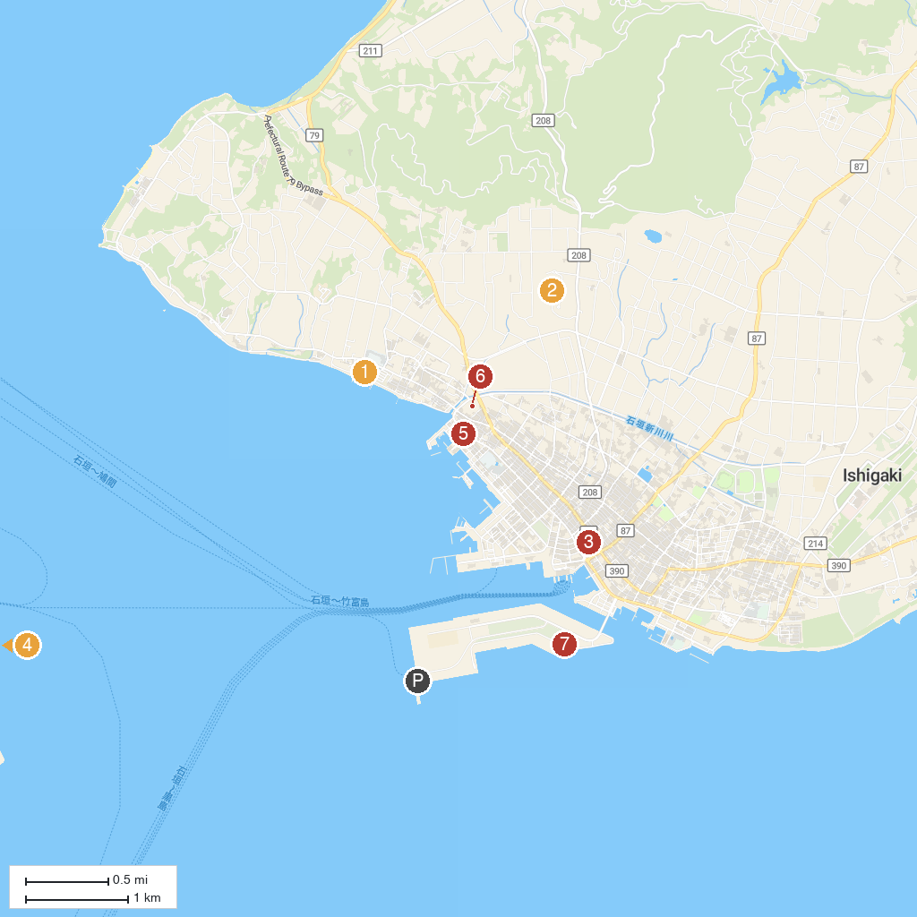
MAP KEY
1. Funakura Park (formerly known as Children's Park) | 5. 川平焼 凜火
2. Ishigaki Stalactite Cave | 6. Yaeyama Peace Memorial Museum
3. Ishigaki City Public Market | 7. Arakawa Park
4. Nagomi Tower | 8. Dolphin Fantasy Ishigaki Island
P. Cruise port / terminal
Map © MapTiler © OpenStreetMap contributors · cruiseports.org

