Isla de la Juventud, Cuba
Cuba's second-largest island moves at its own unhurried pace — a former pirate haven turned political prison island, now celebrated for pristine dive sites and marble-streaked black sand beaches found nowhere else in the Caribbean.
⚓ Tender port (no cruise pier) · 🕒 Typical call: 7–9 hrs · 💵 USD / EUR (cash only — US cards don't work) · 🗣️ Spanish · 🤿 World-class diving
✍️ MY DAY IN PORT (FILL IN)
Ship / Date
In port | arrive ______ · all aboard ______
Booked excursion
Notes / meeting point
GETTING ASHORE
- Docking: Tender — ships anchor offshore; tenders land at Nueva Gerona or Siguanea Bay
- Walk to center: 5–10 min from Nueva Gerona tender dock to Calle Real
- Best For: Scuba diving, cold-war history, off-the-beaten-path Cuba
- Don't Miss: Presidio Modelo (Castro's prison) and Playa Punta Francés
GETTING AROUND
- 🚕 Taxi: $2–$7 USD — Official Cuban taxis (Cubataxi) are the primary transport from the tender pier in Nueva Gerona to town. Negotiate fare b
- 📱 Rideshare: ❌ not available
TOP THINGS TO DO
- Presidio Modelo — Cuba's Panopticon Prison — Tour the panopticon prison complex built 1926–1931 under President Gerardo Machado, designed for up to 5,000 inmates and most…
- Cuevas de Punta del Este — Aboriginal Cave Art — Known as the Sistine Chapel of Caribbean rock art, these caves on the island's southeastern tip hold over 230 pre-Columbian…
- Scuba Diving at Punta Francés Marine Park — World-renowned dive site on the island's southwest tip with crystal-clear Caribbean water, vibrant coral walls, and accessible…
- Nueva Gerona Walking Tour & Local Lunch — Stroll Calle Real's pastel colonial buildings, browse the local art market, visit Parque Central and the Church of Nuestra Señora…
- Finca El Abra — José Martí Exile Site — Visit the hacienda where Cuba's national hero José Martí spent 65 days in exile in 1870, recovering under the care of the Sardá…
BEST WALKS
- Nueva Gerona Town Stroll: 1.5 km · Flat · 30–40 min — From the tender dock walk along the Las Casas riverfront to Parque Central, then south along…
WEATHER · DAYLIGHT · MONEY
Month | High °F | Low °F | Rainy days
May | 85 | 77 | 18
Jul | 88 | 80 | 16
Sep | 86 | 79 | 21
Daylight: May 6:52AM–8:03PM · Jul 6:57AM–8:17PM · Sep 7:18AM–7:33PM
cruiseports.org/isla-de-la-juventud · Confirm terminal & all-aboard time with your ship

Isla de la Juventud, Cuba — Port Map
Red = walkable sights · Amber = excursions farther out · P = cruise terminal
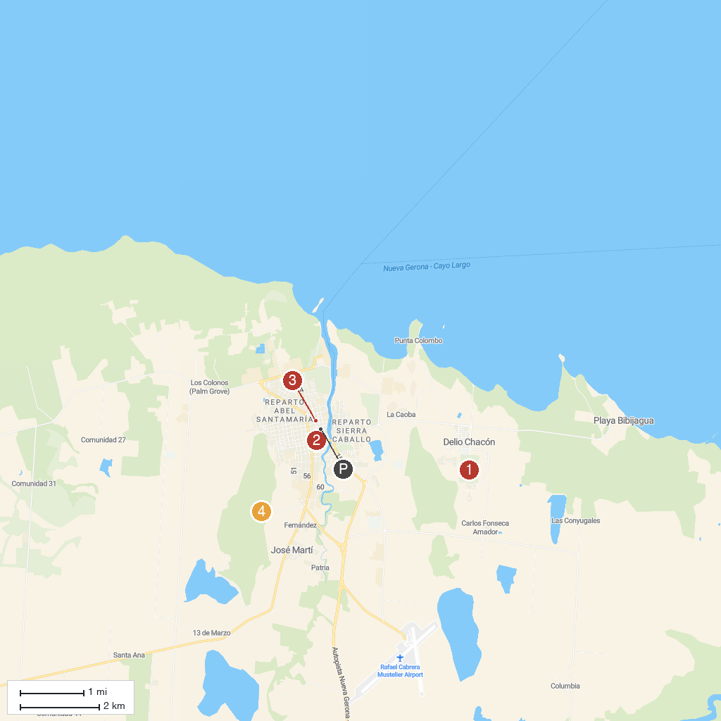
MAP KEY
1. Presidio Modelo | 3. Parque José Martí
2. Museo de Historia Natural | 4. Finca El Abra
P. Cruise port / terminal
Map © MapTiler © OpenStreetMap contributors · cruiseports.org

