Isla Gámez, Chiriquí, Panama
An uninhabited gem in Panama's Pacific — two pristine beaches on a single sand spit, humpback whales offshore, and no one else around.
⚓ Tender only (wet Zodiac landing) · 🕒 Typical call: 5–7 hrs · 💵 USD (no shops on island) · 🗣️ Spanish (no staff ashore) · 🐋 Humpback whales Jul–Oct
✍️ MY DAY IN PORT (FILL IN)
Ship / Date
In port | arrive ______ · all aboard ______
Booked excursion
Notes / meeting point
GETTING ASHORE
- Docking: Anchor & Zodiac wet landing — no pier
- Walk to center: You're on the beach the moment you step off
- Best For: Snorkeling, kayaking, whale watching, total solitude
- Don't Miss: The tombolo double-beach spit at the island's narrow waist
GETTING AROUND
- 🚕 Taxi: ~$35–50 per taxi — If you reach the mainland at Boca Chica, local taxis can take you to David, the provincial capital of Chiriquí, about 45
TOP THINGS TO DO
- Double-Beach Day — Claim a palm-shaded spot on the tombolo sand spit with turquoise water on both sides.
- Snorkeling the Rocky Points — The volcanic outcroppings at each end of the spit host parrotfish, damselfish, sea urchins, and occasional reef sharks and sea…
- Kayaking & Stand-Up Paddleboarding — Most expedition ships bring kayaks and SUPs ashore.
- Humpback Whale Watching (Jul–Oct) — The Gulf of Chiriquí is a Southern Hemisphere humpback breeding ground.
- Deep-Sea Fishing — The Gulf of Chiriquí is world-class for black marlin, yellowfin tuna, and dorado.
BEST WALKS
- Island End-to-End Stroll: ~0.5 km · 10–15 min · Easy — Walk the length of the tombolo spit from one crescent beach to the other, passing through coconut…
WEATHER · DAYLIGHT · MONEY
Month | High °F | Low °F | Rainy days
May | 86 | 74 | 28
Jul | 85 | 73 | 28
Sep | 84 | 72 | 30
Daylight: May 6:10AM–6:40PM · Jul 6:18AM–6:52PM · Sep 6:19AM–6:29PM
cruiseports.org/isla-gamez-panama · Confirm terminal & all-aboard time with your ship

Isla Gámez, Chiriquí, Panama — Port Map
Red = walkable sights · Amber = excursions farther out · P = cruise terminal
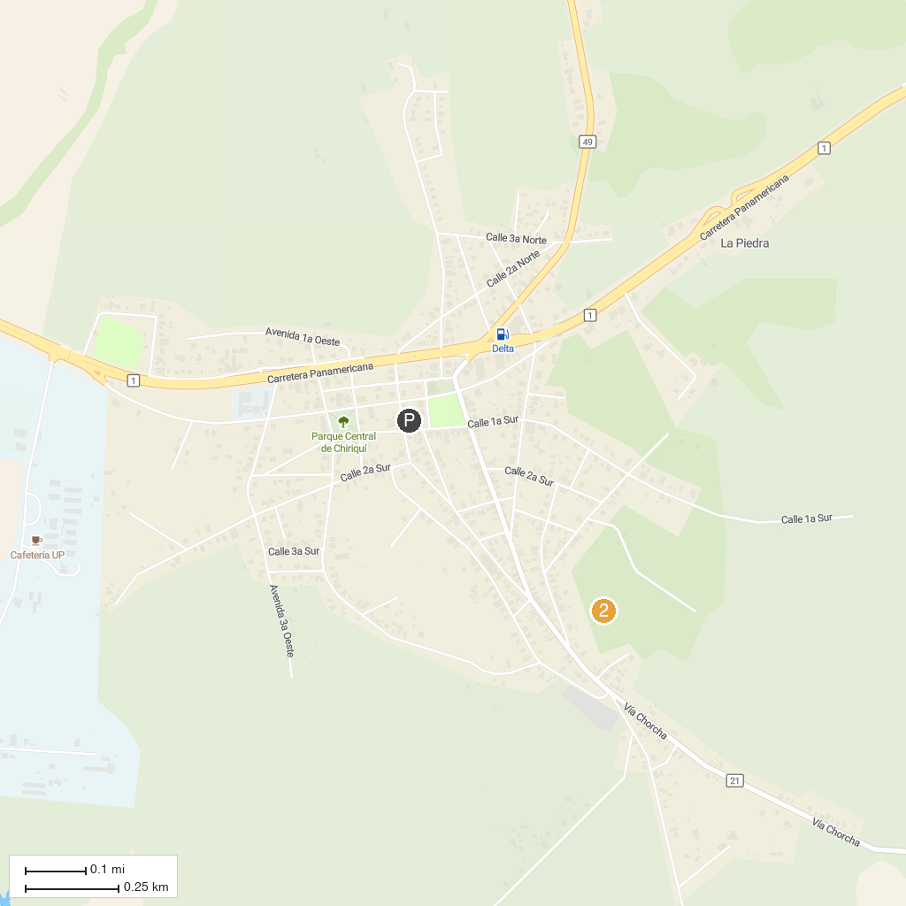
MAP KEY
1. Isla Gamez beach | 2. Isla Bolanos reef
P. Cruise port / terminal
Map © MapTiler © OpenStreetMap contributors · cruiseports.org

