Isle of Bute, Scotland, United Kingdom
A Victorian seaside gem in the Firth of Clyde — where Glasgow's grandees once escaped 'doon the watter', and where palm trees improbably line the esplanade.
⚓ Tender port · 🕒 Typical call: 6–8 hrs · 💷 GBP (British Pounds) · 🗣️ English / Scots Gaelic
✍️ MY DAY IN PORT (FILL IN)
Ship / Date
In port | arrive ______ · all aboard ______
Booked excursion
Notes / meeting point
GETTING ASHORE
- Docking: Tender to Albert Pier, Rothesay
- Walk to centre: 1 min — you step off the pier into town
- Best For: Gothic architecture, seal-watching, Victorian history
- Don't Miss: Mount Stuart House & the famous Victorian Toilets
GETTING AROUND
- 🚕 Taxi: £5–10 (town); £20–25 (cross-island) — Taxis wait at the pier for arriving passengers. Short hops within Rothesay are inexpensive; longer trips to Mount Stuart
- 🚌 Hop-on hop-off: ✅ City Sightseeing Bute (West Coast Motors)
TOP THINGS TO DO
- Mount Stuart House & Gardens — One of Britain's most spectacular Victorian Gothic mansions, built by the 3rd Marquess of Bute — once the world's richest man.
- Rothesay Castle — A rare circular 13th-century castle complete with a water-filled moat, right in the middle of Rothesay.
- Scalpsie Bay Seal Colony — A reddish-sand bay on the west coast that's home to up to 200 harbour seals year-round.
- Ettrick Bay Beach — A wide, golden-sand beach on Bute's west coast with views across to Arran.
- Victorian Rothesay Walking Tour — Explore the Victorian Toilets (an 1899 ceramic masterpiece on the pier), the Esplanade Gardens with their improbable palm trees…
BEST WALKS
- Rothesay Town Highlights Loop: 1.5 miles · 45–60 min · Flat · Self-guided — From Albert Pier, visit the Victorian Toilets right on the harbour, then walk up to Rothesay…
- Ardencraig Gardens: 1.5 miles each way · 25–30 min uphill · Moderate — Head up from the pier through Rothesay to the walled Ardencraig Gardens — a beautiful free council…
WEATHER · DAYLIGHT · MONEY
Month | High °F | Low °F | Rainy days
May | 56 | 46 | 15
Jul | 62 | 54 | 17
Sep | 59 | 52 | 16
Daylight: May 5:08AM–9:26PM · Jul 4:56AM–9:54PM · Sep 6:52AM–7:36PM
cruiseports.org/isle-of-bute · Confirm terminal & all-aboard time with your ship

Isle of Bute, Scotland, United Kingdom — Port Map
Red = walkable sights · Amber = excursions farther out · P = cruise terminal
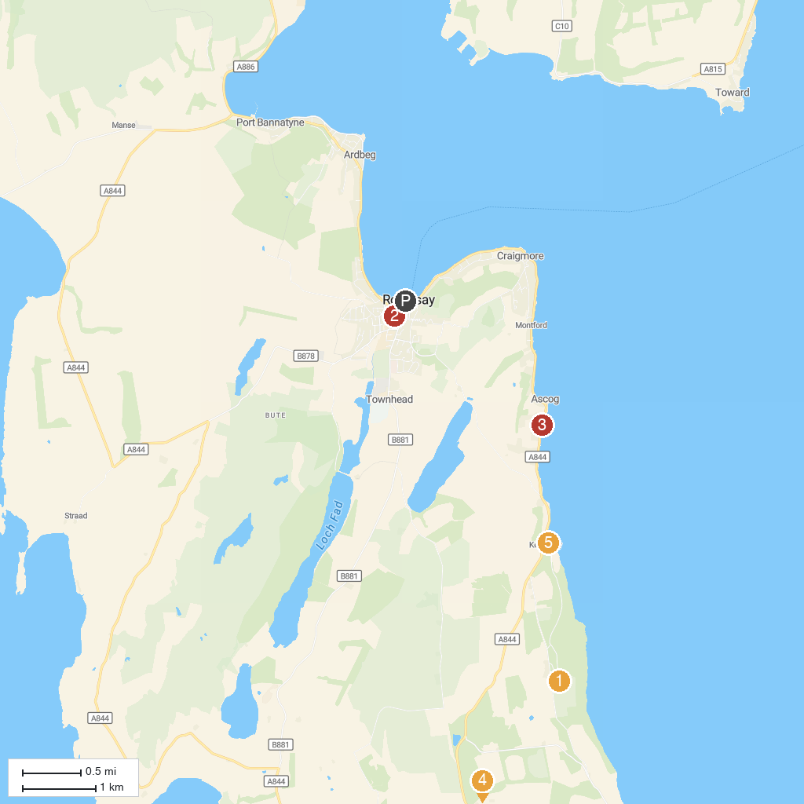
MAP KEY
1. Mount Stuart | 5. Vikingar! Leisure Centre and Visitor Attraction
2. Rothesay Castle | 6. Kerrycroy Bay Beach
3. Ascog Hall Garden and Fernery | 7. Isle of Cumbrae Distillers
4. St. Blane's Chapel
P. Cruise port / terminal
Map © MapTiler © OpenStreetMap contributors · cruiseports.org

