Isle of Coll, Inner Hebrides, Scotland
One of Scotland's most unspoiled islands — turquoise bays, RSPB corncrake habitat, and skies dark enough to stun. Expedition ships only; crowds never.
⚓ Tender (no pier) · 🕒 Typical call: 6-8 hrs · 💷 Currency: GBP · 🗣️ English (Scottish Gaelic heritage) · 🌿 RSPB nature reserve
✍️ MY DAY IN PORT (FILL IN)
Ship / Date
In port | arrive ______ · all aboard ______
Booked excursion
Notes / meeting point
GETTING ASHORE
- Docking: Tender to Arinagour pier — no cruise berth
- Walk to village: 0.6 miles (10-15 min) from tender landing
- Best For: Beaches, birdwatching, cycling, dark-sky stargazing
- Don't Miss: Tràigh Hogh beach and the Coll Hotel's local seafood
GETTING AROUND
- 🚕 Taxi: Price on inquiry — Coll Taxis (Barritts) is the island's only private hire service (01879 230402). Book in advance — transport is very limi
- 📱 Rideshare: ❌ not available
TOP THINGS TO DO
- Tràigh Hogh & Feall Bay Bike Ride — Cycle 3-5 miles through flower-studded machair to Coll's best beaches — vast Atlantic sweeps of white sand backed by dunes, often…
- RSPB Corncrake & Bird Walk — Coll holds one of the UK's last corncrake populations.
- Breachacha Castles — Two castles stand side-by-side at the island's south end — a 15th-century medieval tower house and an 18th-century laird's mansion.
- Arinagour Village Wander — Explore the island's only village: whitewashed cottages, the award-winning eco-community hall An Cridhe (free Wi-Fi + restrooms)…
- Sea Kayaking & Coastal Wildlife — Paddle the sheltered bays around Arinagour and Loch Eatharna, spotting grey seals, herons, and — in summer — possibly basking…
BEST WALKS
- Pier to Arinagour Village: 0.6 mi / 15 min / flat — Follow the single-track coastal road from the tender landing into the village.
- Village to Cliad Beach: 3.5 mi one-way / ~75 min / minor road — Head north from Arinagour along the island road to reach Cliad, a quiet north-facing beach with…
WEATHER · DAYLIGHT · MONEY
Month | High °F | Low °F | Rainy days
May | 54 | 48 | 17
Jul | 60 | 55 | 19
Sep | 58 | 54 | 19
Daylight: May 5:09AM–9:36PM · Jul 4:57AM–10:05PM · Sep 6:57AM–7:43PM
cruiseports.org/isle-of-coll · Confirm terminal & all-aboard time with your ship

Isle of Coll, Inner Hebrides, Scotland — Port Map
Red = walkable sights · Amber = excursions farther out · P = cruise terminal
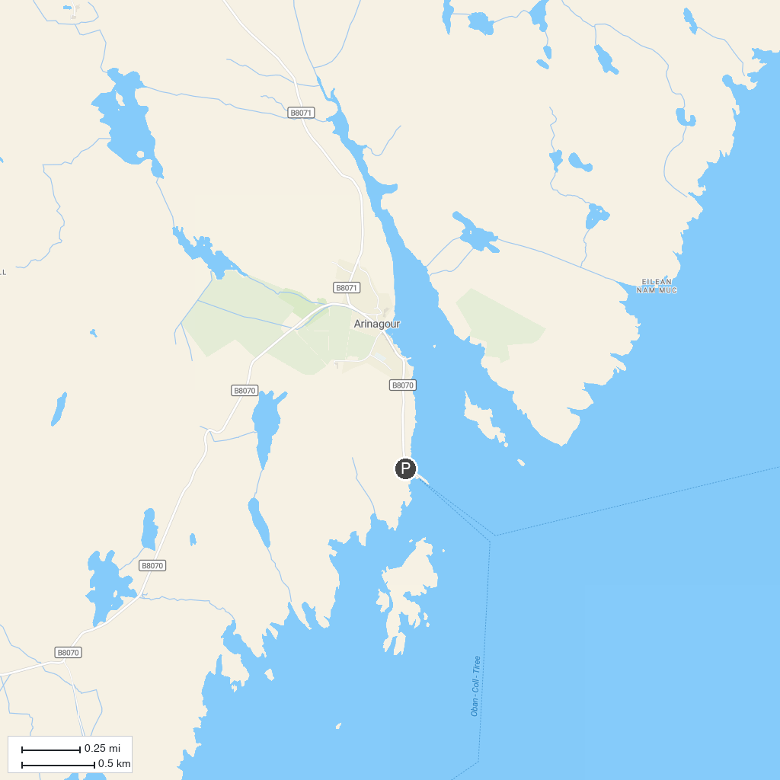
MAP KEY
1. Staffa National Nature Reserve - Fingal's Cave (National Trust for Scotland) | 4. Calgary Beach
2. Ardnamurchan Lighthouse | 5. Langamull Beach
3. Lunga, Treshnish Isles | 6. Calgary Art In Nature (Sculpture Trail)
P. Cruise port / terminal
Map © MapTiler © OpenStreetMap contributors · cruiseports.org

