Isle of Eigg, Inner Hebrides, Scotland
A community-owned Hebridean island powered entirely by renewables, where dramatic pitchstone ridges, singing sands, and dark cave history make every small-ship call unforgettable.
⚓ Tender only (no cruise pier) · 🕒 Typical call: 6–8 hrs · 💷 Currency: British Pound (GBP) · 🗣️ Language: English (Scottish Gaelic spoken by some)
✍️ MY DAY IN PORT (FILL IN)
Ship / Date
In port | arrive ______ · all aboard ______
Booked excursion
Notes / meeting point
GETTING ASHORE
- Docking: Tender to Galmisdale Pier — ships anchor in the bay
- Walk to centre: 0 min — An Laimhrig hub is at the pier
- Best For: Hiking, geology, wildlife, unique Scottish history
- Don't Miss: An Sgùrr ridge hike and the Massacre Cave
GETTING AROUND
- 🚕 Taxi: ~£15 pier to Cleadale — The island has a single taxi service. A ride from the pier to Cleadale costs approximately £15. Best booked in advance a
- 📱 Rideshare: ❌ not available
TOP THINGS TO DO
- Hike An Sgùrr — Europe's Largest Pitchstone Ridge — The island's iconic 393m ridge is the largest exposed pitchstone lava flow in Europe.
- Massacre Cave & Cathedral Cave — On the south coast, these two caves hold centuries of island history.
- Singing Sands & Laig Bay — The Singing Sands (Camas Sgiotaig) in the island's northwest are named for the quartz grains that emit a musical squeak underfoot…
- Wildlife & Ranger Walks — Eigg hosts golden eagles, sea eagles, hen harriers, puffins, and otters year-round, plus dolphins, minke whales, and seals…
- Community Buyout Story & Eigg Electric — In 1997 Eigg's residents bought their own island from an absentee landlord, pioneering land reform in Scotland.
BEST WALKS
- Galmisdale to An Sgùrr Summit: 8 km return | 3–4 hrs | Strenuous — From the pier, follow the single-track road southwest, then take the signposted hillside path up…
- Galmisdale to the Caves: 5 km return | 2–2.5 hrs | Moderate — Head west along the coastal path from the pier, crossing boggy moorland to reach first Cathedral…
- Cleadale & the Northern Beaches (by bike): 14 km return | 1.5 hrs by e-bike | Easy on road — Follow the single-track road north through the crofting township of Cleadale to reach Laig Bay…
WEATHER · DAYLIGHT · MONEY
Month | High °F | Low °F | Rainy days
May | 53 | 46 | 17
Jul | 59 | 53 | 21
Sep | 57 | 52 | 19
Daylight: May 5:06AM–9:36PM · Jul 4:54AM–10:06PM · Sep 6:56AM–7:42PM
cruiseports.org/isle-of-eigg · Confirm terminal & all-aboard time with your ship

Isle of Eigg, Inner Hebrides, Scotland — Port Map
Red = walkable sights · Amber = excursions farther out · P = cruise terminal
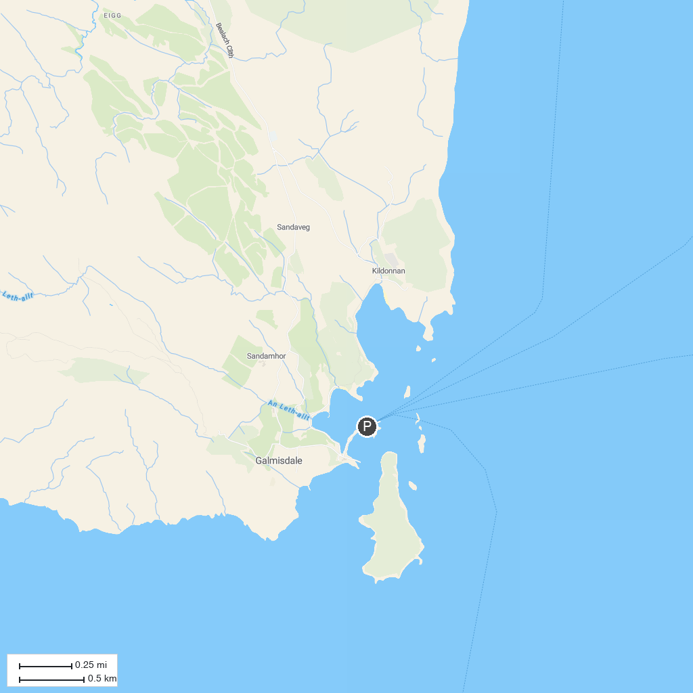
MAP KEY
1. Castle Tioram | 5. Ardnamurchan Lighthouse
2. Mallaig Heritage Centre | 6. Rum National Nature Reserve
3. Bella Jane Boat Trips | 7. Camas Daraich, Aird of Sleat, Skye
4. Ardnamurchan Distillery
P. Cruise port / terminal
Map © MapTiler © OpenStreetMap contributors · cruiseports.org

