Isle of Eriskay, Outer Hebrides, Scotland
Just 2.5 miles long, Eriskay packs in a legendary whisky shipwreck, a Jacobite royal landing beach, and a critically endangered native pony — all in one unhurried Hebridean day.
⚓ Tender port (no pier for cruise ships) · 🕒 Typical call: 5–7 hrs · 💷 Currency: GBP (British Pound) · 🗣️ Language: English & Scottish Gaelic · 🐴 Home of the rare Eriskay Pony
✍️ MY DAY IN PORT (FILL IN)
Ship / Date
In port | arrive ______ · all aboard ______
Booked excursion
Notes / meeting point
GETTING ASHORE
- Docking: Tender — ships anchor offshore; tenders land at south ferry slipway or Acarsaid Mhòr harbour
- Walk to pub: ~30 min from south ferry slipway to Am Politician pub (1.3 miles)
- Best For: History buffs, walkers, wildlife lovers, whisky fans
- Don't Miss: Prince's Beach (Coilleag a' Phrionnsa) and a dram at Am Politician
GETTING AROUND
- 🚕 Taxi: £10–£50 — Several local taxi companies serve Eriskay and the Uists (e.g. DMI Taxi, Lindsay's Taxi, Ken's Taxi). Book well in advan
- 📱 Rideshare: ❌ not available
TOP THINGS TO DO
- Whisky Galore! — the SS Politician Story — In 1941 the cargo ship SS Politician ran aground in the Sound of Eriskay carrying 264,000 bottles of Scotch whisky.
- Eriskay Pony Spotting — The Eriskay Pony is one of the rarest native breeds in the world, adapted to the Hebridean climate with a thick waterproof coat.
- Prince's Beach (Coilleag a' Phrionnsa) — Bonnie Prince Charlie stepped ashore here on 23 July 1745 to launch the Jacobite Rising.
- St Michael's Church & Shipwreck Bell — Built in 1903, this hilltop Catholic church has an altar supported by the bow of a lifeboat washed ashore from the British…
- Eriskay Heritage Centre — Housed in the community hall (Talla an Shlèibh), this small centre displays old photographs, genealogical records, and SS…
BEST WALKS
- South Slipway to Prince's Beach: ~1 mile / 20–25 min each way / Easy–Moderate — Head north-west from the ferry slipway along the main road, then follow the track down to Coilleag…
- Full Island Loop — Slipway to Pub to Church: ~3.5 miles / 2–2.5 hrs / Moderate — From the south slipway, walk north-east to Am Politician pub for a dram and a look at the SS…
cruiseports.org/isle-of-eriskay · Confirm terminal & all-aboard time with your ship

Isle of Eriskay, Outer Hebrides, Scotland — Port Map
Red = walkable sights · Amber = excursions farther out · P = cruise terminal
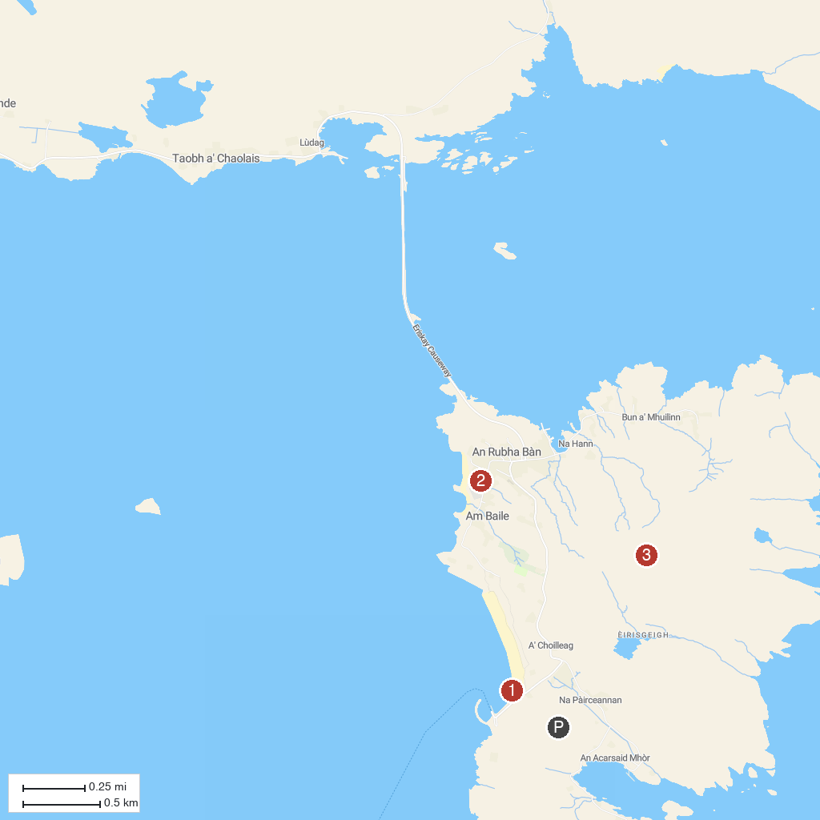
MAP KEY
1. Prince's Beach | 3. Ben Scrien
2. Am Politician
P. Cruise port / terminal
Map © MapTiler © OpenStreetMap contributors · cruiseports.org

