Isle of Gigha, Argyll, Scotland
Seven miles of white sand and wild gardens off the Kintyre coast — Gigha punches well above its size. Community-owned and car-free for most visitors, it's one of the Hebrides' best-kept secrets.
⚓ Tender port · 🕒 Typical call: 5–7 hrs · 💷 Currency: GBP (cash useful) · 🗣️ English / Scottish Gaelic · 🌿 Best: Apr–Jun for gardens
✍️ MY DAY IN PORT (FILL IN)
Ship / Date
In port | arrive ______ · all aboard ______
Booked excursion
Notes / meeting point
GETTING ASHORE
- Docking: Tender to Ardminish pier — no cruise berth
- Walk to centre: Ardminish village is right at the pier; Achamore Gardens ~20 min
- Best For: Gardens, beaches, walking, wildlife
- Don't Miss: Twin Beaches (An Dòirlinn) and Achamore Gardens
GETTING AROUND
- 🚕 Taxi: By negotiation — Island Taxi offers local taxi service around Gigha. Prices are by arrangement — contact in advance as availability is li
- 📱 Rideshare: ❌ not available
TOP THINGS TO DO
- Achamore Gardens — A celebrated west-coast island garden established in 1944 by Sir James Horlick, growing rhododendrons, camellias, New Zealand…
- Twin Beaches (An Dòirlinn) — Two white-sand coves either side of a narrow tombolo linking Gigha to the islet of Eilean Garbh — turquoise water, no crowds…
- Kilchattan Chapel & Standing Stones — The ruins of a 13th-century chapel sit uphill near Ardminish, with the inscribed Ogham Stone just to its west.
- Kayak & Paddleboard Hire — Gigha Boats and Activity Centre rents kayaks, paddleboards, wetsuits, and snorkels.
- Wildlife Walk — Otters, seals, red deer, and a variety of seabirds are regulars on Gigha.
BEST WALKS
- Ardminish to Achamore Gardens: 1.5 miles · ~20 min · Easy — Follow the single-track road south from the pier through Ardminish village and into the gardens.
- Village to Twin Beaches: ~5 miles · ~1.5–2 hrs · Long (bike recommended) — Head north from the pier along the island's single main road to the northern end, then take the…
WEATHER · DAYLIGHT · MONEY
Month | High °F | Low °F | Rainy days
May | 55 | 47 | 15
Jul | 61 | 54 | 19
Sep | 59 | 53 | 17
Daylight: May 5:11AM–9:28PM · Jul 5:00AM–9:56PM · Sep 6:55AM–7:39PM
cruiseports.org/isle-of-gigha · Confirm terminal & all-aboard time with your ship

Isle of Gigha, Argyll, Scotland — Port Map
Red = walkable sights · Amber = excursions farther out · P = cruise terminal
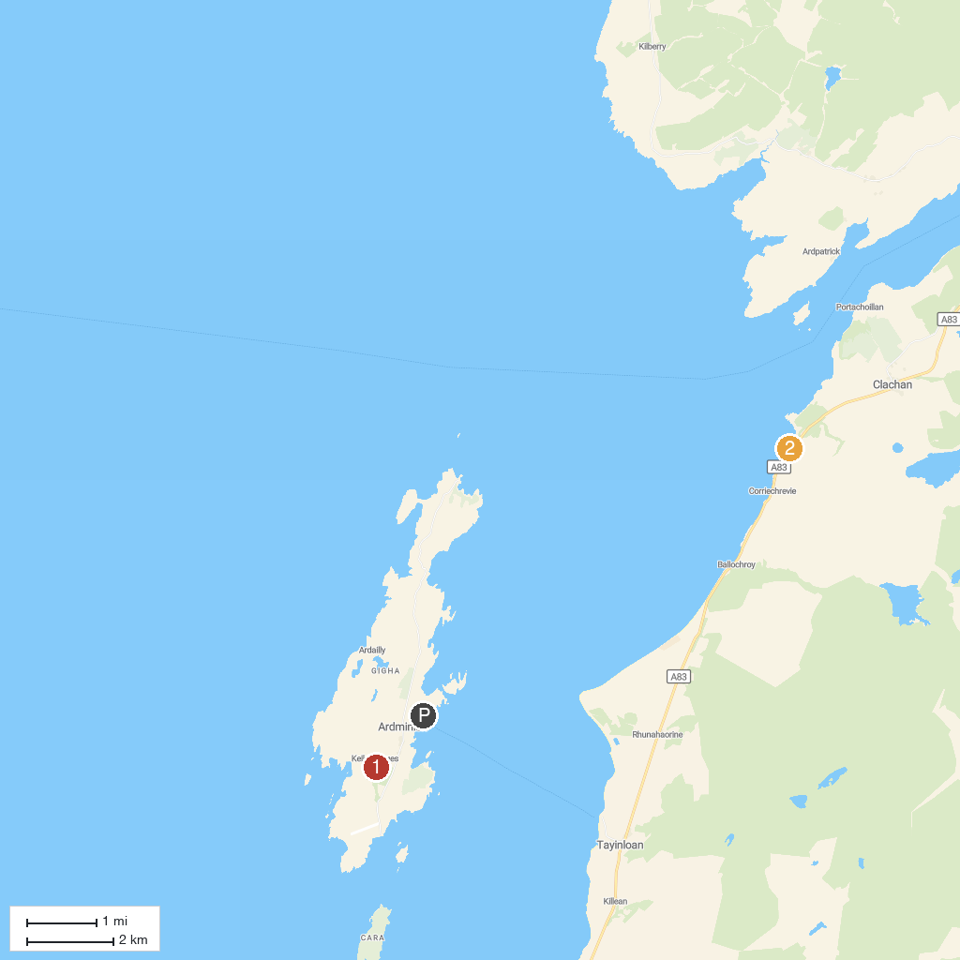
MAP KEY
1. Achamore Gardens | 2. Seal Point
P. Cruise port / terminal
Map © MapTiler © OpenStreetMap contributors · cruiseports.org

