Isle of Islay, Scotland, United Kingdom
The Queen of the Hebrides enchants with ten legendary whisky distilleries, windswept Atlantic beaches, and a coastline alive with seabirds and seals. Most cruise passengers arrive by tender at Port Ellen — and the famous Three Distilleries Path starts right from the pier.
⚓ Tender port (most ships) · 🕒 Typical call: 7-9 hrs · 💷 British Pound (GBP) · 🗣️ English · 🥃 Whisky island
✍️ MY DAY IN PORT (FILL IN)
Ship / Date
In port | arrive ______ · all aboard ______
Booked excursion
Notes / meeting point
GETTING ASHORE
- Docking: Tender to Port Ellen pier (or Port Askaig for some itineraries)
- Walk to center: 2 min from tender pier to Port Ellen village
- Best For: Whisky lovers, wildlife, dramatic coastal scenery
- Don't Miss: The Three Distilleries Path to Laphroaig, Lagavulin & Ardbeg
GETTING AROUND
- 🚕 Taxi: £27–£33 — Taxis run from Port Ellen (where cruise ships dock) to Bowmore (the island capital), about 18–19 minutes. Advance bookin
- 🚌 Hop-on hop-off: ✅ Islay Coaches (Tour Islay Ticket)
TOP THINGS TO DO
- Three Distilleries Pathway Walk — The signature Islay experience: a flat, paved path from Port Ellen along the south coast passing Laphroaig, Lagavulin, and Ardbeg.
- Kildalton High Cross — One of the finest surviving 8th-century Celtic ringed crosses in Europe, standing in a peaceful ruined churchyard about 7 miles…
- Whisky Distillery Tour — Go deeper with a guided tour at one of Islay's legendary distilleries — Laphroaig, Lagavulin, Ardbeg (south coast), Bowmore…
- American Monument & The Oa — A dramatic clifftop memorial to the American servicemen and British crew lost when the troopships Tuscania and Otranto sank off…
- Wildlife & Birdwatching Tour — Islay hosts over 100 bird species, including barnacle geese in winter, hen harriers, golden eagles, and choughs.
BEST WALKS
- Three Distilleries Path: 3.5 miles one way | Easy, flat | 2-3 hrs walking — Islay's signature walk follows the south coast from Port Ellen through moorland and sea-views to…
- Kilnaughton Bay & Singing Sands: 3-4 miles round trip | Easy | 1.5-2 hrs — From Port Ellen, walk around Kilnaughton Bay to the distinctive square Carraig Fhada lighthouse…
WEATHER · DAYLIGHT · MONEY
Month | High °F | Low °F | Rainy days
May | 54 | 47 | 15
Jul | 61 | 54 | 19
Sep | 59 | 53 | 17
Daylight: May 5:13AM–9:29PM · Jul 5:02AM–9:57PM · Sep 6:57AM–7:41PM
cruiseports.org/isle-of-islay · Confirm terminal & all-aboard time with your ship

Isle of Islay, Scotland, United Kingdom — Port Map
Red = walkable sights · Amber = excursions farther out · P = cruise terminal
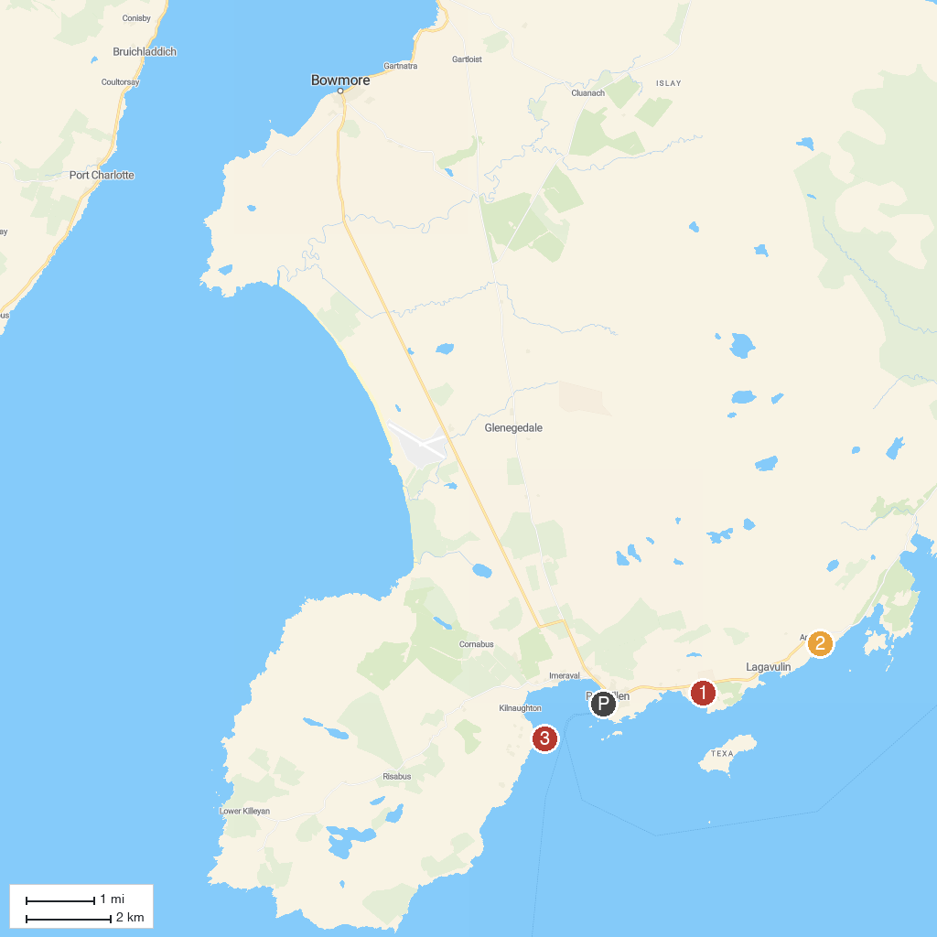
MAP KEY
1. Round Church | 3. Ardbeg Distillery
2. Laphroaig Distillery | 4. Carraig Fhada Lighthouse
P. Cruise port / terminal
Map © MapTiler © OpenStreetMap contributors · cruiseports.org

