Isle of Mull, Scotland, United Kingdom
Tobermory's row of candy-colored harbourfront buildings is one of Scotland's most photographed scenes. Behind it lies a wild island of sea eagles, ancient castles, white-sand beaches, and single malt whisky.
⚓ Tender port · 🕒 Typical call: 6–8 hrs · 💷 Currency: British Pound (GBP) · 🗣️ Language: English (Gaelic spoken locally) · 🦅 Wildlife: White-tailed Sea Eagles
✍️ MY DAY IN PORT (FILL IN)
Ship / Date
In port | arrive ______ · all aboard ______
Booked excursion
Notes / meeting point
GETTING ASHORE
- Docking: Tender to Tobermory Harbour pontoon (Ledaig)
- Walk to Main Street: 1 min flat from tender pontoon
- Best For: Scottish scenery, wildlife, whisky, history
- Don't Miss: Tobermory Distillery tasting & the harbor colorful buildings
GETTING AROUND
- 🚕 Taxi: Varies (metered/negotiated) — Local firms like Mull Taxi Service offer island-wide transfers and tours. Useful for reaching remote areas not well serv
TOP THINGS TO DO
- Tobermory Distillery Tour & Tasting — One of Scotland's oldest distilleries (est.
- Duart Castle — The 13th-century clifftop seat of Clan Maclean commands dramatic views over the Sound of Mull.
- Isle of Iona & Iona Abbey — The 'Cradle of Christianity' in Scotland.
- Staffa & Fingal's Cave — Sail to this uninhabited island of hexagonal basalt columns.
- White-tailed Sea Eagle Watching — Mull has Europe's highest density of White-tailed Sea Eagles — wingspan up to 8 ft.
BEST WALKS
- Tobermory Harbour Front Stroll: 30 min · Flat · No transport needed — Walk the length of the iconic painted harbor buildings, browse the independent shops and galleries…
- Rubha nan Gall Lighthouse Walk: 3 miles / 1.5 hrs round trip · Easy coastal path — Head north out of Tobermory along a flat, well-marked coastal path through woodland and along the…
- Aros Park Rainforest Trail: 1–2 hrs · Easy · 15-min walk from pier — A temperate Atlantic rainforest walk with waterfalls, wooden footbridges, giant ferns, and…
WEATHER · DAYLIGHT · MONEY
Month | High °F | Low °F | Rainy days
May | 55 | 45 | 17
Jul | 61 | 52 | 21
Sep | 58 | 50 | 20
Daylight: May 5:09AM–9:34PM · Jul 4:54AM–10:05PM · Sep 6:54AM–7:43PM
cruiseports.org/isle-of-mull · Confirm terminal & all-aboard time with your ship

Isle of Mull, Scotland, United Kingdom — Port Map
Red = walkable sights · Amber = excursions farther out · P = cruise terminal
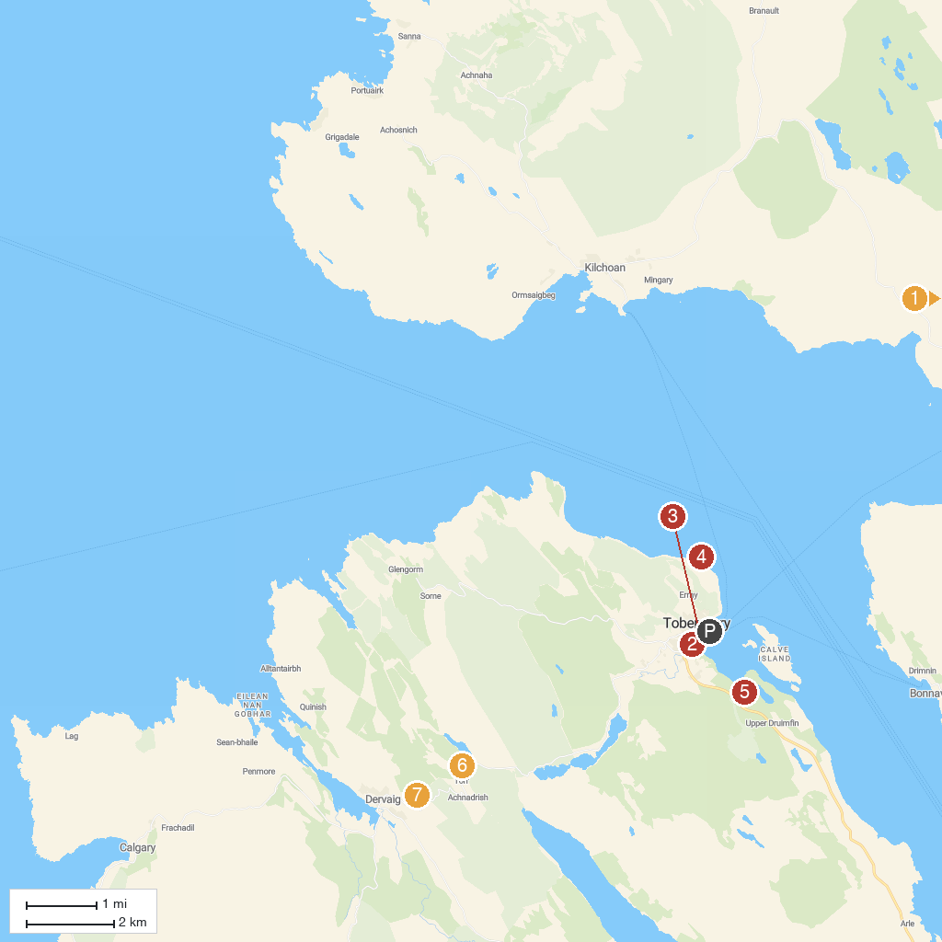
MAP KEY
1. Ardnamurchan Distillery | 5. Aros Park
2. Tobermory Distillery Visitor Centre | 6. Loch Torr Wildlife Hide
3. The Mull Museum | 7. Kilmore Standing Stones/ Dervaig Centre
4. Rubha nan Gall Lighthouse
P. Cruise port / terminal
Map © MapTiler © OpenStreetMap contributors · cruiseports.org

