Isle of Tiree, Inner Hebrides, Scotland
Known as the 'Hawaii of the North', Tiree is a flat, windswept island of brilliant white beaches and machair carpeted in summer wildflowers — one of Scotland's most unspoiled and sunshine-rich spots.
⚓ Tender (anchor at Gott Bay) · 🕒 Typical call: 6-8 hrs · 💷 Currency: British Pounds (GBP) · 🗣️ Language: English (Gaelic spoken)
✍️ MY DAY IN PORT (FILL IN)
Ship / Date
In port | arrive ______ · all aboard ______
Booked excursion
Notes / meeting point
GETTING ASHORE
- Docking: Tender — anchor in Gott Bay; tenders land at Scarinish Ferry Pier
- Walk to village: ~1.2 miles (20–25 min flat walk) from pier to Scarinish centre
- Best For: Beaches, birdwatching, cycling, walking, Hebridean tranquility
- Don't Miss: The Ringing Stone near Vaul — a glacial erratic that rings like a bell when tapped
GETTING AROUND
- 📱 Rideshare: ❌ not available
TOP THINGS TO DO
- Machair Wildflower Walk — In June–August, Tiree's coastal machair bursts into a carpet of yellow, purple, and white wildflowers — one of Europe's rarest…
- The Ringing Stone (Clach a' Choire) — A massive glacial erratic on the north coast that produces a clear metallic ring when tapped with a small pebble.
- Skerryvore Shore Station, Hynish — Built by Robert Louis Stevenson's uncle Alan, this Victorian shore station supported construction of the Skerryvore Lighthouse…
- An Iodhlann Historical Centre — Tiree's community archive in Scarinish holds historical documents, photographs, and stories covering Gaelic heritage, emigration…
- Balevullin Beach & Surf Watch — Tiree's wildest beach on the northwest coast faces open Atlantic swells, making it Scotland's premier windsurfing and surfing…
BEST WALKS
- Gott Bay Beach Stroll: 1-2 miles • 30-45 min • Easy — From the tender landing at Scarinish Pier, walk north along the sweeping arc of Gott Bay — 2.5…
- Scarinish Village & Old Harbour: 1.2 miles • 20-25 min • Easy — Walk from the pier into Scarinish to find the Yellow Hare café, An Iodhlann archive, the Scarinish…
WEATHER · DAYLIGHT · MONEY
Month | High °F | Low °F | Rainy days
May | 53 | 48 | 17
Jul | 59 | 55 | 18
Sep | 58 | 54 | 18
Daylight: May 5:11AM–9:36PM · Jul 4:59AM–10:06PM · Sep 6:59AM–7:44PM
cruiseports.org/isle-of-tiree · Confirm terminal & all-aboard time with your ship

Isle of Tiree, Inner Hebrides, Scotland — Port Map
Red = walkable sights · Amber = excursions farther out · P = cruise terminal
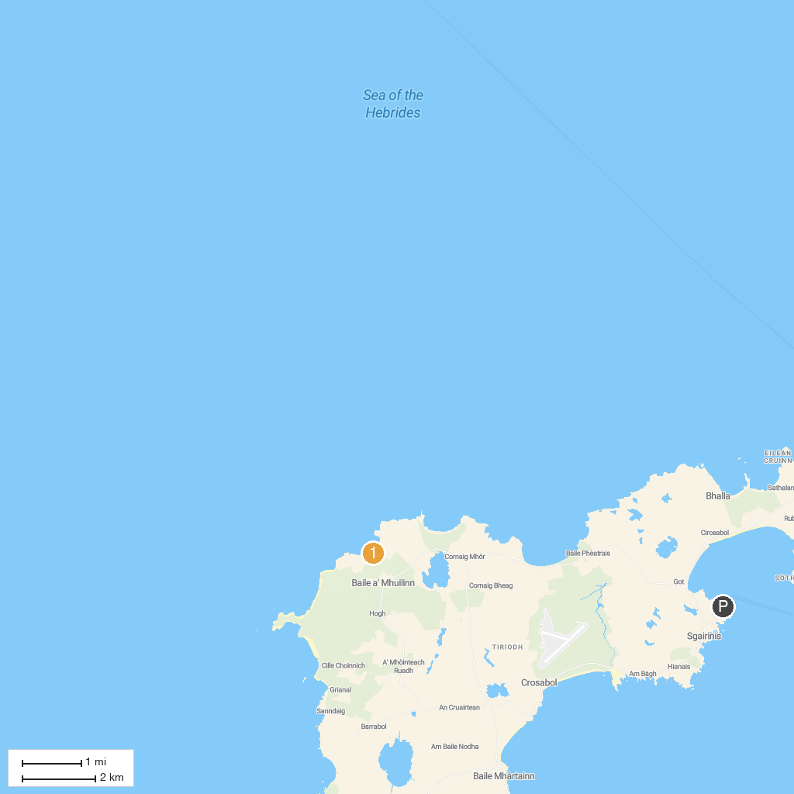
MAP KEY
1. Staffa National Nature Reserve - Fingal's Cave (National Trust for Scotland) | 3. Lunga, Treshnish Isles
2. Balevullin Beach
P. Cruise port / terminal
Map © MapTiler © OpenStreetMap contributors · cruiseports.org

