Itajaí, Santa Catarina, Brazil
Brazil's Sailing Capital sits at the mouth of a river flanked by skyscraper-lined beaches and a café-filled historic center steeped in Azorean and German heritage. One port day, two very different worlds.
⚓ Pier (dedicated cruise terminal) · 🕒 Typical call: 8–10 hrs · 💵 Brazilian Real (BRL) — cards accepted everywhere · 🗣️ Portuguese — English in tourist areas · 🌊 Gateway to Balneário Camboriú
✍️ MY DAY IN PORT (FILL IN)
Ship / Date
In port | arrive ______ · all aboard ______
Booked excursion
Notes / meeting point
GETTING ASHORE
- Docking: Pier — Port of Itajaí berths on the Itajaí-Açu River; no tendering
- Walk to center: ~10 min to the historic center and Public Market along the riverfront
- Best For: Beach day at Laranjeiras, Balneário Camboriú cable car, fresh seafood, European-influenced town walks
- Don't Miss: Parque Unipraias cable car over the ocean and a shrimp sequência at the Mercado Público
GETTING AROUND
- 🚕 Taxi: R$15–25 — Taxis are available at the port. The short distance to the city center keeps fares low; agree on a price before boarding
- 📱 Rideshare: ✅ Uber, 99
TOP THINGS TO DO
- Balneário Camboriú Cable Car (Parque Unipraias) — Ride the Unipraias gondola from the south end of Balneário Camboriú over the ocean to the lush Laranjeiras Beach — one of…
- Praia de Laranjeiras Beach Day — Reached via the cable car, this sheltered cove has calm emerald water, restaurant chairs on the sand, and far fewer crowds than…
- Blumenau German Heritage Town — An hour inland, Blumenau looks like a Bavarian village transplanted to the Brazilian jungle — half-timbered facades, craft…
- Beto Carrero World Theme Park — Latin America's largest theme park is 40 minutes south in Penha — roller coasters, live shows, and a zoo.
- Itajaí Seafood & Public Market — Brazil's largest fishing port puts incredible seafood on every table.
BEST WALKS
- Riverfront to Historic Center Walk: ~1 km | 15–20 min | Flat | Free — Follow Avenida Beira Rio from the pier along the manicured riverfront to the Mercado Público, then…
- Balneário Camboriú Boardwalk: ~2 km | 25 min one-way | Flat | Free — Take an Uber to the south end of Balneário Camboriú and walk the beachfront Avenida Atlântica…
WEATHER · DAYLIGHT · MONEY
Month | High °F | Low °F | Rainy days
May | 73 | 62 | 12
Jul | 69 | 57 | 8
Sep | 72 | 62 | 12
Daylight: May 6:47AM–5:34PM · Jul 7:02AM–5:38PM · Sep 6:12AM–6:07PM
cruiseports.org/itajai · Confirm terminal & all-aboard time with your ship

Itajaí, Santa Catarina, Brazil — Port Map
Red = walkable sights · Amber = excursions farther out · P = cruise terminal
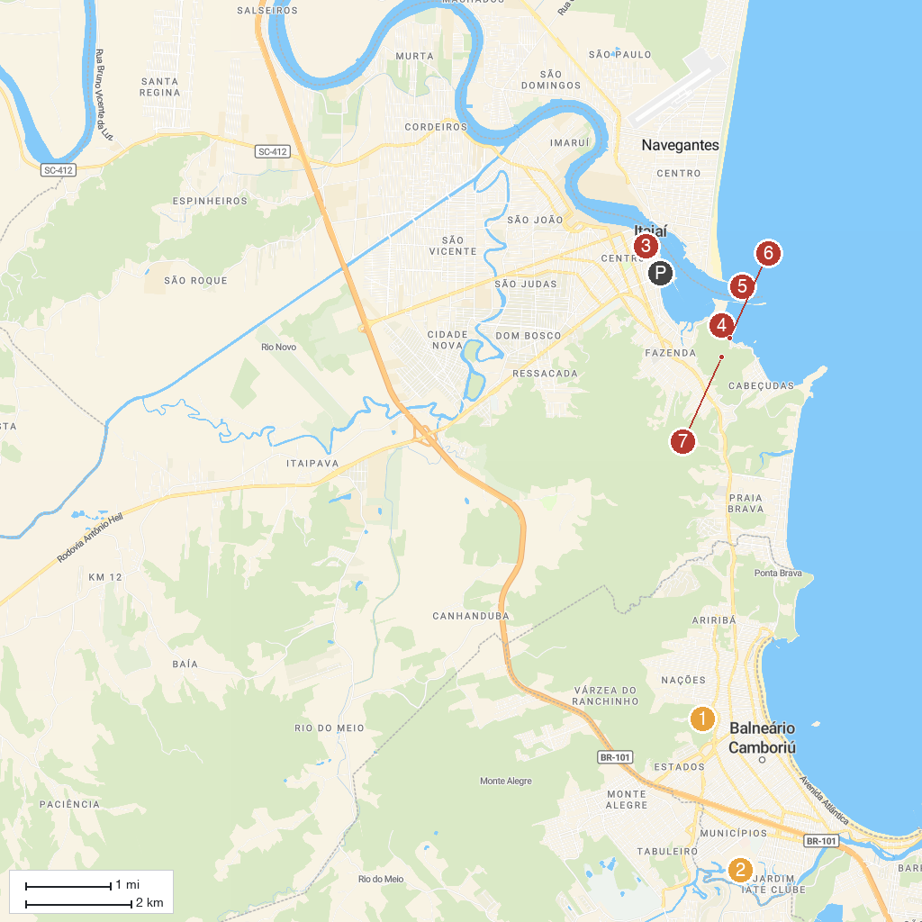
MAP KEY
1. Cristo Luz | 5. Atalaia Beach
2. Beto Carrero World | 6. Farol de Navegantes
3. Parque Ecológico Raimundo Gonçález Malta | 7. Parrot beak
4. Igrejinha | 8. Parque Natural Municipal do Atalaia - PNMA
P. Cruise port / terminal
Map © MapTiler © OpenStreetMap contributors · cruiseports.org

