Itsukushima (Miyajima), Hiroshima Prefecture, Japan
Home to Japan's most photographed image — a vermilion torii gate rising from the sea — Miyajima pairs a UNESCO World Heritage shrine with deer that roam freely among the temples, street-grilled oysters, and sweeping views from sacred Mt. Misen.
⚓ Ferry from mainland port (most ships) or tender to island (small ships) · 🕒 Typical call: 7-10 hrs · 💴 Currency: Japanese Yen (¥) · 🗣️ Language: Japanese · 🦌 UNESCO World Heritage Site
✍️ MY DAY IN PORT (FILL IN)
Ship / Date
In port | arrive ______ · all aboard ______
Booked excursion
Notes / meeting point
GETTING ASHORE
- Docking: Most ships dock at Hiroshima Port (Ujina) or Itsukaichi Wharf; small/expedition ships may tender directly to Miyajima Ferry Terminal
- Walk to shrine: 10-12 min flat walk from Miyajima Ferry Terminal to Itsukushima Shrine
- Best For: Shrines & temples, iconic photography, street food, scenic mountain views
- Don't Miss: The floating torii gate at high tide, grilled oysters on Omotesando, Daisho-in Temple's 500 Rakan statues
GETTING AROUND
- 🚕 Taxi: ¥2,400–¥5,500 — Cruise ships dock at Ujina Wharf (taxi to Hiroshima city ¥2,400–¥3,000) or Itsukaichi Wharf (taxi to Hiroshima Station ¥
TOP THINGS TO DO
- Itsukushima Shrine & the Floating Torii — Walk the covered corridors of the 12th-century UNESCO shrine built on stilts over the tidal inlet, then step out to photograph…
- Mount Misen & Ropeway — Take the two-stage ropeway up to the Mt.
- Daisho-in Temple — One of Japan's most important Shingon Buddhist temples, set at the foot of Mt.
- Hiroshima Peace Memorial & Museum — Most ship excursions pair Miyajima with the Hiroshima Peace Memorial Park and Museum, one of the world's most moving sites.
- Omotesando Street Food Crawl — Miyajima's main shopping street is a gauntlet of free samples and open-air grills.
BEST WALKS
- Ferry Terminal to Itsukushima Shrine: 1.0 km | 12 min | Flat | Paved coastal path — The classic Miyajima walk.
- Shrine to Daisho-in Temple: 1.2 km | 20-25 min | Gentle uphill | Mix of paved and stone paths — From the shrine, follow signs inland and uphill through quiet residential lanes to Daisho-in Temple.
WEATHER · DAYLIGHT · MONEY
Month | High °F | Low °F | Rainy days
May | 73 | 58 | 10
Jul | 85 | 74 | 17
Sep | 81 | 70 | 14
Daylight: May 5:09AM–7:05PM · Jul 5:09AM–7:23PM · Sep 5:53AM–6:17PM
cruiseports.org/itsukushima-island-japan · Confirm terminal & all-aboard time with your ship

Itsukushima (Miyajima), Hiroshima Prefecture, Japan — Port Map
Red = walkable sights · Amber = excursions farther out · P = cruise terminal
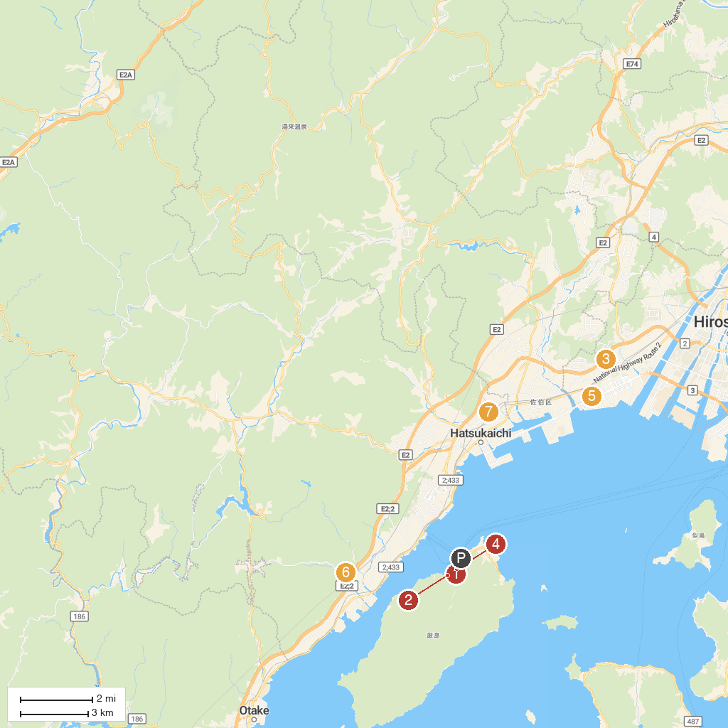
MAP KEY
1. Itsukushima Jinja | 5. WoodEgg OKONOMIYAKI MUSEUM
2. Miyajima Public Aquarium | 6. Imosenotaki Park
3. Suzugamine Park | 7. Dounji
4. Rokai Bune (Roaring Boat)
P. Cruise port / terminal
Map © MapTiler © OpenStreetMap contributors · cruiseports.org

