Ixtapa-Zihuatanejo, Guerrero, Mexico
Two worlds in one port day: Zihuatanejo is the bohemian fishing village Andy Dufresne escaped to at the end of Shawshank Redemption; Ixtapa is the polished resort zone three miles down the road. Your tender drops you right in the middle of the real thing.
⚓ Tender port (no pier) · 🕒 Typical call: 8–10 hrs · 💵 USD accepted, MXN preferred · 🗣️ Spanish (English in tourist zones)
✍️ MY DAY IN PORT (FILL IN)
Ship / Date
In port | arrive ______ · all aboard ______
Booked excursion
Notes / meeting point
GETTING ASHORE
- Docking: Tender — ships anchor in Zihuatanejo Bay; 10–15 min tender ride to Muelle Municipal
- Walk to Center: 0 min — tender pier lands in downtown Zihuatanejo
- Best For: Beach days, fresh seafood, artisan shopping, snorkeling at Las Gatas
- Don't Miss: Tiritas de pescado (local raw-fish dish) and Playa La Ropa
GETTING AROUND
- 🚕 Taxi: MXN 30–80 (~USD 2–4) — Fixed-rate taxis (no meters) are plentiful. Confirm the fare before getting in. Rides to Playa La Ropa or other beaches
- 📱 Rideshare: ❌ not available
TOP THINGS TO DO
- Playa La Ropa Beach Day — The bay's best swimming beach — a mile of palm-shaded sand with calm water, palapas, and open-air restaurants serving fresh fish.
- Snorkeling at Playa Las Gatas — A short water-taxi hop from the pier ($5–8 USD round-trip) reaches a sheltered cove with a pre-Hispanic stone reef barrier that…
- Xihuacan Archaeological Site — About 45 minutes south, Xihuacan holds a clay-brick pyramid, ancient ball court, and museum of Cuitlateca artifacts — a…
- Ixtapa Crocodile Sanctuary & Bike Path — Cycle Ixtapa's 5-mile jungle path (rental bikes ~$5), then visit the Aztlán Park sanctuary at Playa Linda where wild crocs…
- Bay Catamaran Sail & Snorkel — Catamarans depart from the Zihuatanejo pier for half-day sails around the bay with snorkeling stops at secluded coves including…
BEST WALKS
- Paseo del Pescador Waterfront Walk: 1 km · Flat · 20 min — Start at the Muelle Municipal tender pier and follow the pedestrian boardwalk past morning fish…
- El Centro Artisan Market Loop: 0.5 km · Flat · 30 min browsing — From the pier, duck into the Mercado de Artesanías for silver jewelry, ceramics, and woven goods…
WEATHER · DAYLIGHT · MONEY
Month | High °F | Low °F | Rainy days
May | 88 | 76 | 4
Jul | 88 | 78 | 16
Sep | 85 | 77 | 21
Daylight: May 6:13AM–7:11PM · Jul 6:19AM–7:24PM · Sep 6:34AM–6:47PM
cruiseports.org/ixtapa-zihuatanejo · Confirm terminal & all-aboard time with your ship

Ixtapa-Zihuatanejo, Guerrero, Mexico — Port Map
Red = walkable sights · Amber = excursions farther out · P = cruise terminal
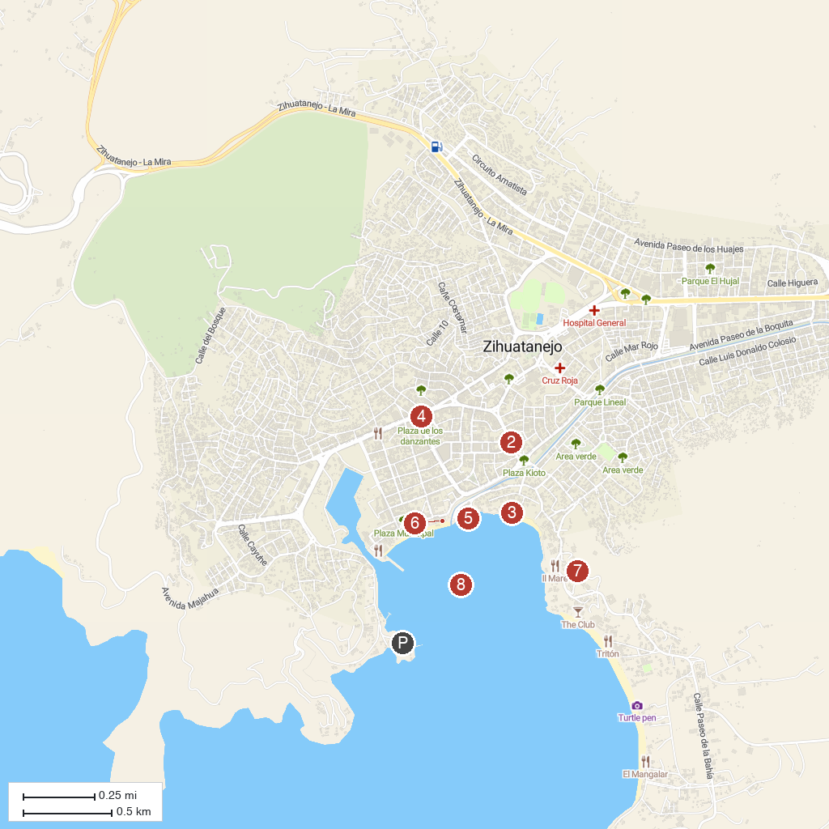
MAP KEY
1. Picante Cruises | 5. Malecón Zihuatanejo
2. Zihuatanejo | 6. Museo Arqueológico de la Costa Grande
3. Playa la Madera | 7. PARTENON ZIHUATANEJO
4. Los Bailarines | 8. Bahia de Zihuatanejo
P. Cruise port / terminal
Map © MapTiler © OpenStreetMap contributors · cruiseports.org

