Izmir, Aegean, Turkey
Turkey's most cosmopolitan city anchors an Aegean coast dripping with history — from the world-class ruins of Ephesus to the smoky lanes of Kemeralti Bazaar and the breezy Kordon promenade.
⚓ Docked (Alsancak Pier) · 🕒 Typical call: 8–10 hrs · 💵 Turkish Lira (TRY) · 🗣️ Turkish (English widely spoken in tourist areas)
✍️ MY DAY IN PORT (FILL IN)
Ship / Date
In port | arrive ______ · all aboard ______
Booked excursion
Notes / meeting point
GETTING ASHORE
- Docking: Pier at Alsancak Port — no tender required
- Walk to center: 15–20 min walk along the Kordon to Konak Square; taxis plentiful
- Best For: Ephesus day trip, bazaar browsing, waterfront dining
- Don't Miss: Library of Celsus at Ephesus and the Kemeralti Bazaar
GETTING AROUND
- 🚕 Taxi: ₺150–180 (~$3–4 USD) — Metered taxis are plentiful at the port. Base fare ₺25, then ₺36/km; short city-center trips run ₺150–180. Minimum fare
- 📱 Rideshare: ✅ Uber, Bolt
TOP THINGS TO DO
- Ephesus & the Library of Celsus — One of the best-preserved Roman cities on earth, 80 km south of Izmir.
- Kemeralti Bazaar & Ancient Agora — Lose yourself in Izmir's 17th-century market — a labyrinth of spice stalls, carpet shops, Ottoman caravanserais, mosques, and…
- Kadifekale (Velvet Castle) — Izmir's ancient hilltop citadel, built during Alexander the Great's era, offers sweeping panoramas over the Gulf of Izmir.
- Turkish Breakfast & Local Food Walk — Izmir has its own culinary identity.
- Şirince Village & Wine Tasting — Combine an Ephesus visit with a stop in Şirince, a whitewashed hilltop village famous for its fruit wines (pomegranate, peach…
BEST WALKS
- Kordon Promenade to Konak Square: 2.5 km · 30–35 min · Flat, paved — Walk south along the Kordon waterfront promenade from Alsancak Port past outdoor cafes, palm trees…
- Kemeralti Bazaar & Ancient Agora Loop: 2 km · 2–3 hrs exploring · Cobblestones — From Konak Square, plunge into Kemeralti Bazaar along Anafartalar Caddesi.
WEATHER · DAYLIGHT · MONEY
Month | High °F | Low °F | Rainy days
May | 78 | 60 | 7
Jul | 95 | 72 | 1
Sep | 87 | 67 | 3
Daylight: May 6:00AM–8:15PM · Jul 6:00AM–8:34PM · Sep 6:53AM–7:19PM
cruiseports.org/izmir · Confirm terminal & all-aboard time with your ship

Izmir, Aegean, Turkey — Port Map
Red = walkable sights · Amber = excursions farther out · P = cruise terminal
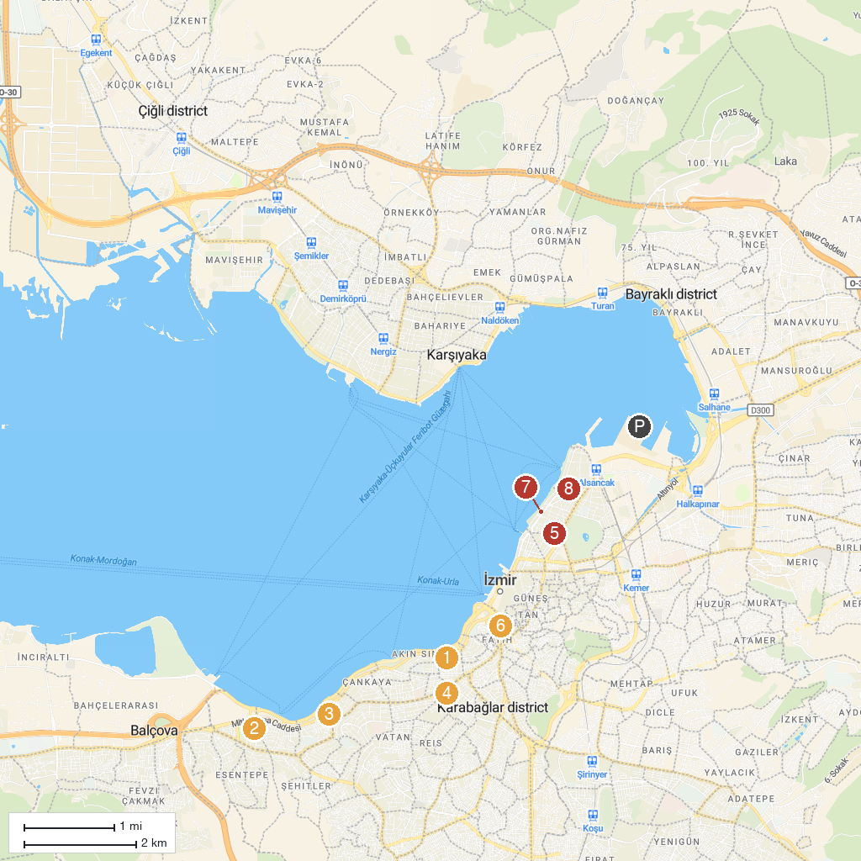
MAP KEY
1. İzmir Historical Elevator Building | 5. St. John's Cathedral
2. Ahmed Adnan Saygun Sanat Merkezi | 6. Izmir Archaeological Museum
3. İzmir Büyükşehir Belediyesi Susuzdede Parkı | 7. Arkas Sanat Alsancak
4. Karabağlar Belediyesi Uğur Mumcu Parkı | 8. Izmir Mask Museum
P. Cruise port / terminal
Map © MapTiler © OpenStreetMap contributors · cruiseports.org

