Jakarta, Java, Indonesia
The Big Durian: a sprawling, electrifying megacity where Dutch colonial warehouses face traditional wooden sailing ships and golden-capped skyscrapers loom over 17th-century cobblestones.
⚓ Pier (Tanjung Priok) · 🕒 Typical call: 8-10 hrs · 💵 Indonesian Rupiah (IDR) · 🗣️ Indonesian (Bahasa)
✍️ MY DAY IN PORT (FILL IN)
Ship / Date
In port | arrive ______ · all aboard ______
Booked excursion
Notes / meeting point
GETTING ASHORE
- Docking: Pier — Nusantara Pura Passenger Terminal, Tanjung Priok
- Walk to center: Not walkable — transport required; 45-90 min to Kota Tua
- Best For: Colonial history, street food, vibrant city culture
- Don't Miss: Kota Tua (Old Town), Sunda Kelapa harbor, Istiqlal Mosque
GETTING AROUND
- 🚕 Taxi: IDR 50,000–80,000 — Metered taxi from Tanjung Priok cruise terminal to Kota Tua (Old Town) is about 12 km. Bluebird is the most trusted comp
- 📱 Rideshare: ✅ Grab, Gojek
- 🚌 Hop-on hop-off: ✅
TOP THINGS TO DO
- Kota Tua (Old Batavia) — Stroll Fatahillah Square surrounded by restored 18th-century Dutch buildings, visit the Jakarta History Museum in the old City…
- Sunda Kelapa Harbor — Walk the 500-year-old harbor where traditional wooden pinisi schooners still load cargo by hand, just as they have for centuries.
- Istiqlal Mosque & Cathedral — Southeast Asia's largest mosque stands directly across the street from a neo-Gothic Dutch colonial cathedral — a living symbol of…
- National Monument (Monas) — Ride the elevator to the top of Jakarta's 132-meter golden-flame obelisk for panoramic city views, then explore the independence…
- National Museum of Indonesia — The 'Elephant Building' houses stunning Hindu-Buddhist gold treasures, ancient artifacts, and ethnographic collections spanning…
BEST WALKS
- Kota Tua to Sunda Kelapa: ~1.5 km | Easy | 45-60 min | Historical — From Fatahillah Square, wander through the old Dutch colonial quarter, past the Jakarta History…
WEATHER · DAYLIGHT · MONEY
Month | High °F | Low °F | Rainy days
May | 88 | 75 | 23
Jul | 88 | 74 | 13
Sep | 90 | 75 | 13
Daylight: May 5:54AM–5:43PM · Jul 6:05AM–5:52PM · Sep 5:46AM–5:49PM
cruiseports.org/jakarta · Confirm terminal & all-aboard time with your ship

Jakarta, Java, Indonesia — Port Map
Red = walkable sights · Amber = excursions farther out · P = cruise terminal
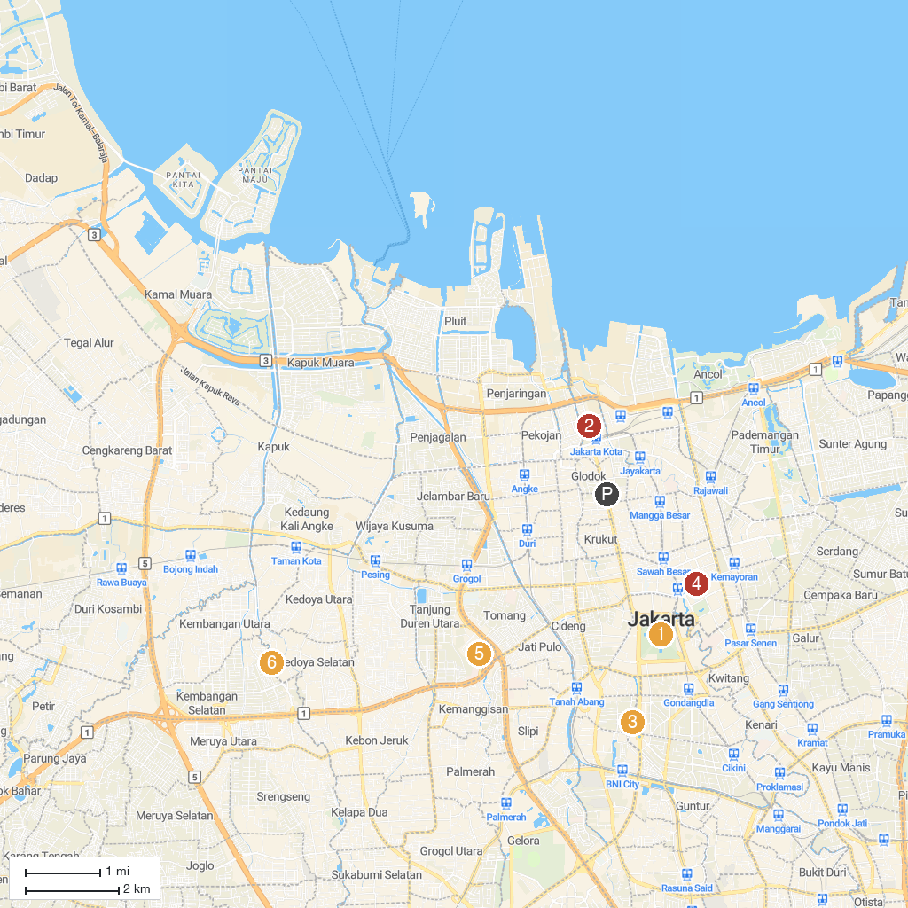
MAP KEY
1. National Monument | 5. Antara Gallery of Photo Journalism
2. Taman Mini Indonesia Indah | 6. Skyrink Jakarta - Mall Taman Anggrek
3. Jakarta History Museum | 7. Akili Museum of Art
4. Miniapolis | 8. Orchid Park Indonesia Permai
P. Cruise port / terminal
Map © MapTiler © OpenStreetMap contributors · cruiseports.org

