Jersey, Channel Islands, UK
A tiny island with an outsized story — five years of Nazi occupation, 800-year-old castles, and some of Britain's finest beaches, all packed into nine miles by five.
⚓ Tender (most ships) or pier for small vessels · 🕒 Typical call: 8–10 hrs · 💷 Jersey Pound (= GBP; UK cards accepted everywhere) · 🗣️ English (French street names) · 🌊 Channel Islands, Crown Dependency
✍️ MY DAY IN PORT (FILL IN)
Ship / Date
In port | arrive ______ · all aboard ______
Booked excursion
Notes / meeting point
GETTING ASHORE
- Docking: Tender to Albert Pier Pontoon (ships >185m); small ships may berth at Albert Pier, St Helier
- Walk to centre: ~10 min from Albert Pier to Liberation Square, St Helier
- Best For: WWII history, castle-hopping, wildlife conservation, beaches
- Don't Miss: Jersey War Tunnels and Mont Orgueil Castle
GETTING AROUND
- 🚕 Taxi: £5–£10 — Taxi ranks are at St. Helier Harbour (the cruise terminal) and throughout the city. The port is right in the heart of St
- 📱 Rideshare: ❌ not available
- 🚌 Hop-on hop-off: ✅
TOP THINGS TO DO
- Jersey War Tunnels (Hohlgangsanlage 8) — An extensive underground hospital complex carved by forced labour under German occupation, now a powerful WWII museum.
- Mont Orgueil Castle — A 13th-century fortress perched dramatically above Gorey harbour on Jersey's east coast.
- Elizabeth Castle & Liberation Square — A magnificent 16th-century sea fortress on a tidal islet in St Aubin's Bay — reach it by amphibious vehicle or on foot at low tide.
- Durrell Wildlife Park (Jersey Zoo) — Founded by naturalist Gerald Durrell, this world-renowned conservation park is home to some of the planet's most endangered…
- St Brelade's Bay — Jersey's most popular beach — a sweeping crescent of golden sand on the sheltered south-west coast.
BEST WALKS
- Liberation Square & St Helier Town Centre: 1–2 hrs · Flat · Free — From the Albert Pier Pontoon, walk west along the waterfront to Liberation Square — home to the…
- Gorey Harbour & Mont Orgueil Village: 1 hr on foot (after bus) · Moderate · Paid castle entry — Take LibertyBus to Gorey, then walk the quayside past brightly coloured boats to the foot of Mont…
cruiseports.org/jersey-island · Confirm terminal & all-aboard time with your ship

Jersey, Channel Islands, UK — Port Map
Red = walkable sights · Amber = excursions farther out · P = cruise terminal
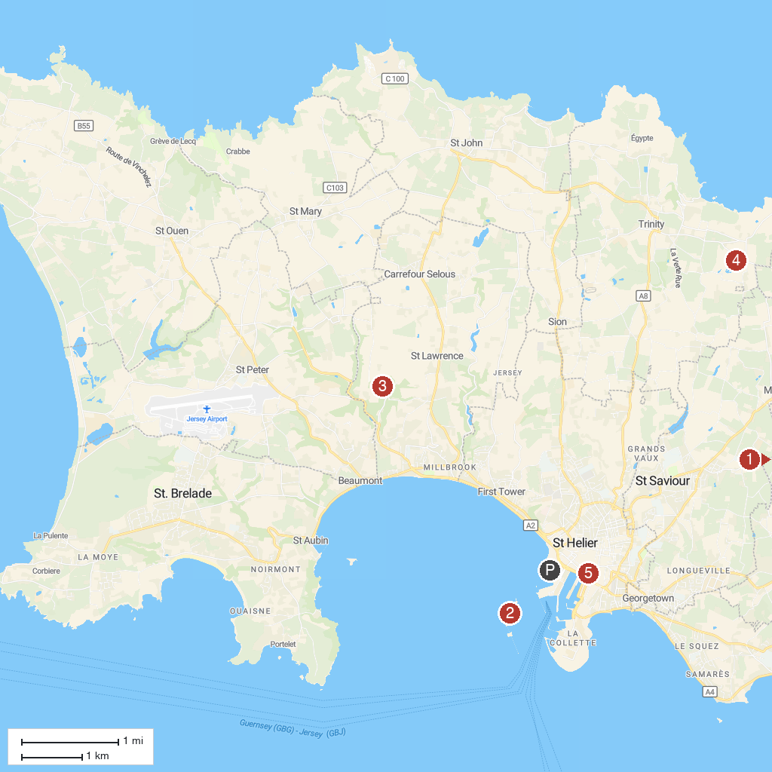
MAP KEY
1. Mont Orgueil Castle | 4. Durrell Wildlife Park
2. Elizabeth Castle | 5. Jersey Museum & Art Gallery
3. Jersey War Tunnels
P. Cruise port / terminal
Map © MapTiler © OpenStreetMap contributors · cruiseports.org

