Jizan, Jizan Region, Saudi Arabia
Saudi Arabia's southernmost Red Sea port blends coral-fringed islands, green mountain terraces, and a living culture unchanged for centuries — the Flower Men still crown their heads with jasmine and marigolds.
⚓ Pier (deep-water berth) · 🕒 Typical call: 8-10 hrs · 💵 Saudi Riyal (SAR) · 🗣️ Arabic (English limited) · 🌡️ Hot & humid; Oct–Apr best
✍️ MY DAY IN PORT (FILL IN)
Ship / Date
In port | arrive ______ · all aboard ______
Booked excursion
Notes / meeting point
GETTING ASHORE
- Docking: Pier — deep-water commercial port; shuttle to city center
- Walk to center: Not walkable from port; shuttle or taxi required
- Best For: Island snorkeling, mountain scenery, authentic Arabian culture
- Don't Miss: Farasan Islands day trip and the Heritage Village
GETTING AROUND
- 🚕 Taxi: 30–50 SAR (~$8–14 USD) — Metered taxis available outside the terminal. Estimated 7 km to city center; negotiate or confirm meter use before depar
- 📱 Rideshare: ✅ Uber, Careem
TOP THINGS TO DO
- Farasan Islands Snorkel & Beach — An 80-island Red Sea archipelago with turquoise lagoons, pristine coral reefs, turtles, and the ancient sandstone ruins of…
- Faifa Mountains & the Flower Men — Drive about 2 hours into misty, terraced highlands where the Faifa hill tribes — the 'Flower Men' — wear wreaths of fresh jasmine…
- Heritage Village & Al-Dosariyah Castle — The open-air Heritage Village on the Corniche recreates Tihamah architecture with mud-brick houses, thatched huts, and live…
- Fish Souk & Spice Market — Jizan's waterfront souk bursts with the morning's Red Sea catch alongside stalls selling frankincense, local honey, and the…
- Al-Khoubah Hot Springs — About 75 km from the port, mineral-rich natural hot springs surrounded by date palms.
BEST WALKS
- Jizan Corniche & Heritage Village Stroll: 1.5 km · Easy · ~30 min — From the shuttle drop-off near the Heritage Village, walk north along the South Corniche promenade.
WEATHER · DAYLIGHT · MONEY
Month | High °F | Low °F | Rainy days
May | 94 | 85 | 1
Jul | 96 | 86 | 2
Sep | 95 | 87 | 0
Daylight: May 5:38AM–6:33PM · Jul 5:44AM–6:46PM · Sep 5:58AM–6:11PM
cruiseports.org/jizan · Confirm terminal & all-aboard time with your ship

Jizan, Jizan Region, Saudi Arabia — Port Map
Red = walkable sights · Amber = excursions farther out · P = cruise terminal
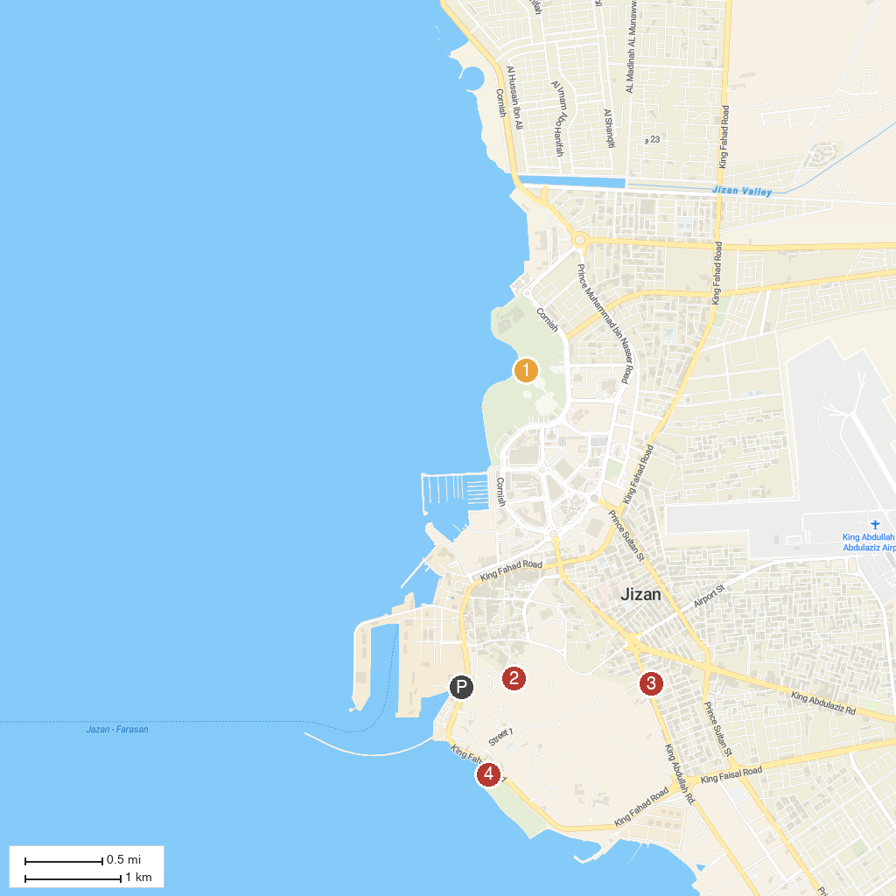
MAP KEY
1. North Corniche Park | 3. Literary Club in Jazan
2. Adosareyah Castle | 4. Awqat Saeeda Theme Park
P. Cruise port / terminal
Map © MapTiler © OpenStreetMap contributors · cruiseports.org

