Jondal, Vestland, Norway
One of the Hardangerfjord's quietest ports, Jondal trades tourist bustle for cherry orchards, an outsized church, and a glacier you can ski in July.
⚓ Tender port · 🕒 Typical call: 5–7 hrs · 💵 NOK (cards widely accepted) · 🗣️ Norwegian / English spoken
✍️ MY DAY IN PORT (FILL IN)
Ship / Date
In port | arrive ______ · all aboard ______
Booked excursion
Notes / meeting point
GETTING ASHORE
- Docking: Tender to Jondal Guest Harbour (village centre)
- Walk to centre: 1–2 min from tender dock
- Best For: Quiet fjord scenery, summer glacier skiing, Hardanger embroidery
- Don't Miss: Jondal Church — the 'Hardanger Cathedral' — and a drive to Folgefonna Glacier
GETTING AROUND
- 🚕 Taxi: NOK 200–550 (~$19–$52 USD) — Limited local taxis may be available at the pier. Availability can be strained when multiple ships call; short village t
- 📱 Rideshare: ❌ not available
TOP THINGS TO DO
- Summer Skiing on Folgefonna Glacier — Drive 45 minutes up a winding mountain road to Fonna Glacier Ski Resort, where you can ski or snowboard at 1,200 m elevation with…
- Hardangerfjord Kayaking — Paddle the glassy fjord at water level, surrounded by towering peaks and waterfalls.
- Baroniet Rosendal Day Trip — Norway's only barony — a 1665 manor castle with a Renaissance rose garden and a dramatic waterfall backdrop, about an hour from…
- Jondal Church & Village Walk — The 'Hardanger Cathedral' seats about 500 in a village of around 400 — its scale is remarkable.
- Hardanger Cider Tasting — The Hardanger region is Norway's apple heartland.
BEST WALKS
- Village Heritage Walk: 1–2 km · 30–45 min · Easy · Free — From the guest harbour, walk to Jondal Church, admire the 19th-century wooden houses, and end at…
WEATHER · DAYLIGHT · MONEY
Month | High °F | Low °F | Rainy days
May | 56 | 43 | 16
Jul | 66 | 55 | 20
Sep | 61 | 50 | 18
Daylight: May 4:55AM–10:09PM · Jul 4:36AM–10:43PM · Sep 7:03AM–7:55PM
cruiseports.org/jondal · Confirm terminal & all-aboard time with your ship

Jondal, Vestland, Norway — Port Map
Red = walkable sights · Amber = excursions farther out · P = cruise terminal
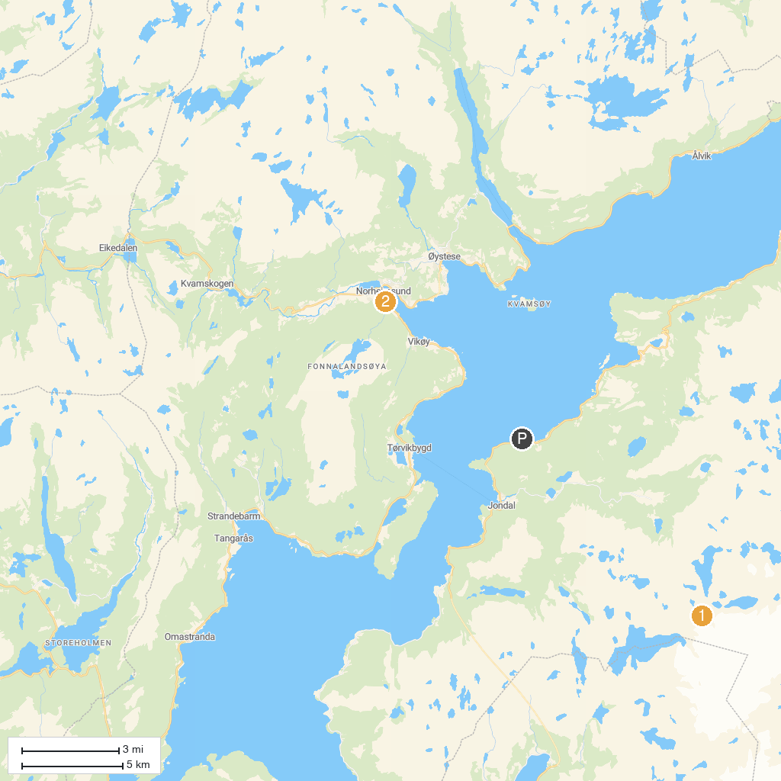
MAP KEY
1. Steinsdalsfossen | 3. Hardanger Maritime Centre
2. Blue Ice Hike, Juklavass Glacier
P. Cruise port / terminal
Map © MapTiler © OpenStreetMap contributors · cruiseports.org

