Jost Van Dyke, British Virgin Islands
Three square miles of barefoot Caribbean perfection — White Bay's blinding sands, legendary beach bars, and the original Painkiller cocktail await. No traffic lights, no chain stores, no hurry.
⚓ Tender port (anchor in Great Harbour) · 🕒 Typical call: 6-8 hrs · 💵 US Dollar (USD) · 🗣️ English · 🏖️ Best for beach & bar crawl
✍️ MY DAY IN PORT (FILL IN)
Ship / Date
In port | arrive ______ · all aboard ______
Booked excursion
Notes / meeting point
GETTING ASHORE
- Docking: Tender into Great Harbour pier; no cruise ship dock
- Walk to White Bay: Taxi recommended — short but steep hill (~½ mile), ~$5–10/person
- Best For: Beach bars, the original Painkiller cocktail, snorkeling
- Don't Miss: Soggy Dollar Bar and swimming with a wet dollar bill
GETTING AROUND
- 🚕 Taxi: $5–$10/person one-way — Open-air safari trucks and 4x4s meet arrivals at Great Harbour dock. Bunn's Taxi Service is a well-known local operator
- 📱 Rideshare: ❌ not available
TOP THINGS TO DO
- White Bay Beach & Bar Crawl — The island's signature experience: stake out a spot on White Bay's stunning white sand, then work your way through Soggy Dollar…
- Bubbly Pool Hike — A natural rock formation on the Atlantic-facing north shore where ocean swells crash through a narrow gap creating a natural…
- Snorkeling Charter to Sandy Cay & Sandy Spit — Two tiny uninhabited islets just offshore — Sandy Cay (a National Park with reef) and Sandy Spit (classic postcard desert island…
- Lunch at Foxy's Tamarind Bar — Legendary Great Harbour institution owned by Foxy Callwood, who may still be playing guitar and singing.
BEST WALKS
- Great Harbour Beachfront Stroll: 15 min | Flat | Free — From the tender pier, walk the sandy waterfront road past Foxy's, small local shops, and colorful…
- Bubbly Pool Trail (from Foxy's Taboo): 30 min round trip | Moderate | Rocky terrain — Taxi to Foxy's Taboo on the east end, then follow the marked trail across salt flats and through…
WEATHER · DAYLIGHT · MONEY
Month | High °F | Low °F | Rainy days
May | 78 | 75 | 11
Jul | 80 | 77 | 14
Sep | 81 | 78 | 16
Daylight: May 5:45AM–6:45PM · Jul 5:51AM–6:58PM · Sep 6:07AM–6:20PM
cruiseports.org/jost-van-dyke-island-bvi · Confirm terminal & all-aboard time with your ship

Jost Van Dyke, British Virgin Islands — Port Map
Red = walkable sights · Amber = excursions farther out · P = cruise terminal
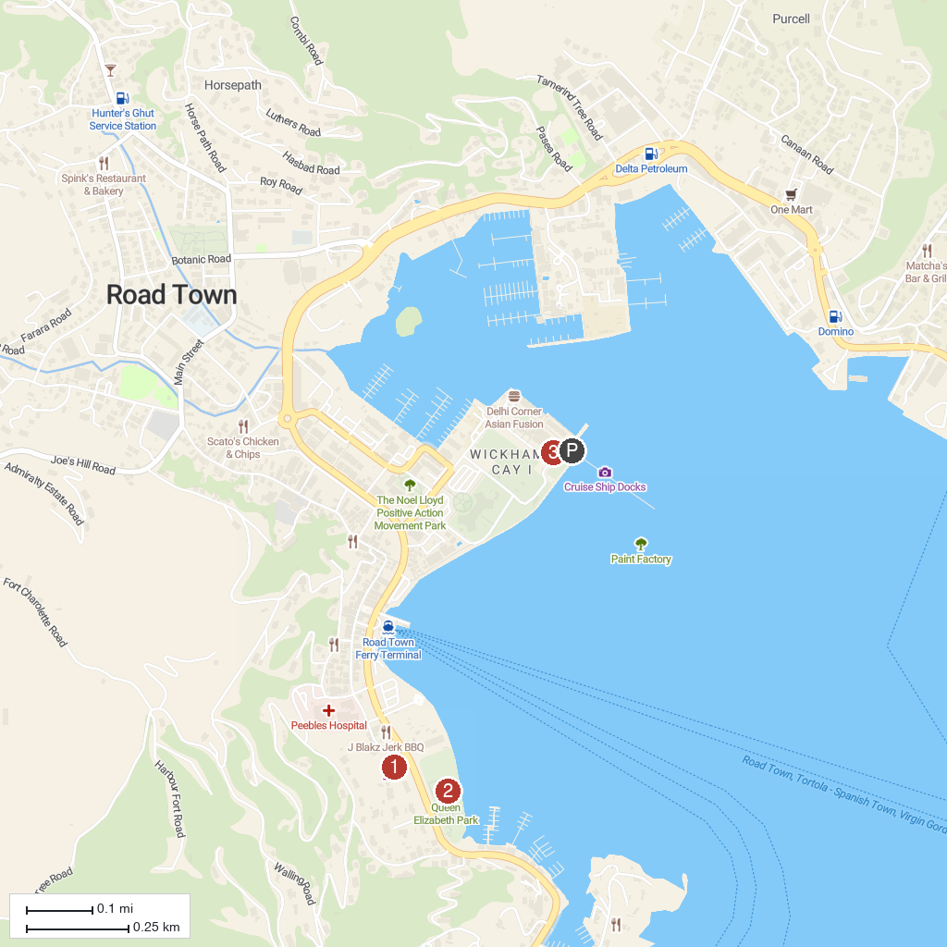
MAP KEY
1. Bubbly Pool | 5. Old Government House Museum
2. Coral Reef Underwater Park Trail | 6. Queen Elizabeth II National Park
3. Annaberg Sugar Plantation | 7. Cruz Bay Visitor Center
4. Carolina Corral | 8. Cyril B. Romney Tortola Pier Park
P. Cruise port / terminal
Map © MapTiler © OpenStreetMap contributors · cruiseports.org

