Juneau, Alaska
Alaska's only road-free capital docks you right downtown — a glacier 13 miles out, humpback whales in the channel, and a rainforest tram steps from the ship.
⚓ Docked (downtown or AJ Dock) · 🕒 Typical call: 8–10 hrs · 💵 US Dollar (USD) · 🌧️ Rain jacket essential
✍️ MY DAY IN PORT (FILL IN)
Ship / Date
In port | arrive ______ · all aboard ______
Booked excursion
Notes / meeting point
GETTING ASHORE
- Docking: Franklin/CT Dock (downtown) or AJ Dock (~1.5 mi south)
- Walk to center: 0 min from downtown docks · 25–30 min or free shuttle from AJ
- Best For: Glaciers · Whale watching · Hiking · Flightseeing
- Don't Miss: Mendenhall Glacier + Nugget Falls
GETTING AROUND
- 🚕 Taxi: Metered — Glacier Taxi, Alaska Taxi & Tours, and Evergreen Taxi queue at the docks. Taxis can drop off at Mendenhall Glacier Visit
- 📱 Rideshare: ✅ Uber, Lyft
TOP THINGS TO DO
- Mendenhall Glacier & Nugget Falls — The essential Juneau stop.
- Humpback Whale Watching — Juneau is one of the world's top humpback spots.
- Helicopter Glacier Landing & Dog Sledding — Fly over the Juneau Icefield, land on a glacier, and mush a dog team across the ice.
- Mount Roberts Tramway — Right at the downtown dock — rise 1,800 ft for panoramic Gastineau Channel views, a Tlingit culture theater, eagle aviary, nature…
- Sea Kayaking — Auke Bay or Gastineau Channel — Paddle calm waters through rainforest scenery.
BEST WALKS
- Downtown Seawalk & Capitol Loop: ~2.5 km · 1–1.5 hrs · easy · flat — From the dock, follow the Seawalk past Marine Park's bronze whale sculpture, up S.
- Perseverance Trail — Gold Creek Canyon: ~5 km out-and-back · 2–3 hrs · moderate · some elevation — Juneau's most rewarding town-accessible hike.
- Nugget Falls Trail (at Mendenhall): ~3 km out-and-back · 1 hr · easy · flat gravel — If you make your own way to Mendenhall (bus or shuttle), this flat path leads along the lakeshore…
WEATHER · DAYLIGHT · MONEY
Month | High °F | Low °F | Rainy days
May | 54 | 41 | 14
Jul | 64 | 54 | 18
Sep | 57 | 47 | 21
Daylight: May 4:30AM–9:18PM · Jul 4:17AM–9:48PM · Sep 6:28AM–7:15PM
cruiseports.org/juneau · Confirm terminal & all-aboard time with your ship

Juneau, Alaska — Port Map
Red = walkable sights · Amber = excursions farther out · P = cruise terminal
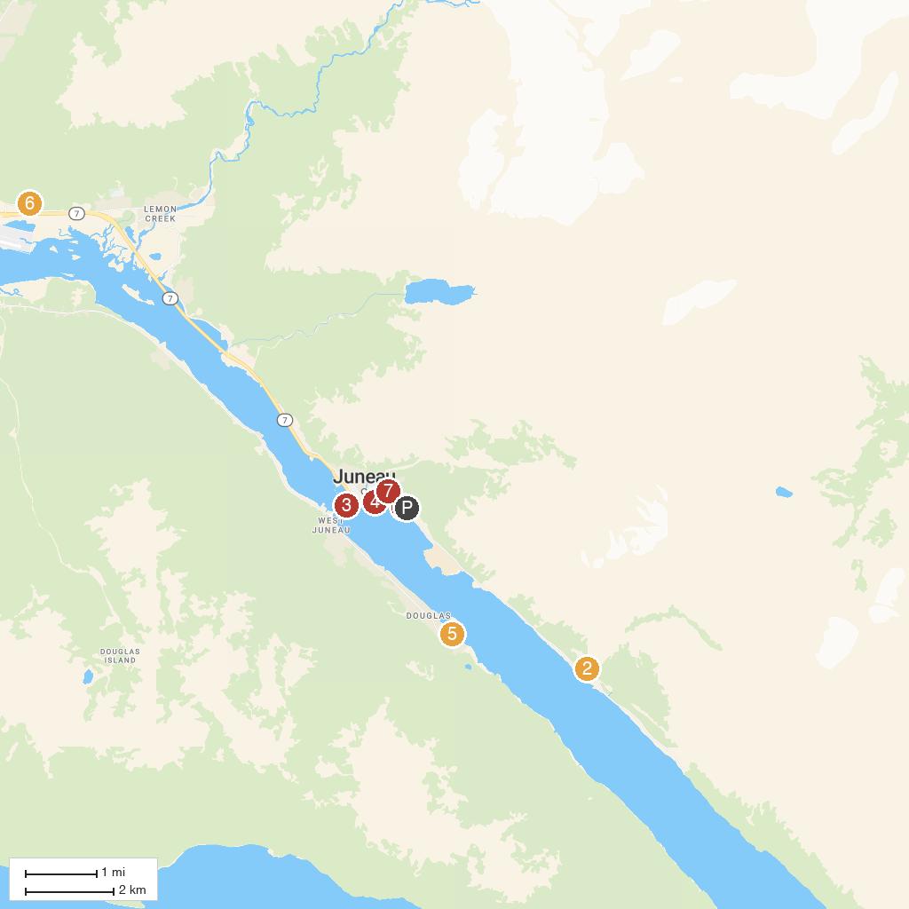
MAP KEY
1. Liquid Alaska Tours | 5. Savikko Park
2. AJ Mine Gastineau Mill Tours | 6. Glacier Gardens Rainforest Adventure
3. The Whale Project | 7. Alaska State Capitol
4. Alaska State Museum | 8. Mendenhall Glacier Visitor Center
P. Cruise port / terminal
Map © MapTiler © OpenStreetMap contributors · cruiseports.org

