Kagoshima, Kyushu, Japan
Kagoshima sits at the feet of Sakurajima, one of Japan's most active volcanoes — a constant, smoke-puffing presence across the bay. Between a UNESCO garden, samurai streets, and a ferry to the caldera's edge, this southern Kyushu city punches well above its port-call weight.
⚓ Pier (Marine Port Kagoshima) · 🕒 Typical call: 8–10 hrs · 💴 Currency: Japanese Yen (JPY) · 🗣️ Language: Japanese
✍️ MY DAY IN PORT (FILL IN)
Ship / Date
In port | arrive ______ · all aboard ______
Booked excursion
Notes / meeting point
GETTING ASHORE
- Docking: Pier — Marine Port Kagoshima, modern 340m quay south of city center
- Walk to center: ~5 km — shuttle bus or tram recommended; City View tourist bus available
- Best For: Volcano day trip, traditional gardens, samurai history, Japanese street food
- Don't Miss: Sakurajima ferry + lava trail footbath, Sengan-en garden, shirokuma shaved ice
GETTING AROUND
- 🚕 Taxi: ¥2,800–¥3,400 one-way — Taxis wait at the port terminal — about 10 minutes to city center. Good value for groups of 3–4. Starting fare ¥560; met
- 📱 Rideshare: ✅ Uber
- 🚌 Hop-on hop-off: ✅
TOP THINGS TO DO
- Sakurajima Volcano Ferry & Lava Trail — A 15-minute ferry across Kinko Bay lands you on one of Japan's most active volcanoes.
- Sengan-en Garden & Shoko Shuseikan Museum — A UNESCO World Heritage landscape garden built by the Shimazu clan in 1658, designed with Sakurajima as its 'borrowed scenery.'…
- Shiroyama Observatory & Castle Ruins — The wooded hilltop above central Kagoshima offers the best panoramic view of the city and Sakurajima.
- Tenmonkan Food & Shopping District — Kagoshima's downtown covered arcade is the place to eat kurobuta (black Berkshire pork) tonkatsu, try shirokuma shaved ice — a…
- Chiran Samurai District & Peace Museum — A beautifully preserved samurai residential street with zen garden-fronted stone walls, about 1 hour south by bus or taxi.
BEST WALKS
- Waterfront to Tenmonkan Walk: 2 km · 25 min · flat · free — From the Dolphin Port waterfront area, walk north along the bayside promenade past Kagoshima…
- Sengan-en Garden Self-Guided Loop: 1 km · 60–90 min · uneven gravel · admission required — Inside Sengan-en, the garden path winds past bamboo groves, stone bridges, shrines, and ponds — all…
WEATHER · DAYLIGHT · MONEY
Month | High °F | Low °F | Rainy days
May | 74 | 61 | 12
Jul | 85 | 75 | 21
Sep | 83 | 72 | 17
Daylight: May 5:21AM–7:06PM · Jul 5:23AM–7:23PM · Sep 6:01AM–6:23PM
cruiseports.org/kagoshima-city · Confirm terminal & all-aboard time with your ship

Kagoshima, Kyushu, Japan — Port Map
Red = walkable sights · Amber = excursions farther out · P = cruise terminal
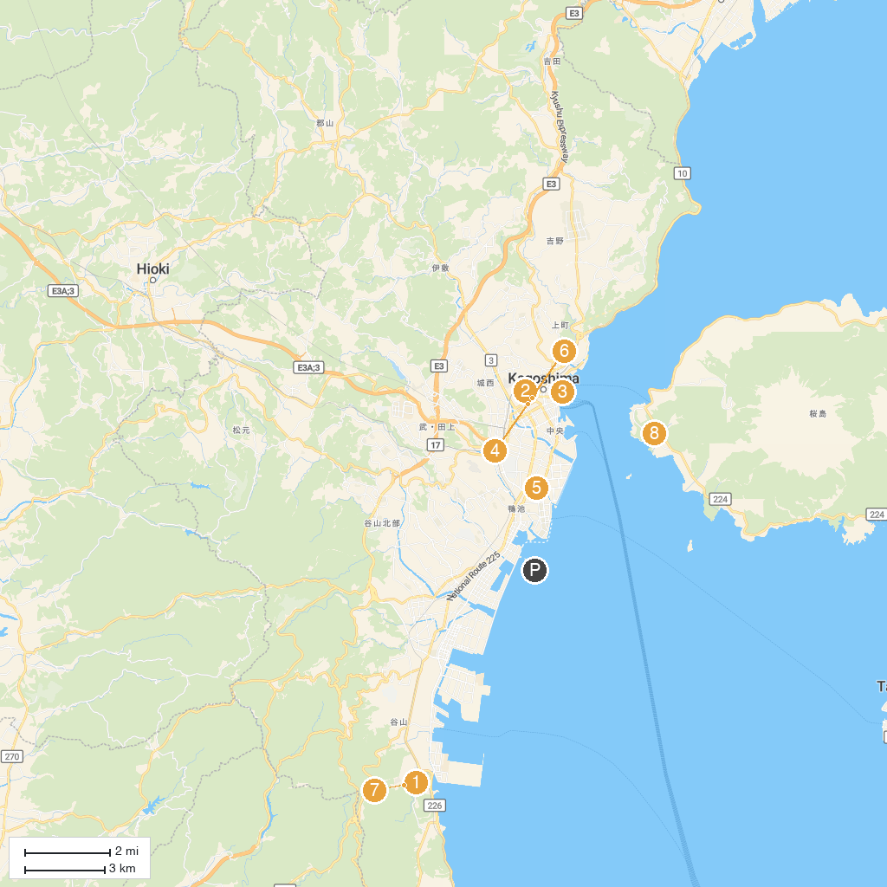
MAP KEY
1. Kinkowan Park | 5. Kagoshima Municipal Science Hall
2. Shiroyama Park Observation Deck | 6. Kagoshima Prefectural Museum
3. Kagoshima City Aquarium | 7. Hirakawa Zoo
4. St Francis Xavier Cathedral | 8. Karasujima Observation deck
P. Cruise port / terminal
Map © MapTiler © OpenStreetMap contributors · cruiseports.org

