Kailua-Kona, Big Island, Hawaii, USA
Where volcanic coastline meets crystal-clear Pacific waters — Kailua-Kona delivers world-class snorkeling, world-famous coffee, and ancient Hawaiian history all within reach of the tender pier.
⚓ Tender port (no docking pier) · 🕒 Typical call: 8–10 hrs · 💵 USD · 🗣️ English / Hawaiian
✍️ MY DAY IN PORT (FILL IN)
Ship / Date
In port | arrive ______ · all aboard ______
Booked excursion
Notes / meeting point
GETTING ASHORE
- Docking: Tender only — ships anchor in Kailua Bay; 15-min ride to Kailua Pier
- Walk to center: Steps from the tender pier to Ali'i Drive shops and restaurants
- Best For: Snorkeling, Kona coffee tours, manta ray night dives, Hawaiian history
- Don't Miss: Kealakekua Bay snorkel, Hulihe'e Palace, Pu'uhonua o Hōnaunau NHP
GETTING AROUND
- 🚕 Taxi: $6–12 in town — Taxis wait near the pier exit. Short hops within town run about $6–12 on the metered rate; rides further afield (e.g., t
- 📱 Rideshare: ✅ Uber, Lyft
- 🚌 Hop-on hop-off: ✅ Clark's Hawaii Tours
TOP THINGS TO DO
- Kealakekua Bay Snorkel — Boat tours from the pier run to this state marine preserve — one of Hawaii's best snorkel sites, with spinner dolphins, tropical…
- Manta Ray Night Snorkel or Dive — One of the Big Island's signature experiences: giant Pacific manta rays swoop through beams of light feeding on plankton.
- Pu'uhonua o Hōnaunau (City of Refuge) — Ancient Hawaiian sanctuary where lawbreakers could seek absolution.
- Kona Coffee Farm Tour — The Kona coffee belt climbs the slopes of Hualalai and Mauna Loa just above town.
- Atlantis Submarine — Descend 100+ feet below Kailua Bay in a passenger submarine operated from the pier.
BEST WALKS
- Ali'i Drive Historical Stroll: ~1.5 miles one-way · Flat · 30–45 min — Walk south along Ali'i Drive from the tender pier past Hulihe'e Palace, Mokuaikaua Church, Kahaluu…
- Kaloko-Honokōhau NHP Shoreline: ~2 miles · Easy · 1 hr · Short drive north — A flat shoreline walk through ancient Hawaiian fishponds and petroglyphs at Kaloko-Honokōhau…
WEATHER · DAYLIGHT · MONEY
Month | High °F | Low °F | Rainy days
May | 78 | 70 | 24
Jul | 81 | 73 | 27
Sep | 81 | 73 | 22
Daylight: May 5:48AM–6:52PM · Jul 5:54AM–7:05PM · Sep 6:11AM–6:25PM
cruiseports.org/kailua-kona · Confirm terminal & all-aboard time with your ship

Kailua-Kona, Big Island, Hawaii, USA — Port Map
Red = walkable sights · Amber = excursions farther out · P = cruise terminal
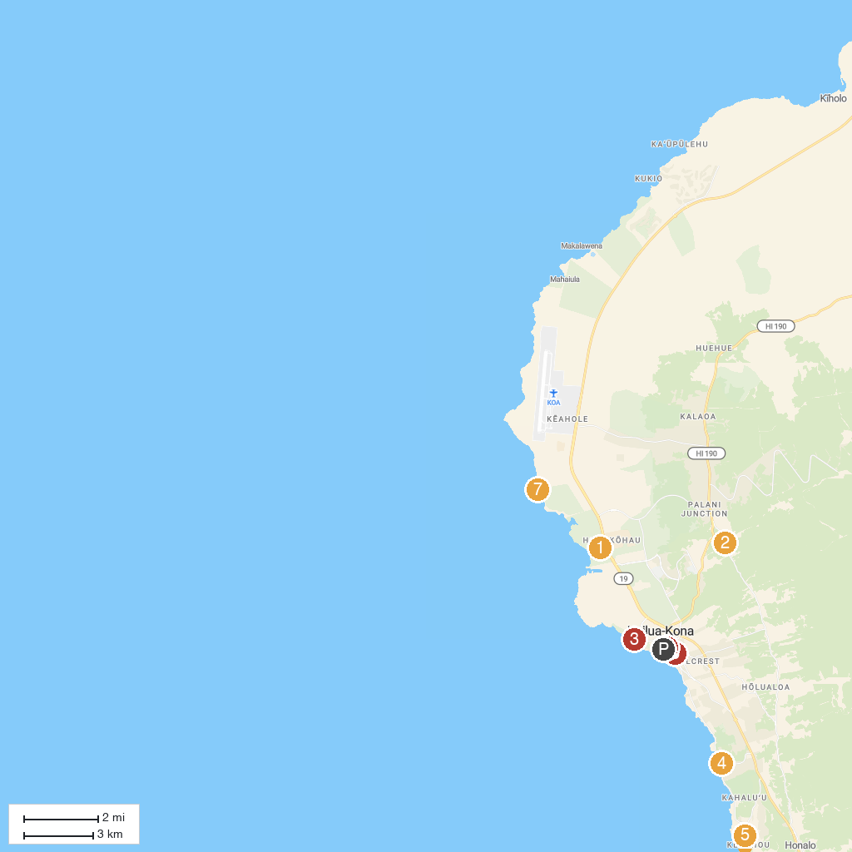
MAP KEY
1. Kaloko-Honokōhau National Historical Park | 5. Fair Wind Cruises
2. Hula Daddy Kona Coffee | 6. St. Michael The Archangel Church
3. Old Kona Airport State Recreation Area | 7. Kohanaiki Beach Park
4. La'aloa Beach Park (aka Magic Sands) | 8. Hulihe‘e Palace
P. Cruise port / terminal
Map © MapTiler © OpenStreetMap contributors · cruiseports.org

