Kaiteriteri, Nelson-Tasman, New Zealand
The sun-drenched gateway to Abel Tasman National Park, where golden mica-flecked beaches meet calm turquoise water and the only way deeper into the park is by boat or boot.
⚓ Tender port (no pier) · 🕒 Typical call: 6-8 hrs · 💵 NZD (New Zealand Dollar) · 🗣️ English
✍️ MY DAY IN PORT (FILL IN)
Ship / Date
In port | arrive ______ · all aboard ______
Booked excursion
Notes / meeting point
GETTING ASHORE
- Docking: Tender to Kaiteriteri Beach jetty — no cruise pier
- Walk to Centre: 0 min — you land right on the main beach
- Best For: Abel Tasman water taxis, kayaking, Split Apple Rock
- Don't Miss: Water taxi into the national park; Kaka Pah Point lookout
GETTING AROUND
- 🚕 Taxi: NZD $85–$114/person — Abel Tasman Sea Shuttles and Wilsons Abel Tasman offer hop-on hop-off water taxis into the national park from the Kaiter
TOP THINGS TO DO
- Abel Tasman Water Taxi & Hike — Hop a fast water taxi from the beach into the national park.
- Guided Sea Kayaking — Paddle the calm golden-sand coastline with a guide from Kaiteriteri Kayaks.
- Split Apple Rock Cruise — A short dedicated boat tour around the headland to Tokangawhā — the iconic giant granite boulder split cleanly in half, steeped…
- Scenic Sailing Catamaran — Trade the tender crowd for a peaceful skippered catamaran through the park's lagoons and bays.
- Kaka Pah Point & Māori History Walk — A free 10-minute walk from the beach to the historic Māori pā/kāinga site on the headland at the northern end of the beach.
BEST WALKS
- Kaka Pah Point Lookout: 30 min round trip · Easy · Free — From the tender jetty, walk along the beach to the northern headland track.
- Kaiteriteri to Little Kaiteriteri: 30 min one way · Easy · Free — Follow the footpath over the southern headland to quieter Little Kaiteriteri Beach — smaller, more…
WEATHER · DAYLIGHT · MONEY
Month | High °F | Low °F | Rainy days
May | 59 | 45 | 12
Jul | 53 | 40 | 12
Sep | 58 | 42 | 13
Daylight: May 7:28AM–5:19PM · Jul 7:49AM–5:18PM · Sep 6:29AM–6:17PM
cruiseports.org/kaiteriteri-nz · Confirm terminal & all-aboard time with your ship

Kaiteriteri, Nelson-Tasman, New Zealand — Port Map
Red = walkable sights · Amber = excursions farther out · P = cruise terminal
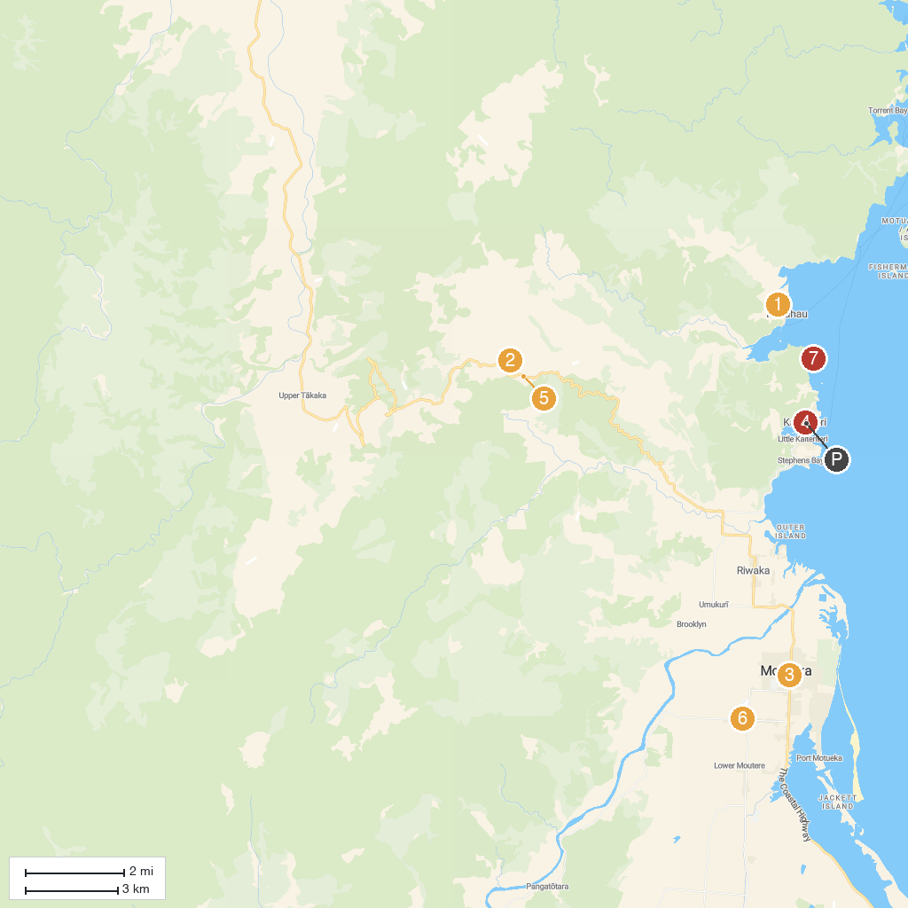
MAP KEY
1. Abel Tasman National Park | 5. Abel Tasman Sailing Adventures
2. Abel Tasman Kayaks | 6. Hawkes Lookout Walk
3. Ngarua Caves | 7. Skydive Abel Tasman
4. Motueka District Museum | 8. Split Apple Rock
P. Cruise port / terminal
Map © MapTiler © OpenStreetMap contributors · cruiseports.org

