Kalmar, Småland, Sweden
Home to one of Scandinavia's best-preserved Renaissance castles and a seamlessly walkable historic core, Kalmar rewards cruisers with 800 years of Swedish history in a single shore day.
⚓ Pier (small ships) or Tender (large ships) · 🕒 Typical call: 7–9 hrs · 💳 Cashless — cards everywhere, no SEK needed · 🗣️ Swedish (near-universal English)
✍️ MY DAY IN PORT (FILL IN)
Ship / Date
In port | arrive ______ · all aboard ______
Booked excursion
Notes / meeting point
GETTING ASHORE
- Docking: Small ships (<145 m) berth at Elevatorkajen, 300 m from centre; large ships tender to purpose-built jetty near harbour
- Walk to centre: 3–10 min on foot from either berth to Kalmar Castle and Old Town
- Best for: History, architecture, Baltic culture, easy walkability
- Don't miss: Kalmar Castle interior + Kronan gold hoard at the County Museum
GETTING AROUND
- 🚕 Taxi: ~50–80 SEK — Local taxis available near the pier with a base fare around 40 SEK. Given the pier's central location, most rides are ve
TOP THINGS TO DO
- Kalmar Castle — One of Sweden's best-preserved Renaissance palaces, with 800 years of history, stone battlements, a deep moat, and lavishly…
- Kronan Warship Exhibition — Kalmar County Museum houses the treasures recovered from the 1676 warship Kronan, including the largest gold coin find in Swedish…
- Kvarnholmen Old Town Walk — Wander the 17th-century island district of Kvarnholmen through the historic Västerport gate, past cobblestone alleys, wooden…
- Öland Island Day Trip — Cross the 6 km Öland Bridge by local bus to reach Sweden's sunniest island — a UNESCO World Heritage landscape with Borgholm…
- Kroppkakor & Swedish Fika — Sample Småland's signature dish — dense potato dumplings stuffed with spiced pork and onions — at local spots around Larmtorget…
BEST WALKS
- Castle to Cathedral Loop: 2.5 km · 45–60 min · Easy — Start at Kalmar Castle, walk through the adjacent Stadsparken city park, pass through the historic…
- Harbour & Museum Stroll: 1.5 km · 25–30 min · Easy — From the tender jetty or Elevatorkajen, walk north along the harbour past the Art Museum to Kalmar…
WEATHER · DAYLIGHT · MONEY
Month | High °F | Low °F | Rainy days
May | 60 | 45 | 9
Jul | 71 | 58 | 10
Sep | 64 | 53 | 9
Daylight: May 4:38AM–9:04PM · Jul 4:25AM–9:34PM · Sep 6:26AM–7:12PM
cruiseports.org/kalmar · Confirm terminal & all-aboard time with your ship

Kalmar, Småland, Sweden — Port Map
Red = walkable sights · Amber = excursions farther out · P = cruise terminal
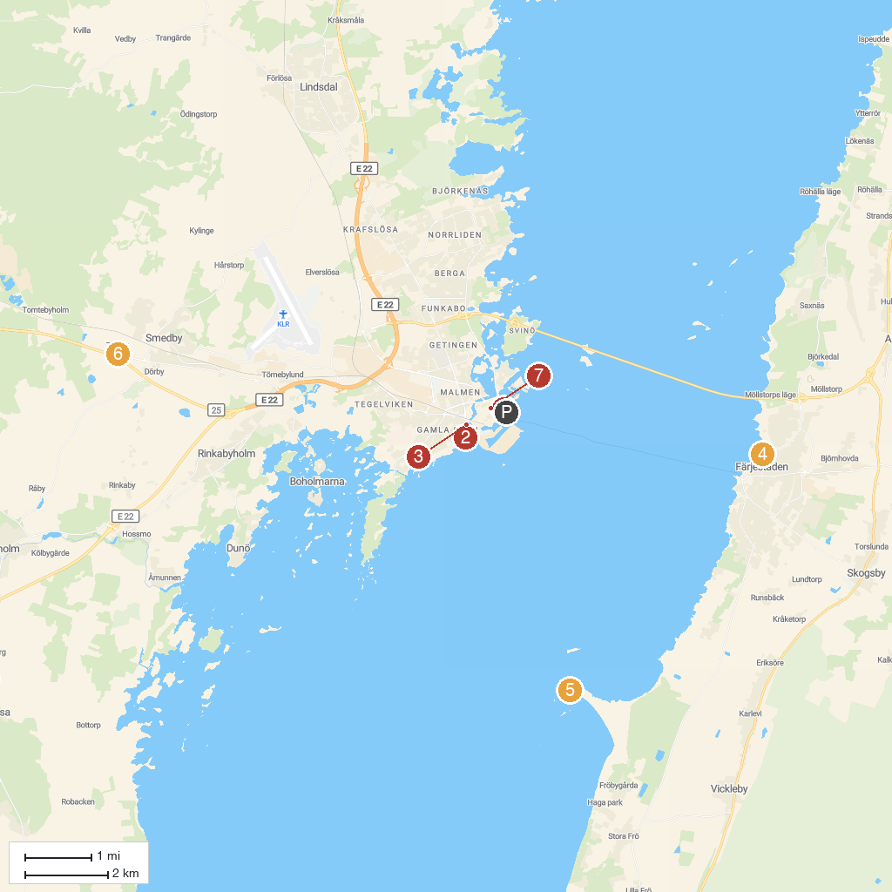
MAP KEY
1. Kalmar County Museum | 5. Beijershamn
2. Kalmar Castle | 6. A World of Dinosaurs
3. Kalmar stadspark | 7. Kalmar Cathedral
4. Färjestadens Dämme
P. Cruise port / terminal
Map © MapTiler © OpenStreetMap contributors · cruiseports.org

