Kalundborg, Zealand, Denmark
Home to the world's only five-towered medieval church built on a Greek cross plan, Kalundborg is a compact Danish town where 800-year-old spires rise above cobbled streets and the Great Belt shimmers beyond the fjord.
⚓ Pier (Ny Vesthavn terminal) · 🕒 Typical call: 6–8 hrs · 💵 Danish Krone (DKK) — cards accepted everywhere · 🗣️ Danish / English widely spoken · 🚌 Free shuttle to town centre (~3 km)
✍️ MY DAY IN PORT (FILL IN)
Ship / Date
In port | arrive ______ · all aboard ______
Booked excursion
Notes / meeting point
GETTING ASHORE
- Docking: Pier — Ny Vesthavn terminal, Piers 5–6; deep-water quay (15 m)
- Walk to Centre: 3–4 km from pier; free shuttle buses almost always provided
- Best For: Medieval architecture, Scandinavian history, easy day trip to Roskilde or Copenhagen
- Don't Miss: Vor Frue Kirke — the world's only five-towered church of its kind
GETTING AROUND
- 🚕 Taxi: €20–27 — Taxis are available at the pier for the 3–4 km ride into the historic town center; journey takes about 10–15 minutes.
- 📱 Rideshare: ✅ Uber
TOP THINGS TO DO
- Vor Frue Kirke — the Five-Tower Church — Built around 1170 by nobleman Esbern Snare, this extraordinary Romanesque brick church has five towers arranged in a Greek cross…
- Kalundborg Museum at Lindegården — Housed in a Renaissance manor built on the remains of King Valdemar Atterdag's city wall, the museum covers Viking Age finds…
- Røsnæs Peninsula Drive — One of Denmark's sunniest spots, the Røsnæs peninsula juts into the Great Belt with dramatic chalk cliffs, the 1846 Røsnæs…
- Roskilde Day Trip — Vikings & UNESCO Cathedral — Just 45 minutes by train, Roskilde offers the world-class Viking Ship Museum with original 11th-century longships, plus a…
- Lerchenborg Castle & Gardens — An elegant 18th-century baroque manor house set in sculpted grounds about 4 km south of Kalundborg.
BEST WALKS
- High Town Heritage Loop: 1.5 km · 30–45 min · Easy — Start at Vor Frue Kirke, circle the cobbled Højbyen streets past half-timbered houses and the old…
- Harbour & Fjord Walk: 2.5 km · 45 min · Easy — From the town centre head down to Kalundborg Havn, follow the waterfront south to Gisseløre Beach…
WEATHER · DAYLIGHT · MONEY
Month | High °F | Low °F | Rainy days
May | 59 | 48 | 11
Jul | 69 | 59 | 14
Sep | 64 | 55 | 12
Daylight: May 5:04AM–9:20PM · Jul 4:53AM–9:49PM · Sep 6:48AM–7:32PM
cruiseports.org/kalundborg · Confirm terminal & all-aboard time with your ship

Kalundborg, Zealand, Denmark — Port Map
Red = walkable sights · Amber = excursions farther out · P = cruise terminal
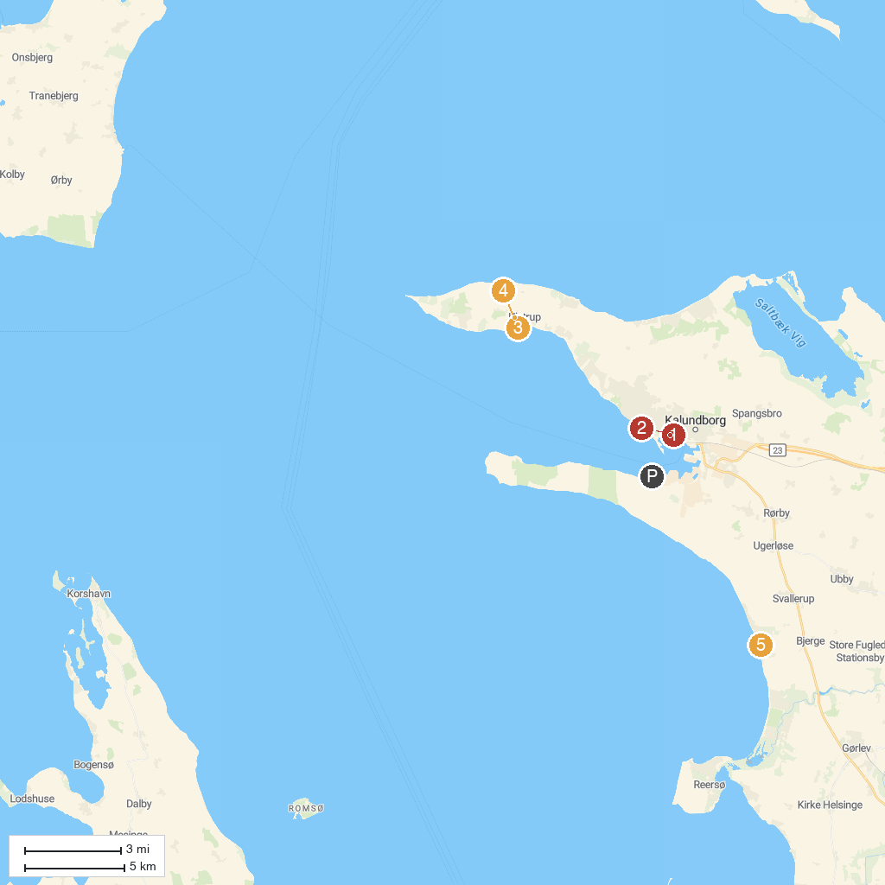
MAP KEY
1. The Bishop's House | 4. Ulstrup Mølle
2. Kalundborg Museum | 5. Bjerge Nordstrand
3. Ulstrup Strand
P. Cruise port / terminal
Map © MapTiler © OpenStreetMap contributors · cruiseports.org

