Kalvåg, Bremanger, Norway
One of Norway's most atmospheric fishing villages, Kalvåg packs century-old rorbuer cabins, world-class seafood, and dramatic coastal scenery into a tiny harbour on Bremanger's outer coast.
⚓ Quay (small vessels) · 🕒 Typical call: 6–8 hrs · 💳 Cashless — cards only (NOK) · 🗣️ Norwegian · 🦞 Seafood destination
✍️ MY DAY IN PORT (FILL IN)
Ship / Date
In port | arrive ______ · all aboard ______
Booked excursion
Notes / meeting point
GETTING ASHORE
- Docking: Public quay for smaller vessels; large ships may tender
- Walk to centre: Quay is in the village — everything within 5 min on foot
- Best For: Seafood, coastal atmosphere, hiking, floating sauna
- Don't Miss: Lunch at Knutholmen restaurant overlooking the harbour
GETTING AROUND
- 🚕 Taxi: Varies (contact ahead) — Eikeset Taxi (Pål Eikeset, +47 959 56 341) serves the Bremanger/Kalvåg area. Pre-booking recommended as availability is
TOP THINGS TO DO
- Knutholmen Seafood Experience — The Knutholmen complex is Kalvåg's centrepiece — a cluster of restored 19th-century sea-houses turned into a restaurant and pub.
- Flona Coastal Walk — An easy loop from the village giving panoramic views over the open sea and breaking Atlantic waves.
- Mount Hornelen Hike — Europe's highest sea cliff (860 m) rises dramatically from the Frøysjøen strait near Kalvåg.
- Floating Sauna — Kok og Bad — Step into a traditional Norwegian sauna moored in Kalvåg harbour, then plunge into the sea for a bracing dip.
- Vingen Rock Carvings — One of Scandinavia's largest concentrations of Stone Age rock carvings sits in dramatic fjord scenery near Bremanger.
BEST WALKS
- Harbour Waterfront Stroll: 30 min · Flat · All abilities — Walk the full length of Kalvåg's harbour past restored rorbuer cabins, the Knutholmen complex, and…
- Flona Coastal Loop: 1.5–2 hrs · Easy · Panoramic sea views — Follow the Flona trail from the village edge out to the open coast for sweeping Atlantic views…
WEATHER · DAYLIGHT · MONEY
Month | High °F | Low °F | Rainy days
May | 52 | 45 | 16
Jul | 61 | 54 | 18
Sep | 58 | 51 | 20
Daylight: May 4:49AM–10:26PM · Jul 4:26AM–11:04PM · Sep 7:07AM–8:02PM
cruiseports.org/kalvag · Confirm terminal & all-aboard time with your ship

Kalvåg, Bremanger, Norway — Port Map
Red = walkable sights · Amber = excursions farther out · P = cruise terminal
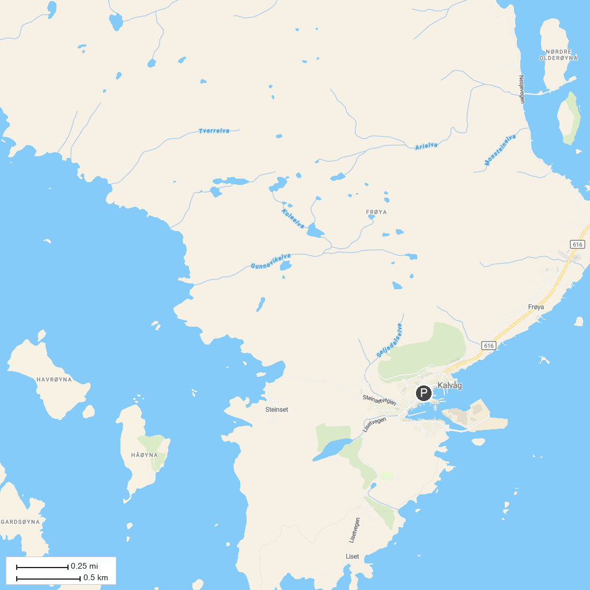
MAP KEY
1. Coastal Museum in Sogn og Fjordane | 3. Ellingskarshornet
2. Brandsøyåsen Viewpoint | 4. Måløyraid Senteret
P. Cruise port / terminal
Map © MapTiler © OpenStreetMap contributors · cruiseports.org

