Kangaamiut, Qeqqata, Greenland
A living Arctic fishing settlement perched on rocky hills at the mouth of two dramatic fjords. No cruise terminal, no tourist traps — just Greenland as it actually is.
⚓ Tender port (no pier) · 🕒 Typical call: 4–6 hrs · 💵 Danish Krone (DKK) — bring cash for crafts · 🗣️ Greenlandic (Kalaallisut) & Danish
✍️ MY DAY IN PORT (FILL IN)
Ship / Date
In port | arrive ______ · all aboard ______
Booked excursion
Notes / meeting point
GETTING ASHORE
- Docking: Tender only — ships anchor offshore, tenders land at Kangaamiut Village Quay
- Walk to center: Immediate — you step off the tender into the village
- Best For: Arctic culture, photography, short hikes, authentic Greenlandic life
- Don't Miss: The small village museum and its historic ivory and soapstone carvings
GETTING AROUND
TOP THINGS TO DO
- Village Museum & Historic Carvings — Kangaamiut was a celebrated carving center in the 1920s–30s.
- Hilltop Hike for Fjord Views — A short, steep hike above the village rewards with panoramic views of Kangaamiut Kangerluarsuat Fjord and, on clear days…
- Fjord Wildlife Spotting — The fjords around Kangaamiut host seals, seabirds, and occasionally whales.
- Local Crafts & Pilersuisoq Store — Local artisans sometimes sell carvings and handicrafts on call days — bring small DKK bills, as cash-only.
BEST WALKS
- Village Loop & Hilltop Viewpoint: 1.5–2 km | 45–90 min | Uneven rocky paths — From the tender quay, walk through the colorful painted houses along the waterfront, then climb the…
WEATHER · DAYLIGHT · MONEY
Month | High °F | Low °F | Rainy days
May | 36 | 29 | 8
Jul | 54 | 45 | 9
Sep | 43 | 34 | 11
Daylight: Sep 7:55AM–8:59PM
cruiseports.org/kangaamiut · Confirm terminal & all-aboard time with your ship

Kangaamiut, Qeqqata, Greenland — Port Map
Red = walkable sights · Amber = excursions farther out · P = cruise terminal
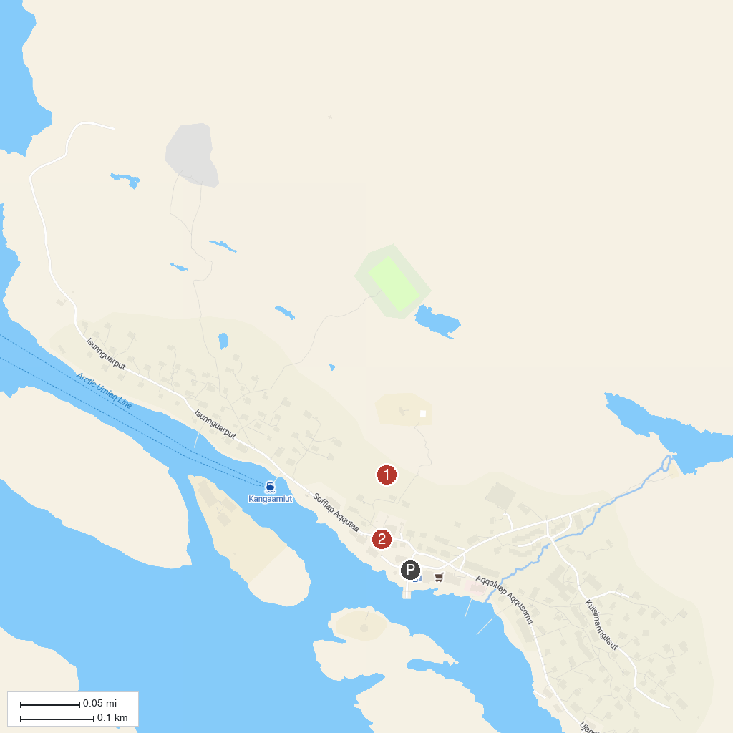
MAP KEY
1. Kangaamiut Old Colonial Buildings | 2. Kangaamiut Church
P. Cruise port / terminal
Map © MapTiler © OpenStreetMap contributors · cruiseports.org

