Kangaroo Island, South Australia, Australia
A zoo without fences, Australia's third-largest island is a sanctuary of wild sea lions, ancient granite boulders, and some of the country's best honey and gin — all just a tender ride from your ship.
⚓ Tender port (no pier) · 🕒 Typical call: 8-10 hrs · 💵 Australian Dollar (AUD) · 🗣️ English · 🦘 Wildlife & nature
✍️ MY DAY IN PORT (FILL IN)
Ship / Date
In port | arrive ______ · all aboard ______
Booked excursion
Notes / meeting point
GETTING ASHORE
- Docking: Tender to Penneshaw Jetty
- Walk to center: ~400 m uphill from the jetty
- Best For: Wildlife encounters, pristine beaches, food & wine
- Don't Miss: Seal Bay sea lions or Remarkable Rocks (both need a tour)
GETTING AROUND
- 🚕 Taxi: Varies by group size — Kangaroo Island Tours & Bus Charters offers fixed-price taxi and minibus charters. Ideal for small groups wanting flexib
- 📱 Rideshare: ❌ not available
TOP THINGS TO DO
- Seal Bay Conservation Park — Walk a guided beach tour among a wild colony of endangered Australian sea lions.
- Remarkable Rocks & Admirals Arch — Enormous lichen-stained granite boulders perched above the Southern Ocean at the western tip of Flinders Chase National Park.
- Dudley Wines & Kangaroo Island Spirits — Dudley Wines sits on a cliff overlooking Backstairs Passage — grab a pizza and a glass 15 minutes from port.
- Raptor Domain Bird Show — An acclaimed wildlife rescue and education center famous for its in-flight bird of prey show — owls, eagles, and falcons fly over…
- Stokes Bay Hidden Beach — Walk through a boulder labyrinth to emerge onto a hidden white-sand beach with a natural rock pool — voted Australia's best beach…
BEST WALKS
- Penneshaw Wallaby Track: 3 km loop · 1-1.5 hrs · Easy coastal path · Free — Start at the Penneshaw Jetty, follow the coastal track past the penguin interpretive display and…
- Penneshaw Sculpture Trail: 1.5 km · 30-45 min · Easy bushland path · Free — A gently winding trail through native bushland in the heart of Penneshaw, dotted with sculptures by…
WEATHER · DAYLIGHT · MONEY
Month | High °F | Low °F | Rainy days
May | 62 | 55 | 10
Jul | 57 | 51 | 13
Sep | 60 | 51 | 10
Daylight: May 7:07AM–5:21PM · Jul 7:25AM–5:22PM · Sep 6:18AM–6:09PM
cruiseports.org/kangaroo-island · Confirm terminal & all-aboard time with your ship

Kangaroo Island, South Australia, Australia — Port Map
Red = walkable sights · Amber = excursions farther out · P = cruise terminal
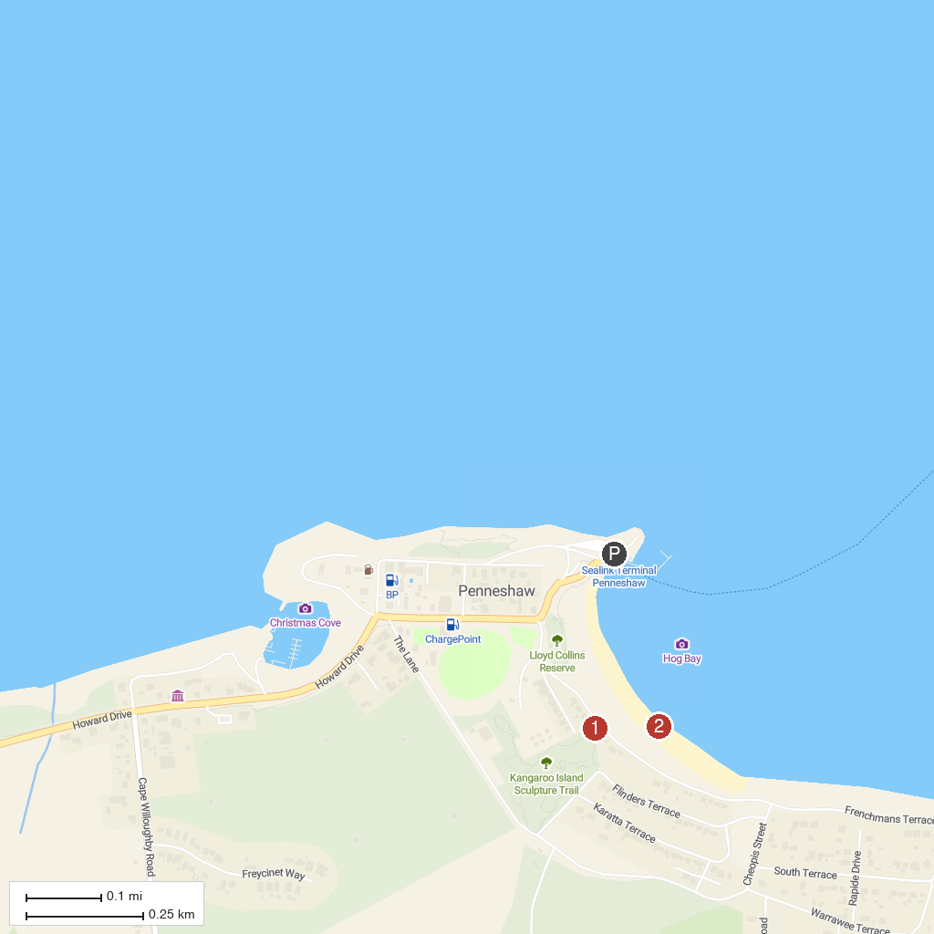
MAP KEY
1. Kangaroo Island Sculpture Trail | 2. Penneshaw Beach
P. Cruise port / terminal
Map © MapTiler © OpenStreetMap contributors · cruiseports.org

