Kangerlussuaq, Western Greenland, Greenland
Deep inside a 190 km fjord, Kangerlussuaq is one of the only places on Earth where you can drive to the Greenland Ice Sheet. Former Cold War air base, now Greenland's main airport — and a wildlife-rich tundra unlike any other Arctic port.
⚓ Tender (anchor in fjord) · 🕒 Typical call: 6-8 hrs · 💵 Danish Krone (DKK) — cards widely accepted · 🗣️ Greenlandic & Danish · 🦌 10,000 musk ox on the tundra
✍️ MY DAY IN PORT (FILL IN)
Ship / Date
In port | arrive ______ · all aboard ______
Booked excursion
Notes / meeting point
GETTING ASHORE
- Docking: Tender / Zodiac — ships anchor in Kangerlussuaq Fjord; small expedition vessels may use the Royal Arctic Line supply quay
- Walk to center: Settlement is ~1 km from tender landing; all main excursions require transport (25 km to glacier)
- Best For: Ice sheet access, musk ox safaris, glacier walks, Arctic wildlife photography
- Don't Miss: Russell Glacier (25 km, drive-to ice wall) and Point 660 — walk on the Greenland Ice Sheet itself
GETTING AROUND
- 🚕 Taxi: 290–430 DKK — Only about 8 taxis serve the entire town and availability during cruise calls is very limited. The tender landing to set
TOP THINGS TO DO
- Russell Glacier & Ice Wall — Drive 25 km across tundra and river valleys to stand below a 60-meter vertical ice wall.
- Walk on the Greenland Ice Sheet (Point 660) — Drive to Point 660 and step onto the world's second-largest ice sheet.
- Musk Ox Tundra Safari — Around 10,000 musk oxen roam the Kangerlussuaq tundra — one of the highest densities anywhere.
- Kangerlussuaq Museum & Airbase History — The small local museum traces the US Air Force Sondrestrom Air Base era (WWII through Cold War) with artifacts, photos, and…
- Hiking: Lake Ferguson & Sugarloaf Mountain — Self-guided or guided hikes from the settlement.
BEST WALKS
- Settlement Stroll: Pier to Museum: 1.5 km | Easy | 20-30 min — Walk from the tender landing along the main road through the former airbase settlement, past the…
- Lake Ferguson Walk: ~8 km round trip | Moderate | 2.5-3 hrs — Follow the trail from the settlement out to Lake Ferguson — a glacially-fed lake on the tundra.
WEATHER · DAYLIGHT · MONEY
Month | High °F | Low °F | Rainy days
May | 44 | 31 | 6
Jul | 63 | 48 | 9
Sep | 44 | 33 | 8
Daylight: Sep 7:42AM–8:51PM
cruiseports.org/kangerlussuaq · Confirm terminal & all-aboard time with your ship

Kangerlussuaq, Western Greenland, Greenland — Port Map
Red = walkable sights · Amber = excursions farther out · P = cruise terminal
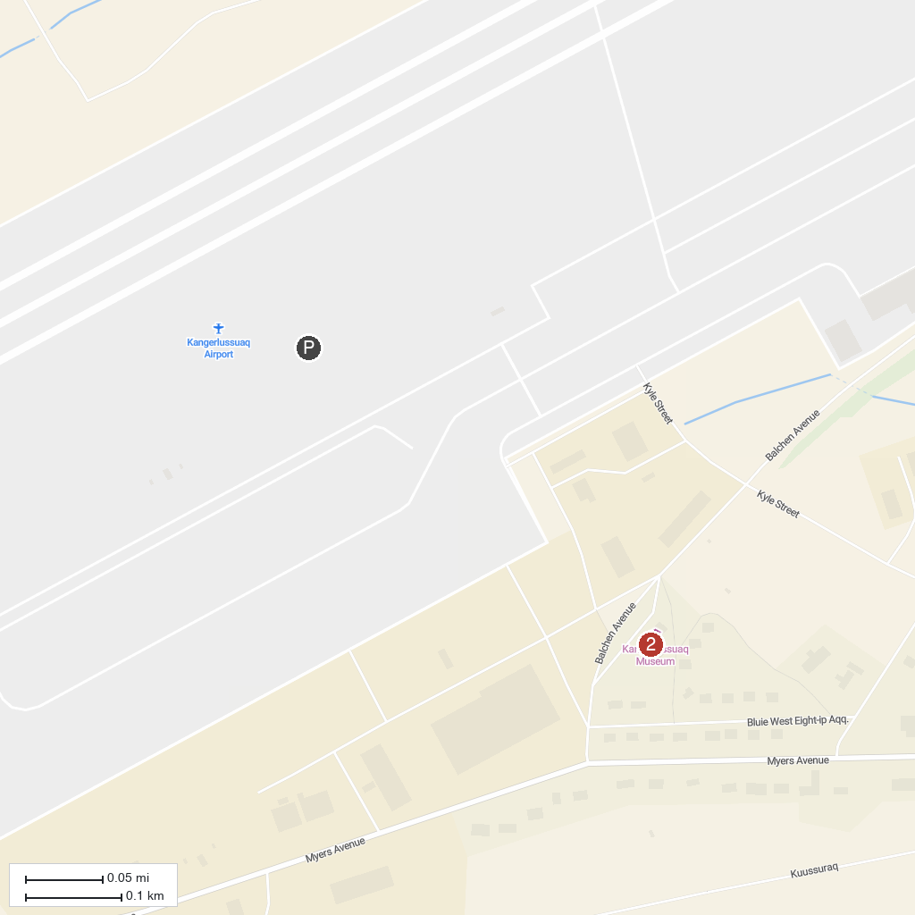
MAP KEY
1. Russell Glacier | 3. Sugar Loaf Mountain
2. Greenland Ice Sheet Edge | 4. Kangerlussuaq Museum
P. Cruise port / terminal
Map © MapTiler © OpenStreetMap contributors · cruiseports.org

