Kaohsiung, Taiwan
Taiwan's second city has reinvented itself from industrial port to one of Asia's most walkable, photogenic cruise destinations — with two brand-new terminals, a harbourside light rail, and legendary street food minutes from the gangway.
⚓ Docked (pier) · 🕒 Typical call: 8-10 hrs · 💵 New Taiwan Dollar (NT$) · 🗣️ Mandarin / Taiwanese · 🚋 Light Rail to city centre
✍️ MY DAY IN PORT (FILL IN)
Ship / Date
In port | arrive ______ · all aboard ______
Booked excursion
Notes / meeting point
GETTING ASHORE
- Docking: Pier — two dedicated cruise terminals; no tendering
- Walk to centre: 5 min walk or 1 LRT stop to Pier-2 Art District
- Best For: Street food, harbour art, Cijin Island day trip
- Don't Miss: Dragon & Tiger Pagodas at Lotus Pond
GETTING AROUND
- 🚕 Taxi: $5–7 USD (NT$150–220) — Metered taxis are plentiful at the port. A ride to central Kaohsiung is approximately 3–5 km and takes under 10 minutes.
- 📱 Rideshare: ✅ Uber
- 🚌 Hop-on hop-off: ✅
TOP THINGS TO DO
- Pier-2 Art Center & Harbour Walk — Warehouses from the 1950s transformed into galleries, giant murals, whimsical street sculptures and indie cafes.
- Cijin Island Ferry Day — A 5-minute ferry (NT$30 cash, ~NT$20 with an iPASS card) delivers you to a narrow island with Taiwan's best cheap seafood street…
- Dragon & Tiger Pagodas, Lotus Pond — Kaohsiung's most iconic image — enter the dragon's mouth and exit the tiger's to turn bad luck to good.
- British Consulate at Takow — Taiwan's oldest Western building (1879), a two-storey colonial-era red-brick residence on a hilltop above Gushan with sweeping…
- Fo Guang Shan Buddha Museum — A world-scale Buddhist complex crowned by the Fo Guang Big Buddha — a 40-metre golden-bronze seated statue rising to 108 metres…
BEST WALKS
- Harbour Art Walk: 2 km · 30 min · flat — Stroll the water's edge from the cruise terminal past the Great Harbour Swing Bridge, along the LRT…
- Cijin Old Street & Beach: 1.5 km loop · 20 min walking · flat — After the 5-minute ferry from Gushan Pier, walk Cijin Old Street for live-seafood restaurants and…
WEATHER · DAYLIGHT · MONEY
Month | High °F | Low °F | Rainy days
May | 86 | 76 | 17
Jul | 88 | 79 | 23
Sep | 87 | 78 | 19
Daylight: May 5:18AM–6:31PM · Jul 5:23AM–6:46PM · Sep 5:45AM–6:02PM
cruiseports.org/kaohsiung · Confirm terminal & all-aboard time with your ship

Kaohsiung, Taiwan — Port Map
Red = walkable sights · Amber = excursions farther out · P = cruise terminal
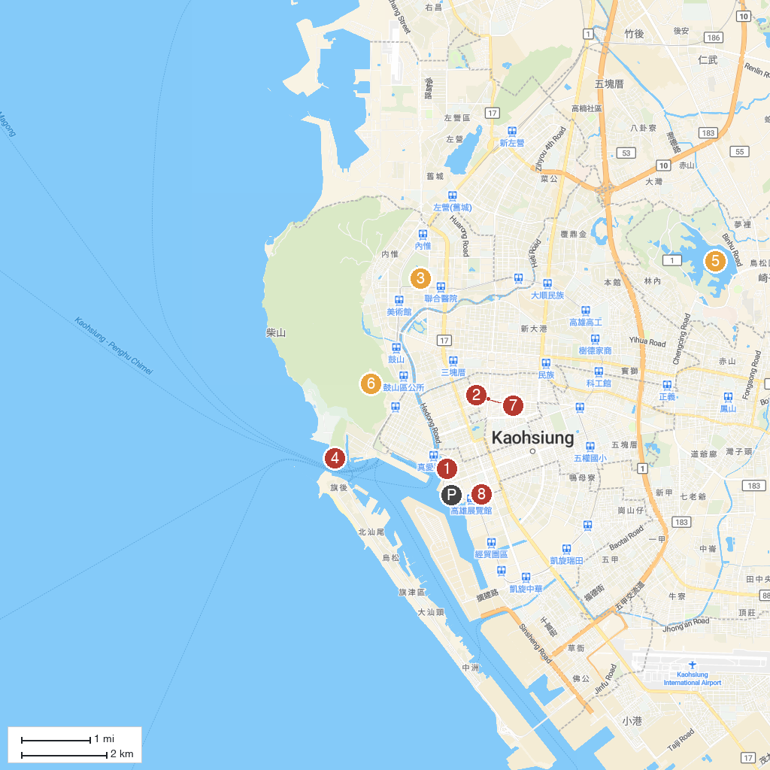
MAP KEY
1. Glory Pier | 5. Chengcing Lake
2. Liouhe Night Market | 6. Shoushan Zoo
3. Kaohsiung Museum of Fine Arts | 7. Dome of Light
4. The British Consulate at Takow | 8. Kaohsiung 85 Observatory
P. Cruise port / terminal
Map © MapTiler © OpenStreetMap contributors · cruiseports.org

