Kaunakakai, Molokai, Hawaii, USA
The Friendly Isle resists resort culture entirely. Kaunakakai's wooden storefronts, royal coconut grove, and fiercely protected Native Hawaiian way of life make this the most genuine stop in all of Hawaii.
⚓ Docked at pier (small ships only) · 🕒 Typical call: 6-8 hrs · 💵 USD · 🗣️ English / Hawaiian · 🏝️ No chain stores or traffic lights
✍️ MY DAY IN PORT (FILL IN)
Ship / Date
In port | arrive ______ · all aboard ______
Booked excursion
Notes / meeting point
GETTING ASHORE
- Docking: Kaunakakai Wharf (1,900 ft pier); small expedition ships dock; some anchor and skiff ashore
- Walk to center: ~1 mile (1.6 km) flat paved walk from pier end to Ala Malama Ave; no shade
- Best For: Native Hawaiian culture, unspoiled scenery, local food, history
- Don't Miss: Kapuaiwa Coconut Grove, Kanemitsu Bakery hot bread, Kalaupapa Lookout
GETTING AROUND
- 🚕 Taxi: ~/mile — Hele Mai Taxi meets tenders at the dock and runs island-wide. Essential for reaching sights like Halawa Valley or Papoha
- 📱 Rideshare: ✅ Uber
TOP THINGS TO DO
- Halawa Valley Cultural Hike — One of Hawaii's oldest inhabited valleys, reachable only with a local guide from the Solatorio family, the valley's last resident…
- Kalaupapa Lookout at Palaau State Park — A short forest walk at Palaau State Park leads to a dramatic overlook of the Kalaupapa Peninsula — the isolated settlement where…
- Kapuaiwa Coconut Grove & Church Row — Planted in the 1860s for King Kamehameha V, this royal coconut grove is one of the last in Hawaii.
- Molokai Plumeria Farm — Just five minutes from the pier, this fragrant working farm lets you pick plumerias and learn to string a traditional Hawaiian…
- Purdy's Macadamia Nut Farm — A family-run organic farm in Hoolehua where you crack raw macadamia nuts straight off the tree.
BEST WALKS
- Ala Malama Avenue Town Stroll: 0.5 mi · Flat · 30 min · Free — Walk the full length of Kaunakakai's main street from the harbor end to the far shops.
- Pier to Coconut Grove Walk: ~2.5 mi one-way · Flat · 45-60 min · Free — Head west along Kamehameha V Highway from the wharf entrance to reach Kapuaiwa Coconut Grove and…
WEATHER · DAYLIGHT · MONEY
Month | High °F | Low °F | Rainy days
May | 83 | 72 | 5
Jul | 86 | 75 | 3
Sep | 87 | 76 | 4
Daylight: May 5:50AM–6:58PM · Jul 5:55AM–7:12PM · Sep 6:15AM–6:30PM
cruiseports.org/kaunakakai · Confirm terminal & all-aboard time with your ship

Kaunakakai, Molokai, Hawaii, USA — Port Map
Red = walkable sights · Amber = excursions farther out · P = cruise terminal
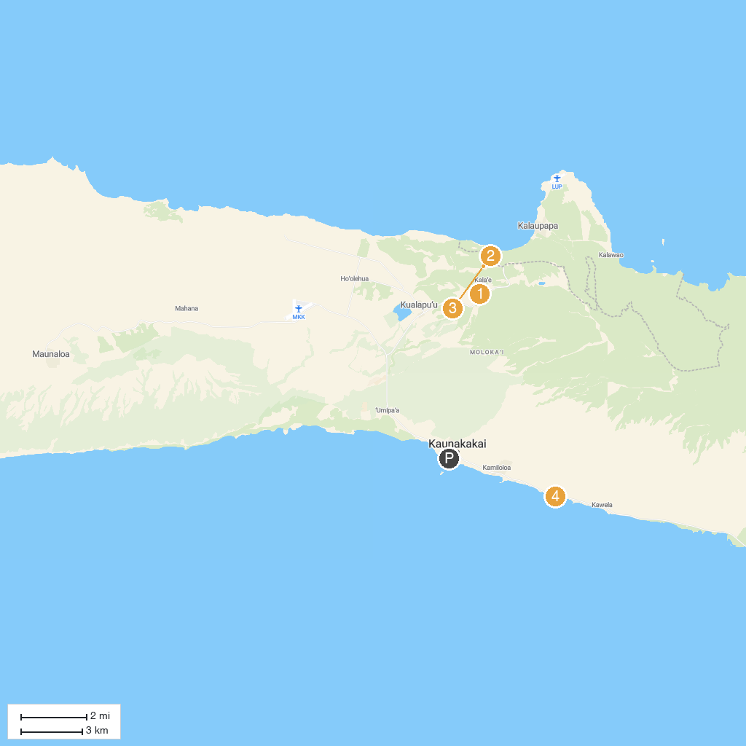
MAP KEY
1. Molokai Museum & Cultural Center | 4. Pālāʻau State Park
2. Kalaupapa Lookout | 5. One Ali’i Park
3. Kalaupapa National Historical Park
P. Cruise port / terminal
Map © MapTiler © OpenStreetMap contributors · cruiseports.org

