Keelung, Northern Taiwan, Taiwan
Taiwan's busiest cruise hub drops you steps from a legendary night market and a fast train to Taipei — but the hillside teahouses of Jiufen may steal the day.
⚓ Docked (cruise terminal) · 🕒 Typical call: 8-10 hrs · 💵 New Taiwan Dollar (NT$) · 🗣️ Mandarin Chinese
✍️ MY DAY IN PORT (FILL IN)
Ship / Date
In port | arrive ______ · all aboard ______
Booked excursion
Notes / meeting point
GETTING ASHORE
- Docking: Docked at E2 or W2 terminal, downtown Keelung — no tender required
- Walk to center: 5-min walk to Miaokou Night Market; 10-min walk to train station
- Best For: Taipei day trips, Jiufen old town, Yehliu rock formations, street food
- Don't Miss: Jiufen Old Street teahouses and Keelung Miaokou Night Market
GETTING AROUND
- 🚕 Taxi: NT$1,000–1,200 (~US$32–38) — Metered taxis are readily available at the port. Journey to Taipei city center takes 30–40 minutes depending on traffic;
- 📱 Rideshare: ✅ Uber, Bolt
- 🚌 Hop-on hop-off: ✅ Keelung Double-Decker Sightseeing Bus
TOP THINGS TO DO
- Taipei City Highlights — Taipei 101's observatory, Chiang Kai-shek Memorial Hall, and the National Palace Museum's imperial art collection — the classic…
- Jiufen Old Street — Narrow, lantern-lit lanes, atmospheric teahouses perched above the sea, and hillside alley shops — this former gold-mining town…
- Yehliu Geopark — Bizarre sea-eroded rock formations along the north coast, including the famous 'Queen's Head' mushroom rock.
- Shifen Sky Lanterns & Waterfall — Write a wish on a paper sky lantern and release it over Shifen Old Street's railway tracks, then walk to the Shifen Waterfall…
- Keelung Miaokou Night Market — One of Taiwan's most famous food markets, operating day and night beside the Dianji Temple.
BEST WALKS
- Pier to Miaokou Night Market: 0.5 km · 5 min · flat · all abilities — Exit the terminal onto Gangxi Road and walk inland to the Dianji Temple precinct — you'll smell the…
- Harbour Waterfront & Keelung Tower: 1.5 km · 20 min · flat · scenic — Stroll the harbour promenade past fishing boats and seafood restaurants to the Keelung Tower at…
- Zhongzheng Park & Guanyin Statue: 2 km round-trip · 45 min · uphill · good views — From the terminal walk to the base of Zhongzheng Park and climb the zigzag steps (or take a short…
WEATHER · DAYLIGHT · MONEY
Month | High °F | Low °F | Rainy days
May | 81 | 73 | 20
Jul | 88 | 80 | 16
Sep | 84 | 78 | 18
Daylight: May 5:08AM–6:30PM · Jul 5:12AM–6:45PM · Sep 5:39AM–5:57PM
cruiseports.org/keelung · Confirm terminal & all-aboard time with your ship

Keelung, Northern Taiwan, Taiwan — Port Map
Red = walkable sights · Amber = excursions farther out · P = cruise terminal
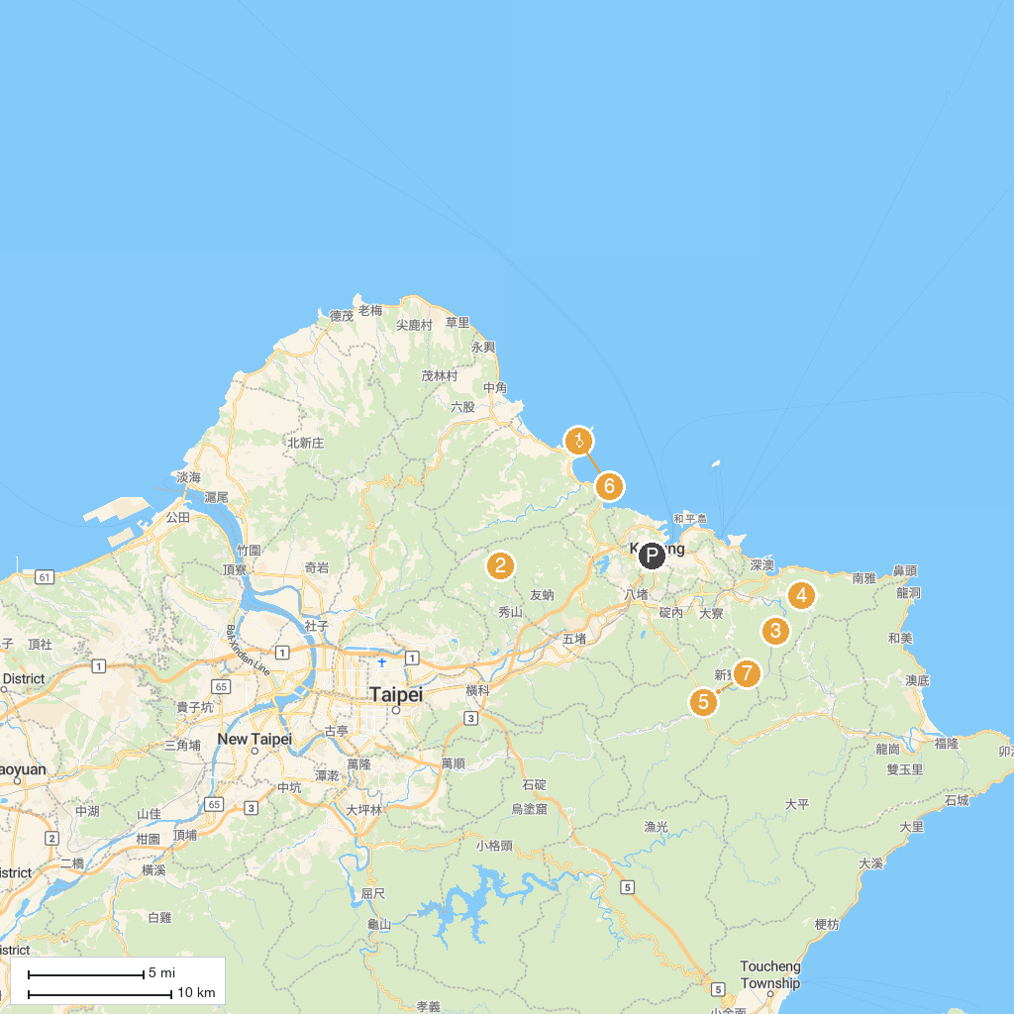
MAP KEY
1. Yehliu Geopark | 5. Gold Museum, New Taipei City Government
2. 新山夢湖 | 6. Shifen Old Street
3. Houtong Cat Village | 7. Yehliu Ocean World
4. Jiufen Old Street | 8. Shifen Waterfall
P. Cruise port / terminal
Map © MapTiler © OpenStreetMap contributors · cruiseports.org

