Kehl-Strasbourg, Baden-Wurttemberg, Germany
A border-crossing Rhine call with Germany on one bank and France on the other. Kehl gives you parks and easy tram access, while Strasbourg brings the cathedral, canals, Petite France, and Alsatian winstubs into a single shore day.
⚓ Docked river port · 🕒 Typical call: 6-9 hrs · 💶 Euro (EUR) · 🗣️ German / French
✍️ MY DAY IN PORT (FILL IN)
Ship / Date
In port | arrive ______ · all aboard ______
Booked excursion
Notes / meeting point
GETTING ASHORE
- Docking: River ships dock at Kehl or Strasbourg river berths; no tendering
- Walk to Center: Kehl center 10-20 min from many berths; Strasbourg old town is best by tram, shuttle, taxi, or excursion
- Best For: Strasbourg Cathedral, Petite France, Rhine parks, Christmas markets, Alsatian food
- Don't Miss: Passerelle des Deux Rives, Cathédrale Notre-Dame de Strasbourg, Barrage Vauban
GETTING AROUND
- 🚕 Taxi: €26–€70 — Taxis meet ships at the dock. The shorter Kehl-station area to Strasbourg centre run is around €26–€31; expect more for
- 📱 Rideshare: ✅ Uber, Bolt
TOP THINGS TO DO
- Strasbourg Cathedral & Grand Île — Explore the UNESCO-listed island heart of Strasbourg, anchored by the soaring Cathédrale Notre-Dame and its astronomical clock.
- Petite France & Barrage Vauban — Strasbourg's most atmospheric quarter is a canal-side maze of half-timbered houses, old mills, and bridges.
- Batorama Canal Cruise — A covered sightseeing boat loop gives you La Petite France, the Neustadt, and the European Quarter without retracing your steps…
- European Quarter — Strasbourg is one of Europe's institutional capitals.
- Alsatian Winstub Lunch — Use your independent time for tarte flambée, choucroute garnie, kougelhopf, Riesling, or Crémant d'Alsace in a traditional…
BEST WALKS
- Kehl Rhine Park & Border Bridge: 2-4 km • 45-90 min • Flat riverside paths — A simple local walk from Kehl's riverfront through the Rhine gardens and across the Passerelle des…
- Strasbourg Old Town Loop: 3 km • 2-3 hrs • Mostly flat cobbles — Ride Tram D or take your ship transfer into central Strasbourg, then loop from the cathedral…
- Kehl Center Coffee Walk: 1.5-2 km • 30-60 min • Easy — If you have a short call or have already seen Strasbourg, walk into Kehl for cafés, pharmacies, and…
WEATHER · DAYLIGHT · MONEY
Month | High °F | Low °F | Rainy days
May | 67 | 50 | 13
Jul | 79 | 62 | 11
Sep | 71 | 55 | 9
Daylight: May 5:48AM–9:02PM · Jul 5:42AM–9:25PM · Sep 7:05AM–7:40PM
cruiseports.org/kehl-strasbourg · Confirm terminal & all-aboard time with your ship

Kehl-Strasbourg, Baden-Wurttemberg, Germany — Port Map
Red = walkable sights · Amber = excursions farther out · P = cruise terminal
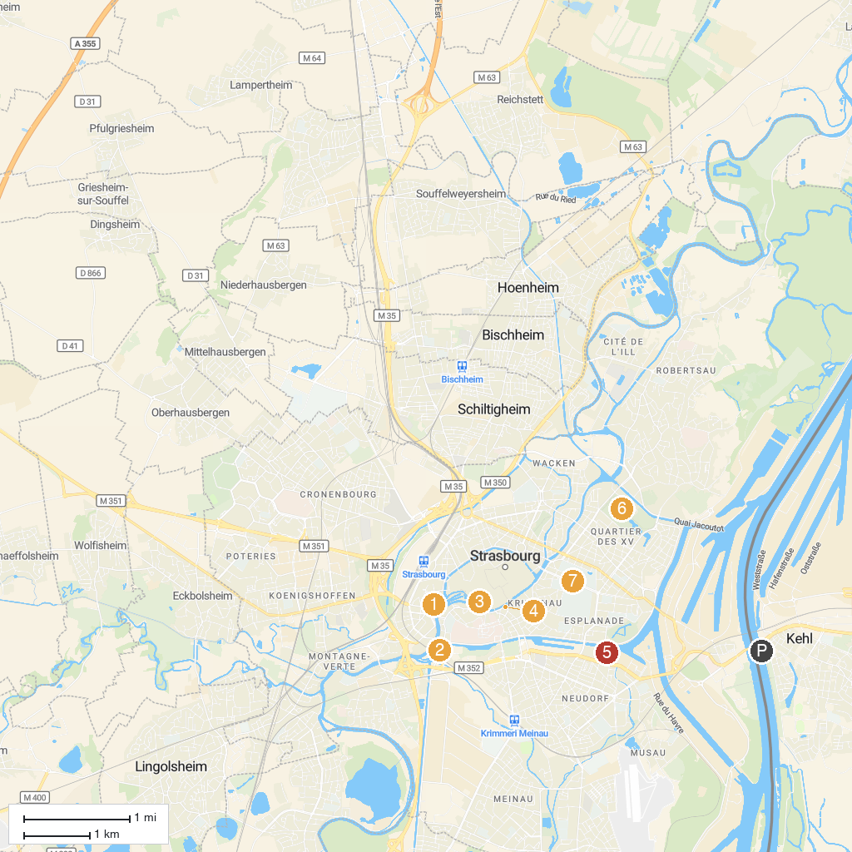
MAP KEY
1. Strasbourg Museum of Modern and Contemporary Art | 5. Le Vaisseau
2. Grande Mosquée de Strasbourg | 6. Parc de l'Orangerie
3. St. Thomas Church | 7. Musée zoologique de Strasbourg
4. Alsatian Museum
P. Cruise port / terminal
Map © MapTiler © OpenStreetMap contributors · cruiseports.org

