Kelheim, Bavaria, Germany
Kelheim sits where the Altmühl, Danube, and Main-Danube Canal meet, making it a natural hinge point for European river cruises. The best shore day pairs a riverside old-town walk with the Danube Gorge boat ride to Weltenburg Abbey or the hilltop Liberation Hall.
⚓ River quay (docked) · 🕒 Typical call: 4–7 hrs · 💶 Currency: Euro (€) · 🗣️ Language: German · 🍺 Abbey brewery country
✍️ MY DAY IN PORT (FILL IN)
Ship / Date
In port | arrive ______ · all aboard ______
Booked excursion
Notes / meeting point
GETTING ASHORE
- Docking: River berth in Kelheim; river ships dock rather than tender
- Walk to center: Usually 5–10 minutes to Ludwigsplatz and the old town
- Best For: Danube Gorge scenery, Bavarian beer gardens, hilltop views
- Don't Miss: Weltenburg Abbey by boat through the Danube Gorge
GETTING AROUND
- 🚕 Taxi: €5–€8 — Local taxis use the official Kelheim district tariff: €4.50 base fare plus €1.20/km. The short distance from the pier to
TOP THINGS TO DO
- Danube Gorge Boat Ride — Board a local excursion boat from Kelheim for the dramatic run through the Donaudurchbruch, where the Danube narrows between…
- Weltenburg Abbey — The Benedictine abbey at Weltenburg sits beside the river at the upstream end of the gorge.
- Liberation Hall — Befreiungshalle crowns Michelsberg above Kelheim, a monumental 19th-century rotunda commissioned by King Ludwig I.
- Kelheim Old Town — Stay close to the ship for Ludwigsplatz, pastel Bavarian facades, medieval town gates, small shops, and cafes.
- Bavarian Beer Garden Lunch — Pair the shore day with pretzels, Obatzda, sausages, pork roast, or local wheat beer.
BEST WALKS
- Old Town and River Gates: 1.5–2 km | 45–75 min | Easy — From the river landing, walk into the old town for Ludwigsplatz and Kelheim's surviving gates, then…
- Liberation Hall View Walk: 3–4 km round trip | 1.5–2 hrs | Moderate uphill — Climb from the old town toward Befreiungshalle for the classic panorama over Kelheim and the rivers.
- Weltenburg Abbey Arrival Stroll: Under 1 km | 30–45 min | Easy — After the gorge boat lands at Weltenburg, walk from the landing area to the abbey church…
WEATHER · DAYLIGHT · MONEY
Month | High °F | Low °F | Rainy days
May | 65 | 48 | 15
Jul | 77 | 59 | 11
Sep | 68 | 52 | 10
Daylight: May 5:30AM–8:47PM · Jul 5:25AM–9:11PM · Sep 6:49AM–7:24PM
cruiseports.org/kelheim · Confirm terminal & all-aboard time with your ship

Kelheim, Bavaria, Germany — Port Map
Red = walkable sights · Amber = excursions farther out · P = cruise terminal
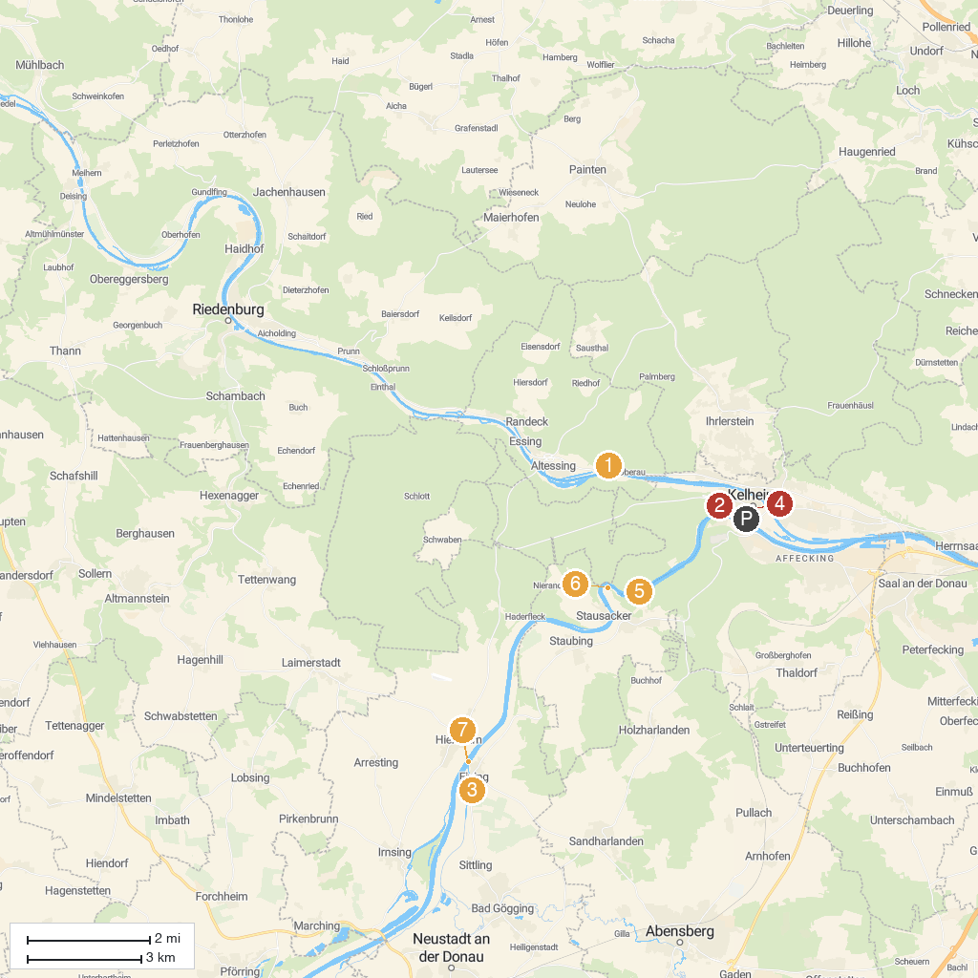
MAP KEY
1. Flowstone cave Schulerloch | 5. Danube Gorge
2. Liberation Hall | 6. Weltenburg Abbey
3. Römerkastell Abusina | 7. Fähre Eining-Hienheim
4. Archaeological Museum Kelheim | 8. Schönwerth Märchenpfad
P. Cruise port / terminal
Map © MapTiler © OpenStreetMap contributors · cruiseports.org

