Kemi, Lapland, Finland
Kemi is Finnish Lapland's sea gate: an industrial Gulf of Bothnia port with real Arctic character just beyond the gangway. The shore day works best as a shuttle-assisted mix of year-round ice, quiet waterfront cafes and low-key northern nature.
⚓ Docked at Ajos · 🕒 Typical call: 6-10 hrs · 💶 Currency: Euro · 🗣️ Finnish; English common
✍️ MY DAY IN PORT (FILL IN)
Ship / Date
In port | arrive ______ · all aboard ______
Booked excursion
Notes / meeting point
GETTING ASHORE
- Docking: Alongside at Ajos harbour
- Walk to center: Not walkable; 10-12 km
- Best For: Arctic ice, nature, quiet town walks
- Don't Miss: SnowExperience365 or Kiikeli
GETTING AROUND
- 🚕 Taxi: €25–€40 — Ajos Harbor is ~10–12 km from the city center. Taxis are the most reliable option; some companies (e.g. Menevä) offer fi
- 📱 Rideshare: ✅ Uber
TOP THINGS TO DO
- SnowCastle & SnowExperience365 — Visit Kemi's SnowCastle area and the year-round chilled SnowExperience365 room for ice sculptures, an ice slide and Arctic photos…
- Icebreaker Sampo — On winter and early spring calls, the famous icebreaker cruise can include a ship tour, frozen-sea scenery and floating in a…
- Kiikeli Nature Trail — A gentle forest-and-shore walk from the Inner Harbour leads to birdlife, sea views and a lookout tower on a small protected…
- Kemi Church & Cultural Centre — Pair the red-brick Kemi Church with the town's museum and art collections for a compact look at northern Finnish life and…
- Gemstone Gallery — See gemstones, replicas of famous crowns and the unusual crown designed for Finland's short-lived 1918 monarchy plan.
BEST WALKS
- SnowCastle to Inner Harbour: Easy, 20-40 minutes plus stops — A short waterfront stroll linking the SnowCastle area, Mansikkanokka beach and the old Inner…
- Kiikeli Nature Reserve: Easy, 1-2 hours — Cross from the Inner Harbour onto Kiikeli for a peaceful forest path, Gulf of Bothnia views and a…
- Town Center Landmarks: Easy, 45-90 minutes — Use this simple town walk for Kemi Church, the cultural center and central cafes when the weather…
WEATHER · DAYLIGHT · MONEY
Month | High °F | Low °F | Rainy days
May | 50 | 37 | 10
Jul | 67 | 56 | 12
Sep | 54 | 46 | 12
Daylight: Sep 6:43AM–7:48PM
cruiseports.org/kemi · Confirm terminal & all-aboard time with your ship

Kemi, Lapland, Finland — Port Map
Red = walkable sights · Amber = excursions farther out · P = cruise terminal
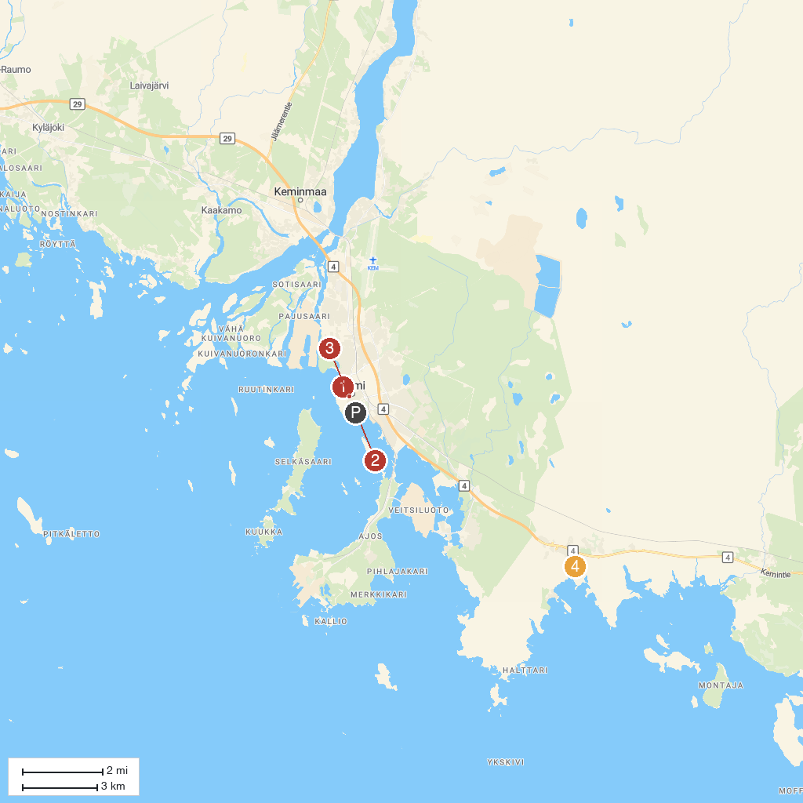
MAP KEY
1. Kemi Historical Museum | 3. Kemi Church
2. The SnowCastle of Kemi | 4. Arkadia Reindeerfarm
P. Cruise port / terminal
Map © MapTiler © OpenStreetMap contributors · cruiseports.org

