Key West, Florida, USA
America's southernmost city packs Hemingway bars, coral reef snorkeling, and a legendary nightly sunset celebration into a compact, walkable island — all steps from the ship.
⚓ Docked (3 piers) · 🕒 Typical call: 7-9 hrs · 💵 USD · 🗣️ English
✍️ MY DAY IN PORT (FILL IN)
Ship / Date
In port | arrive ______ · all aboard ______
Booked excursion
Notes / meeting point
GETTING ASHORE
- Docking: Mallory Square Dock and Pier B; Navy Outer Mole use depends on the sailing’s confirmed berth — check cruise-line documents
- Walk to center: Steps from Mallory/Pier B; if assigned Navy Outer Mole, confirm authorized transfer arrangements with your cruise line
- Best For: Reef snorkeling, Old Town bars and history, walking Duval Street
- Don't Miss: Mallory Square Sunset Celebration (if ship departs late afternoon or evening)
GETTING AROUND
- 🚕 Taxi: $10-15 (metered) — Confirm the current port-origin meter or group fare with the driver before boarding. As checked 3 October 2026, Key West
- 📱 Rideshare: ✅ Uber, Lyft
- 🚌 Hop-on hop-off: ✅ Old Town Trolley Tours
TOP THINGS TO DO
- Coral Reef Snorkeling — The Florida Reef — the only living coral barrier reef in the continental U.S.
- Ernest Hemingway Home & Museum — Tour the Spanish Colonial house where Hemingway lived and wrote classics like 'To Have and Have Not.' The roughly 60 polydactyl…
- Conch Tour Train or Old Town Trolley — The fastest way to get an overview — narrated 90-minute loop through all of Key West's major sites.
- Kayak & Eco-Tour in the Backcountry — Paddle through the mangrove islands of the Great White Heron National Wildlife Refuge north of Key West — a flat-water escape…
- Fort Zachary Taylor Beach — The best beach accessible from the cruise port — clear water, good shade, and a historic Civil War fort.
BEST WALKS
- Old Town Heritage Walk: 2 miles • 1-1.5 hrs • Easy/flat — The classic loop from the port through Key West's historic core — past Mallory Square, down Duval…
- Historic Seaport & Waterfront Stroll: 1 mile • 30-45 min • Easy — Head east along the waterfront from the cruise piers through the Historic Seaport — charter boats…
WEATHER · DAYLIGHT · MONEY
Month | High °F | Low °F | Rainy days
May | 81 | 78 | 11
Jul | 85 | 82 | 15
Sep | 84 | 81 | 19
Daylight: May 6:43AM–8:03PM · Jul 6:48AM–8:18PM · Sep 7:13AM–7:30PM
ESSENTIAL TRAVEL QUALIFICATIONS
Confirm assigned berth and Navy Mole shore-access/transfer arrangements with cruise line. Duval Loop current operation unconfirmed; not a free-service promise. Confirm current port-origin taxi fare, not an airport tariff assumption.
cruiseports.org/key-west · Confirm terminal & all-aboard time with your ship

Key West, Florida, USA — Port Map
Red = walkable sights · Amber = excursions farther out · P = cruise terminal
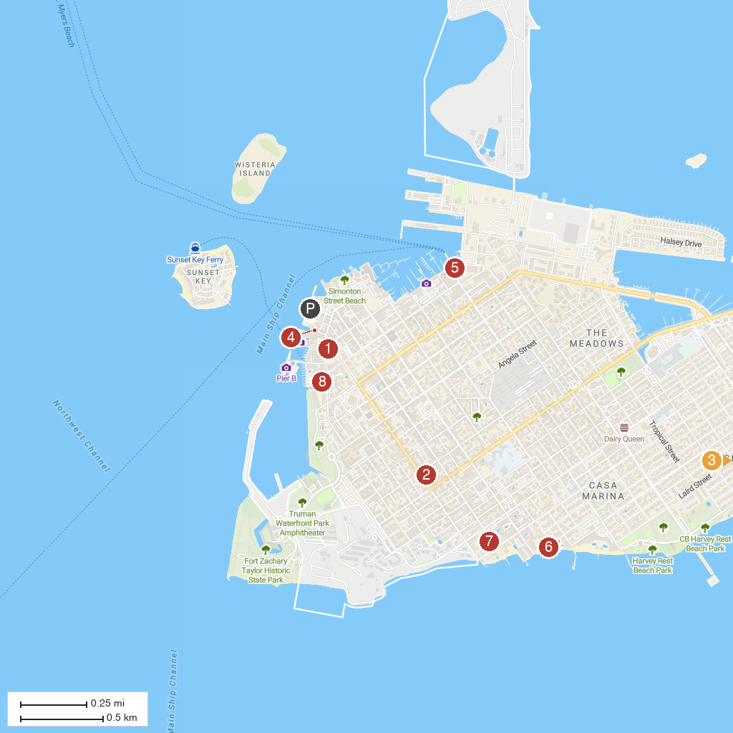
MAP KEY
1. Mel Fisher Maritime Museum | 5. Yankee Freedom Dry Tortugas Ferry
2. The Hemingway Home and Museum | 6. Barefoot Billy's Watersports - The Reach Resort
3. Smathers Beach | 7. The Key West Butterfly and Nature Conservatory
4. Key West Aquarium | 8. Truman Little White House
P. Cruise port / terminal
Map © MapTiler © OpenStreetMap contributors · cruiseports.org

