Khor Fakkan, Sharjah, UAE
Where jagged Hajar Mountains plunge into turquoise Gulf of Oman waters, this Sharjah exclave offers rugged hiking, coral-rich snorkeling, and a beautifully restored corniche — all without a skyscraper in sight.
⚓ Pier (shuttle to gate) · 🕒 Typical call: 7-9 hrs · 💵 UAE Dirham (AED) · 🗣️ Arabic / English widely spoken · 🚫 Dry emirate — no alcohol ashore
✍️ MY DAY IN PORT (FILL IN)
Ship / Date
In port | arrive ______ · all aboard ______
Booked excursion
Notes / meeting point
GETTING ASHORE
- Docking: Deep-water pier (6 quays); free shuttle to port gate
- Walk to Center: Not walkable — active industrial port; shuttle or taxi required
- Best For: Snorkeling, hiking, beaches, UAE history off the beaten path
- Don't Miss: Khor Fakkan Amphitheatre & the 45m-long waterfall carved into the mountain
GETTING AROUND
- 🚕 Taxi: AED 14 minimum (~) — Metered taxis follow Sharjah rates: AED 3 flag-fall by day, AED 14 minimum fare. Short city-center rides typically hit t
- 🚌 Hop-on hop-off: ✅ City Sightseeing Sharjah – Khorfakkan Tour
TOP THINGS TO DO
- Snorkel Shark Island (Sira Khorfakkan) — Hire a local boat to reach this rocky offshore islet — one of the UAE's top snorkel spots.
- Al Rabi Watchtower Hike — A well-marked 4-5 km round-trip trail from this 1915 defense tower climbs into the Hajar Mountains for panoramic views over the…
- Hisn Khor Fakkan Fort & Museum — This lovingly restored 1950s fort houses exhibits on the east coast's history, archaeological finds, and traditional Emirati life…
- Khor Fakkan Beach & Corniche — Three kilometres of crescent white sand with calm, warm Gulf of Oman water.
- Al Rafisah Dam Lake — A mountain lake ringed by greenery — a rare sight in the UAE.
BEST WALKS
- Corniche Promenade Walk: ⏱ 45-60 min one way · 🚶 Easy · 🌊 Waterfront — Follow the 3km seafront promenade from near the fort northward past the beach to the amphitheatre…
WEATHER · DAYLIGHT · MONEY
Month | High °F | Low °F | Rainy days
May | 98 | 77 | 0
Jul | 105 | 87 | 0
Sep | 102 | 82 | 0
Daylight: May 5:33AM–6:56PM · Jul 5:37AM–7:11PM · Sep 6:04AM–6:22PM
cruiseports.org/khor-fakkan · Confirm terminal & all-aboard time with your ship

Khor Fakkan, Sharjah, UAE — Port Map
Red = walkable sights · Amber = excursions farther out · P = cruise terminal
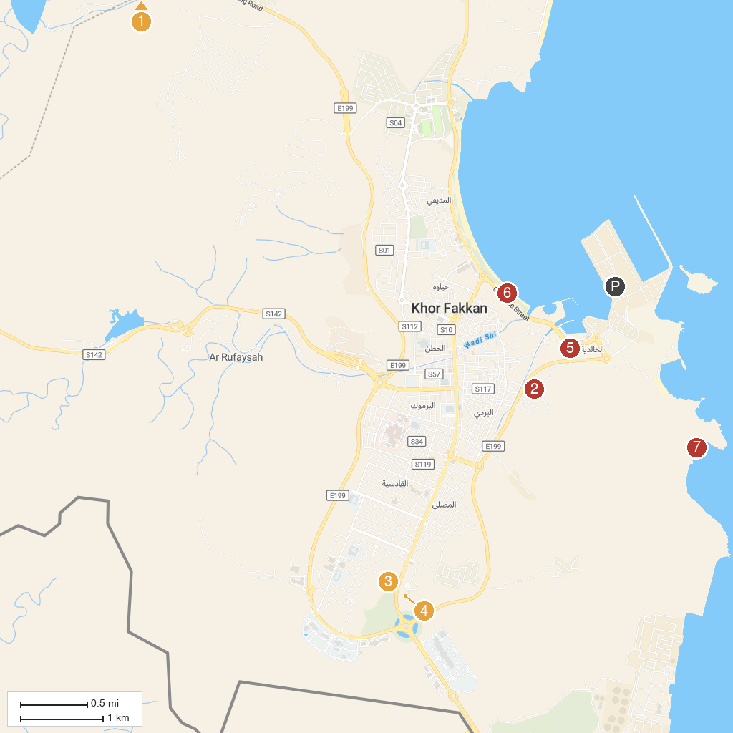
MAP KEY
1. Wadi Wurayah Biosphere Reserve محمية وادي الوريعة | 5. Old town Khorfakan
2. Al Rabi Tower | 6. Khorfakkan Beach
3. Resistance Monument | 7. AlQalqali beach
4. Flag Area
P. Cruise port / terminal
Map © MapTiler © OpenStreetMap contributors · cruiseports.org

