King Abdullah Port KAEC, Makkah, Saudi Arabia
Saudi Arabia's bold new planned city on the Red Sea — pristine beaches, a championship golf course, and a futuristic promenade that feels more Dubai than desert.
⚓ Pier (docked) · 🕒 Typical call: 7-10 hrs · 💵 Saudi Riyal (SAR) — nearly cashless · 🗣️ Arabic / English widely spoken · 🚌 Shuttle required from port to city
✍️ MY DAY IN PORT (FILL IN)
Ship / Date
In port | arrive ______ · all aboard ______
Booked excursion
Notes / meeting point
GETTING ASHORE
- Docking: Pier — ships dock at King Abdullah Port; no tendering
- Walk to center: Not walkable — shuttle bus ~15-20 min to Bay La Sun
- Best For: Red Sea beaches, golf, modern Saudi culture, water sports
- Don't Miss: Yam Beach snorkeling and the Bay La Sun canal promenade
GETTING AROUND
- 🚕 Taxi: Negotiated; ~50–150 SAR within KAEC — Private taxis are available at the port. Fares within KAEC are short distances; negotiate or use the meter. Pre-booked p
- 📱 Rideshare: ✅ Uber, Careem
TOP THINGS TO DO
- Yam Beach Day — KAEC's signature beach in Bay La Sun — calm Red Sea waters protected by a coral reef, sun loungers, paddleboards, and kayaks.
- Red Sea Snorkeling & Diving — Boat trips from KAEC Bay run 30-minute coastal cruises or full-day diving expeditions on the coral-rich Red Sea reefs.
- Haramain High-Speed Train to Jeddah — KAEC has its own bullet-train station.
- Juman Karting — A 700-metre outdoor go-kart track near Bay La Sun — fast, fun, and popular with families.
- Mangrove Kayaking — Guided kayak tours through the mangrove forests along KAEC's protected coastline — a surprisingly lush Red Sea ecosystem right at…
BEST WALKS
- Bay La Sun Canal Promenade: 1.5 km · Flat · 20-30 min — Stroll the waterfront boardwalk from the Bay La Sun Hotel marina south past Juman Park and the…
WEATHER · DAYLIGHT · MONEY
Month | High °F | Low °F | Rainy days
May | 95 | 77 | 0
Jul | 98 | 81 | 0
Sep | 98 | 81 | 0
Daylight: May 5:43AM–6:56PM · Jul 5:48AM–7:10PM · Sep 6:10AM–6:26PM
cruiseports.org/king-abdullah-port-kaec · Confirm terminal & all-aboard time with your ship

King Abdullah Port KAEC, Makkah, Saudi Arabia — Port Map
Red = walkable sights · Amber = excursions farther out · P = cruise terminal
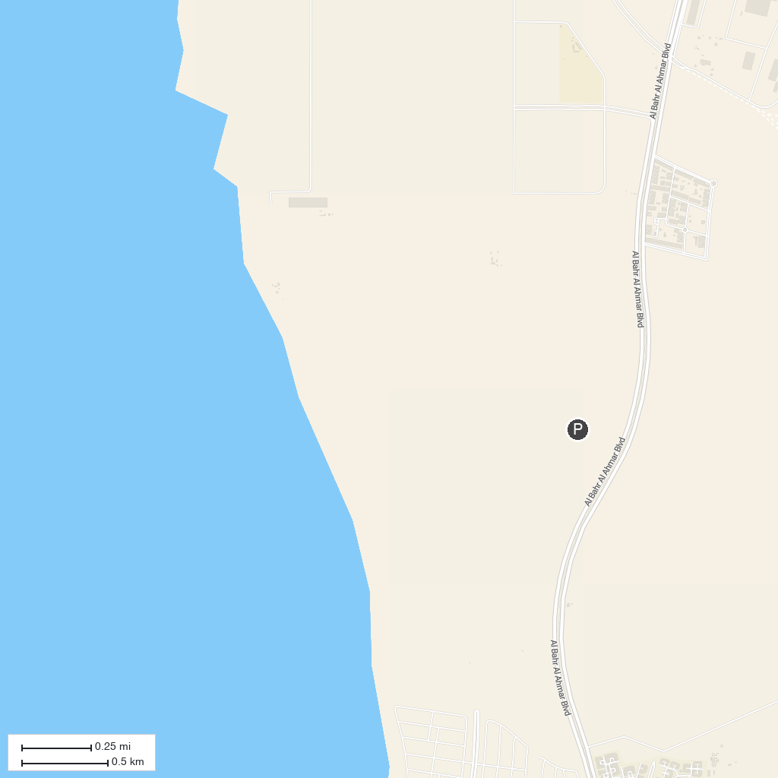
MAP KEY
1. Safaa and Marwah (Saee) | 5. Aisha Al Rajhi Mosque
2. Masjid al-Haram | 6. Exhibition of the Two Holy Mosques Architecture
3. Mecca Museum | 7. باب - السلام - As Salam
4. Albaya Mosque
P. Cruise port / terminal
Map © MapTiler © OpenStreetMap contributors · cruiseports.org

